Sinclair Community College
Continuous Improvement Annual Update 2015-16

Please submit to your Division Assessment Coordinator / Learning Liaison for feedback no later than March 1, 2016

After receiving feedback from your Division Assessment Coordinator, please revise accordingly and make the final submission to your dean and the Provost’s Office no later than May 2, 2016

Department: BPS - 0415 - Computer Information Systems
Year of Last Program Review: FY 2011-2012
Year of Next Program Review: FY 2016-2017

Section I: Progress Since the Most Recent Review

Below are the goals from Section IV part E of your last Program Review Self-Study. Describe progress or changes made toward meeting each goal over the last year. Responses from the previous year’s Annual Update are included, if there have been no changes to report then no changes to the response are necessary.
GOALS | Status | Progress or Rationale for No Longer Applicable
Explore development of new courses, including courses on Cyber Security and Information Assurance, Data Analysis and Analytics, Games, Graphics and Visualization, Health Care Information Technology, Mobile Computing Devices, courses of Virtualization, and especially VMWare and Microsoft Hyper-V, Network Engineering courses on Enterasys and Juniper Equipment, Microsoft Windows PowerShell Task Automation Framework. | In progress X  Completed  No longer applicable | The department continues to explore new curriculum given changes in technology.
Explore development of new programs, including Cyber Security and Information Assurance (CSIS) Certificate, Health Care Information Technology (HCIT) Certificate, Mobile Computing Device (MCD) Certificate, Cyber Security and Information Assurance (CSIA) AAS Degree, Data Analysis and Analytics (DAA) AAS Degree, Health Care Information Technology (HCIT) AAS Degree, Mobile Computing Device (MCD) AAS Degree. | In progress X  Completed  No longer applicable | The department continues to explore new curriculum.
Explore greater use of on-line, hybrid, and face-to-face delivery formats in all CIS courses. | In progress X  Completed  No longer applicable | The department continues to offer classes in many modes: face-to-face, online, and competency learning.
Explore offerings at Courseview, all satellite locations, high schools, WPAFB, MVCTC, Miami Valley Research Park, and Kettering-Dwight L. Barnes Community and Continuing Education Center. | In progress X  Completed  No longer applicable | The department has increased course offerings at Courseview but enrollment numbers have been disappointing. Perhaps some advertising of CIS courses would help.

Below are the Recommendations for Action made by the review team. Describe the progress or changes made toward meeting each recommendation over the last year. Responses from the previous year’s Annual Update are included, if there have been no changes to report then no changes to the response are necessary.
RECOMMENDATIONS | Status | Progress or Rationale for No Longer Applicable
Most of the data provided in the self-study regarding assessment were course success rates. While this can be a valuable data point, assessment data needs to be more focused and targeted. Course success rates do not provide much data regarding how well specific outcomes in the course are being met. Other assessment strategies need to be developed. As the department noted in its self-study, “A consistent assessment for every faculty to use for all courses is needed for general education outcomes. Consistent collection of these results would be helpful to identify areas of improvement.” The department is encouraged to develop a formal assessment plan that specifies the exams, assignments, and activities in classes that will be used to demonstrate that students are achieving general education and program outcomes. Thought will need to be given to how data will be collected, analyzed, and reported. It was mentioned in the review team meeting that the department is talking about developing pre/post measures for program outcomes – it is also recommended that the department move toward development of these measures. | In progress  Completed  No longer applicable | The department is continuing to improve this process
The department is responsible for overseeing a large number of academic programs. Where possible, it is beneficial to students for degree programs to be as short as possible without sacrificing quality and the ability to prepare students for transfer or employment. It is recommended that the department review its academic programs to explore whether there are opportunities for trimming credit hours, although it is emphasized that lowering program credit hours should never be done in a way that would compromise the preparation of our graduates. | In progress  Completed  No longer applicable | All degrees are less than 65 hours.
Related to exploring whether degree programs should be shortened, it is also recommended that the department work to be sure its programs are current and are preparing students adequately for the types of jobs they will be applying for at the time they leave Sinclair. | In progress  Completed  No longer applicable | The success of preparing students for jobs in IT is evidenced through the success of the internship program data.  The internship instructor visits all internship sites and the feedback from internship sites is very positive.  Faculty meet twice a year with the CIS Advisory Committee to get feedback from about how to update the curriculum with industry needs and what are the future IT needs.
The adjunct mentoring program that the department has under development has the potential to have a great impact on adjuncts. It is recommended that the department pursue this program and provide updates through the Annual Update process every year on how well it is working. | In progress  Completed  No longer applicable | The mentoring program has been very successful. Each new adjunct faculty member is assigned to an experienced full time tenure track or tenured faculty member. Each mentor is given a check sheet and a list of duties.
.  There are a number of higher education competitors for this department – the department should carefully examine these competitors and think about ways that they could increase their market share by attracting students to Sinclair instead of these competitors. This would be beneficial for both the department and the students who would be recruited who would have otherwise gone to other educational providers. | In progress  Completed  No longer applicable | With no resources within the department to devote to marketing our programs, we are limited to college wide marketing efforts to positively impact our programs and enrollments. To date, those efforts have not produced measurable positive results.
The department has an aggressive Action Plan – however, given that there are constraints in terms of the resources that can be devoted to its activities, it is recommended that the department formalize priorities that it will focus on in terms of implementation of the Action Plan. This is also true of the degree programs that the department is considering developing – since new degree development is a time consuming process, it is recommended that the department prioritize development of one or two degree programs it feels would be most likely to lead to gainful employment for students in areas where there are great opportunities for employment. | In progress  Completed  No longer applicable | The department has not prioritized which degrees to focus on since all the CIS degrees lead to employment.
The department has done a good job of keeping up with trends in the field, and the department is encouraged to continue to look at emerging technologies and trends and to explore developing courses and programs in response where appropriate. | In progress  Completed  No longer applicable | The department continues to regularly meet with Advisory Committee members and attend local and regional meetings of IT Professionals in order to maintain the currency of courses and programs.  Juniper equipment was purchased and curriculum (content and assessment) was added to the Networking degree. Currently Palo Alto equipment was purchased and the department is adding it to the CIS 2418 course renamed Basic Network Security.
With the current emphasis on completion at the institution, the department is encouraged to make sure that its activities are well aligned with Sinclair’s and the state’s completion goals, and that the department is actively working to increase completion rates. | In progress  Completed  No longer applicable | The department is still working on this recommendation

Section II: Assessment of General Education & Degree Program Outcomes

The Program Outcomes for the degrees are listed below. All program outcomes must be assessed at least once during the 5 year Program Review cycle, and assessment of program outcomes must occur each year.

PLEASE NOTE – FOR THE PREVIOUS YEAR AND THIS YEAR, REPORTING OF GENERAL EDUCATION OUTCOME ASSESSMENT HAS BEEN TEMPORARILY POSTPONED. WE WOULD ASK THAT IN THIS ANNUAL UPDATE YOU IDENTIFY AT LEAST ONE COURSE IN YOUR DEGREE PROGRAM(S) WHERE ASSESSEMENT AT THE MASTERY LEVEL WILL OCCUR FOR THE FOLLOWING GENERAL EDUCATION OUTCOME:

- Cultural Diversity & Global Citizenship: Apply knowledge of cultural diversity to real world context by acknowledging, understanding, and engaging constructively within the contemporary world.

PLEASE RESPOND TO THE FOLLOWING QUESTIONS:

Do you have a required course in your program curriculum where Cultural Diversity & Global Citizenship could be assessed for mastery?
☐Yes ☒No If yes, please list the course: Click here to enter text.

If no, is there an elective course that is listed on your Preferred Program Pathway Template where Cultural Diversity & Global Citizenship could be assessed for mastery?
☐Yes ☒No If yes, please list the course: Click here to enter text.

If no, is there another elective course that is an option in your program curriculum where Cultural Diversity & Global Citizenship could be assessed for mastery?
☐Yes ☒No If yes, please list the course: Click here to enter text.

If no, where do students master Cultural Diversity & Global Citizenship in your program? Do you need assistance incorporating this General Education outcome into your degree program?

Click here to enter text.

NOTE THAT THERE WILL NEED TO BE AT LEAST ONE EXAM / ASSIGNMENT / ACTIVITY IN THIS COURSE THAT CAN BE USED TO ASSESS MASTERY OF THE COMPETENCY.

YOU MAY ALSO SUBMIT ASSESSMENT RESULTS FOR THIS GENERAL EDUCATION COMPETENCY IF YOU HAVE THEM, BUT IT WILL BE CONSIDERED OPTIONAL.

Program Outcomes | To which course(s) is this program outcome related? | Year assessed or to be assessed. | Assessment Methods  Used | What were the assessment results?  (Please provide brief summary data)
Demonstrate creative and critical thinking skills in the analysis of digital crimes and cyber security issues, problem solving strategies, research, analysis, synthesis, evaluation, assessment, adaption and application of computer forensic techniques. | CIS-1111  CIS-2640  CJS-2111  CJS-2209  CJS-2295  PHY-1100  PHY-1110 | 2013-2014 | CIS 2640 uses hands on labs, assignments and exams to assess whether students have mastered this outcome. | 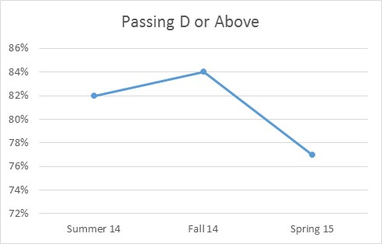
Demonstrate the manner of evidence collection consistent with standard criminal justice chain of Develop programs, databases and business techniques to identify and/or resolve cyber crimes, including the development of plans for incident analysis and avoidance. | BIS-1120  CIS-1111  CIS-2165  ECO-2160  MAN-2150 MAT-1460 MAT-2170 | 2013-2014 | CIS 1111 While the assessments do not specifically assessment cyber crimes they do assess whether students can analyze data. | 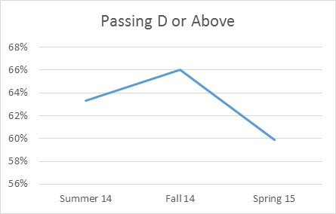
Demonstrate the manner of evidence collection consistent with standard criminal justice chain of Display professional oral and written communication skills and collaborate with a team to deliver and implement a project plan in the business and criminal justice environment to address cyber security problems. | CJS-1102  CJS-2295  COM-2225 ENG-1101  SCC-1101
Demonstrate the manner of evidence collection consistent with standard criminal justice chain of evidence procedures to maximize prosecutorial effectiveness while minimizing legal defense challenges and legal liabilities. | CJS-1104  CJS-2111
Demonstrate the process to find and recover data artifacts present, deleted or hidden to preserve the verifiable integrity of digital evidence. | CIS-2808  CJS-2295 | 2013-2014 | CIS 2808 The hands on labs, assignments, and exams assess the outcome. Note, this course is only taught once a year. | This class runs only once a year and only 3 students took and completed this class as independent study. All three earned an A.
Diagnose and prescribe solutions to hardware, networks and operating systems problems. | CIS-1107  CIS-1130  CIS-2550  CIS-2640  CIS-2717 | 2013-2014 | CIS 1130 uses hands on labs, assignments and exams to assess whether students have mastered this outcome. | 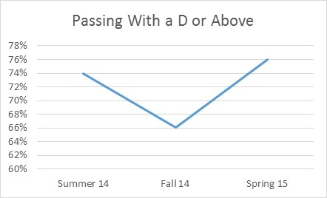
Apply programming, database, operating systems and business application skills to solve and troubleshoot business and information technology problems related to area of concentration. | BIS-1120 CIS-2165 | 2013-2014 | CIS 2165 uses projects and exams to assess whether students have mastered this outcome
Apply programming, website design, database, operating systems and business application skills to solve business and information technology problems. | BIS-1120 CIS-1304 CIS-2165  CIS-2309 CIS-2314 CIS-2319 | 2013-2014 | CIS 2165 uses projects and exams to assess whether students have mastered this outcome  CIS 1304. 2309, 2314, and 2319 have been deactivated
Configure routers and switches and networks, troubleshoot network components and connections. | ACC-1210 BIS-1120 CIS-1107  CIS-1111 CIS-1130 CIS-1140 CIS-1411 CIS-2165 CIS-2416 CIS-2421 CIS-2426 CIS-2640 COM-2225 ECO-2160 ENG-1101 MAN-2150 MAT-1460 MAT-2170 PHY-1100 SCC-1101 |  | The Cisco curriculum, CIS 1411, 2416, 2421, 2426 use labs, Packet Tracer activities and hands on skills exam to assess whether the student has mastered the outcome. | All Cisco Courses  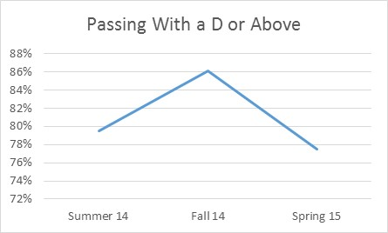
Demonstrate ability to research, select, use and troubleshoot hardware and network components or connections appropriate to area of concentration. | CIS-1130 CIS-1714 CIS-2717  PHY-1100 |  | CIS 1130 uses hands on labs, assignments and exams to assess whether students have mastered this outcome.  CIS 1714 and CIS 2717 are part of the User Support curriculum. The labs and exams are all accumulative. | CIS 1714  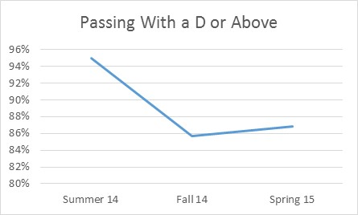  CIS 2717  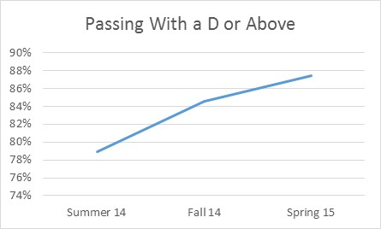
Demonstrate effective oral and written communication skills as well as teamwork skills in the delivery of customer service, project planning and project completion in the information technology business environment. | CIS-1140 CIS-2170  CIS-2178 CIS-2520 COM-2225 ENG-1101 SCC-1101 |  | CIS 2178 students use project documentation, posts, and capstone presentation  CIS 2170 uses assignment focuses on communication, resume and job search skills, networking, and ethics to access whether students have mastered the outcomes | CIS 2178  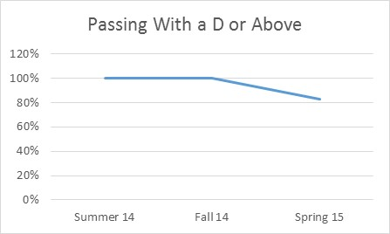  CIS 2170  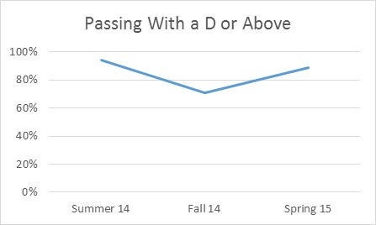
Design, document and implement computer software solutions and websites given definition of a problem and requirements for a solution. | ACC-1210 CIS-1111 CIS-1140  CIS 1350  CIS 1202  CIS 2207  CIS 2212  CIS 2217  CIS 2222  ECO-2160 MAT-1460 MAT-2170 |  | CIS 1111 All assignments, including midterm and final exams are assessed using grading guidelines. These guidelines include documentation, execution, correct naming convention as well as did the student solve the problem.  CIS 1140 Assessment Item: Group assignments and Ethics Project (9 deliverables - individually graded) - 15% of total grade for course  CIS 2217 Assesses the outcome using programming assignments, 2 conceptual exams and 2 practical exams. | CIS 1140  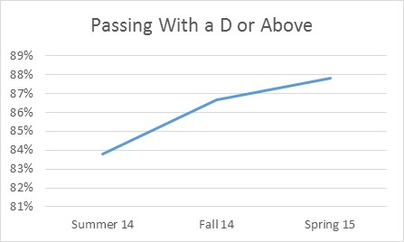  CIS 2217  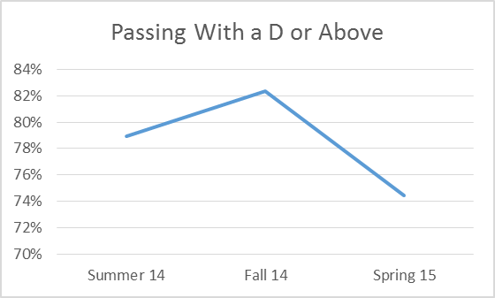
Design, document and implement computer software solutions given definition of a problem and requirements for a solution. | ACC-1210 CIS-1111 CIS-1140 ECO-2160 MAT-1460 MAT-2170 |  | CIS 1111 All assignments, including midterm and final exams are assessed using grading guidelines. These guidelines include documentation, execution, correct naming convention as well as did the student solve the problem
Manage and secure operating systems. | CIS-1107 CIS-1510 CIS-2510  CIS-2515 CIS-2520 CIS-2630 CIS-2640 |  | CIS 1510 uses labs, midterm, and final to assess whether students have mastered the outcome. | 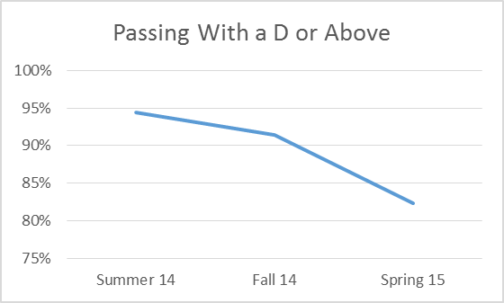
Research, select, use and troubleshoot hardware and network components or connections appropriate to area of concentration. | CIS-2520 PHY-1100 |  | CIS 2520 uses labs, midterm, and final to assess whether students have mastered the outcome. | 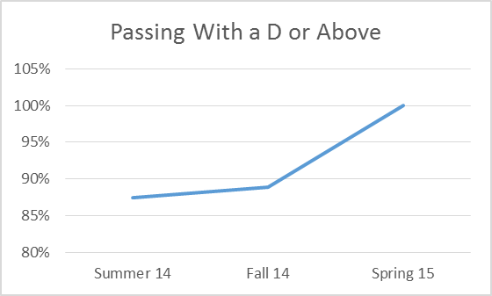
Use operating system commands to manipulate files and directories and perform systems software troubleshooting. | CIS-1107 CIS-1510  CIS-2510 CIS-2515 CIS-2520 |  | CIS 2510 uses labs, midterm, and final to assess whether students have mastered the outcome. | 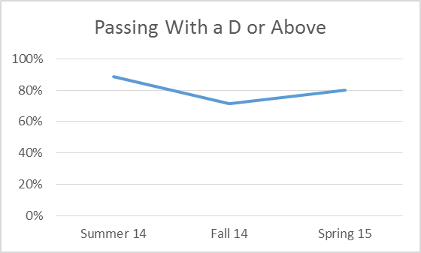

Are changes planned as a result of the assessment of program outcomes? If so, what are those changes? | CIS 1107 is in the process of being redesigned.
How will you determine whether those changes had an impact? | For CIS 1107 passing grades and how well students perform in subsequent classes.

