Sinclair Community College
Continuous Improvement Annual Update 2016-17

Please submit to your Division Assessment Coordinator / Learning Liaison for feedback no later than March 1, 2017

After receiving feedback from your Division Assessment Coordinator, please revise accordingly and make the final submission to your dean and the Provost’s Office no later than May 1, 2017

Department: BPS - 0423 - Paralegal / 0422 - Law / 0497 - Real Estate
Year of Last Program Review: FY 2012-2013
Year of Next Program Review: FY 2019-2020

Section I: Progress Since the Most Recent Review

Below are the goals from Section IV part E of your last Program Review Self-Study. Describe progress or changes made toward meeting each goal over the last year. Responses from the previous year’s Annual Update are included, if there have been no changes to report then no changes to the response are necessary.

GOALS | Status | Progress or Rationale for No Longer Applicable
The department continues to evaluate its required and elective courses. Based on input from the Advisory Board, internship meetings, graduate surveys and community surveys, the department is committed to expanding its selection of one- and two-hour electives, when appropriate. These courses give current students the basics for expanding their knowledge of specialty areas of the law and also provide opportunities for graduates to upgrade skills. Currently under consideration are courses in Elder Law, Mortgage Foreclosures, and Health Care Law. | In progress  Completed  No longer applicable | The Department has created an online Criminal Law course which consolidated two other electives and has boosted our Average Class Size. As mentioned in previous Annual Updates, the department does not plan to add more one and two credit hour electives due to students being more interested in three credit hour online electives than one or two credit hour electives. In addition, having a lot of one or two credit hour electives was damaging to our ACS. The department will continue to review our electives and assess the best possible method to give students variety in electives while at the same time keeping our ACS where it needs to be. In addition, the department will attempt to hold CLEs in areas where we are not offering electives so that the students can still hear about those areas of law.
There is currently no plan to offer paralegal courses at other locations. The library requirements, software requirements, and faculty limitations do not make that feasible at this time. However, the department is committed to assisting the Courseview Campus in establishing an ABA-approved paralegal program when CVCC decides to move that project forward. | In progress  Completed  No longer applicable | There is no plan to offer paralegal courses at other locations at this time, because in doing so we would be out of compliance with the ABA. The ABA does not approve offering classes at branch campuses. Branch campuses are required to get their own ABA Approval if they plan to start an ABA Approved program. Former Chair, Mike Brigner, met with the leaders of the Courseview campus in June of 2013 and it was determined that at this time devloping a Paralegal Program is not a priority that the CVCC is pursuing at this time.
Below are the Recommendations for Action made by the review team. Describe the progress or changes made toward meeting each recommendation over the last year. Responses from the previous year’s Annual Update are included, if there have been no changes to report then no changes to the response are necessary.

RECOMMENDATIONS | Status | Progress or Rationale for No Longer Applicable
The department noted that retention and graduation rates are a challenge – what can be done to increase graduation rates? Efforts should be made to document the number of students who fail to complete because they have accepted full-time employment and present that information along with graduation rate information. Perhaps the department should emphasize to a greater extent the benefits of finishing an associate’s degree prior to taking full-time employment in the field. | In progress  Completed  No longer applicable | We continue to engage in several practices that we hope will assist in this area. First, in our introductory course, Paralegal Principles, students are required to create a map of their courses and present it as part of a homework assignment. This is important as many students do not realize that they must take the Paralegal courses in a certain sequence. This makes them aware of this right up front through an assignment. While we already make this very clear through all of our promotional materials, we are hopeful that getting feedback as part of a grade will also help in this endeavor. Second, our Administrative Assistant does contact students that leave the program in their first term. She calculates these results for us and provides the data in a report to the Chair. Finally, we also hold a mandatory Orientation before school starts. We have been doing this for years, but in this orientation we do emphasize the importance of completion.
Related to the issue of increasing graduation is consideration of which students are admitted into the Paralegal program. The department should explore and consider offering a survey course that students would take prior to getting into their other Paralegal courses that would serve as an introduction to the field and an opportunity for students to find out what becoming a paralegal entails. A model of this approach is used by the Dental Hygiene program, where the Introduction to Dental Hygiene course is taken prior to the student being officially admitted into the program, allowing students to know what they are getting into prior to beginning the program proper. | In progress  Completed  No longer applicable | The department has met with the Dean about the idea of a survey course. However, with the state requirement that degrees are reduced to 65 credit hours, a survey course does not make sense at this time.
Similarly, the department should consider the approaches that are being used to admit students into the program who are most likely to succeed. Exploration of additional admissions requirements would be appropriate, with an emphasis on an improved writing assessment requirement (Core Grammar was mentioned in the review as one possible example of a writing assessment). There should likewise be discussions on the appropriateness of increasing the GPA requirement to get into the program. Attempts should be made to estimate the impact of any changes to admissions policies using available data. | In progress  Completed  No longer applicable | The department addressed this issue during the 2014 PAR retreat. The consensus of the department is to leave the admissions requirements as they stand. Faculty members have observed students starting with a 2.0 GPA being successful in our program and experiencing positive job placement. In addition, the department worries about enrollment if requirements were to be made any stricter.
Like many other departments across the college, this department struggles with getting feedback from graduates and other students. Research, Analytics, and Reporting is working with departments to try and increase response rates for graduate surveys, the department is encouraged to be actively engaged in these efforts. Other new approaches to staying in touch with graduates for the purpose of tracking their outcomes should be considered. | In progress  Completed  No longer applicable | The department is using social media, both Facebook and LinkedIn, to keep in contact with alumni. During our most recent ABA review, the department was able to contact 96% of our recent Paralegal graduates. Chair Jenna Beck has worked with RAR and now survey links are sent from Jenna’s email and being posted in a private facebook group of alumni. This has greatly increased the number of responses the department has received. For the first time in several years, we now have a full-time faculty member teaching in Real Estate. Our Real Estate Coordinator, Lauren Dreshman, will be sending the survey out to RES graduates to attempt to raise the response of RES surveys as well.
.  The department noted problems with student writing skills – exploring a writing assessment of some kind prior to admission to the program has already been recommended. What other things can be done to avoid having to teach students grammar in the Legal Research course? How can students be informed ahead of time of the intensive writing component of the program – is there the possibility of noting on MAPs that a high level of writing skill is required in the program? Should there be a course that addresses writing early in the curriculum, perhaps a “Composition and Contracts” course or something similar? | In progress  Completed  No longer applicable | There are multiple ways in which the department is tackling this issue. First, more writing intensive assignments have been implemented into Paralegal Principles, our introductory course. In addition, the student can earn extra credit for writing assignments in this course for going to the Writing Center. Unfortunately, going to the Writing Center cannot be made mandatory due to the full-time work and class schedule held by some of our students. In Paralegal Principles, students will also start to learn correct citation format under the Ohio Manual of Citations in an effort to make them more prepared for the concepts they will learn in Legal Research & Writing. Second, we have already indicated successful students who did well in our writing intensive classes to tutor students who are having difficulties through tutorial services so that this option is available for a student as soon as they feel that they need extra assistance. Third, the notation has been made on department planning guides that a high level of writing skill is required. Finally, the department offered a writing workshop to all faculty, staff and students in the Fall of 2014.
The upcoming retirement of a key faculty member highlights the importance of taking a close look at potential replacements as former faculty transition out and there is a need for new faculty to transition in. Formal documentation of processes and other issues should be a priority so that as little institutional memory as possible is lost with the retirement of long-time faculty members. Planning ahead for personnel changes should be a priority for the department. | In progress  Completed  No longer applicable | At this point, this is no longer applicable.
The department should give consideration to opportunities for continuing education offerings, both in the Paralegal and Real Estate programs. | In progress  Completed  No longer applicable | The Paralegal Department has offered multiple CLEs since given this recommendation including “Advanced Legal Writing” approved for 2 hours of general CLE credit, “E-Discovery: Process and Purpose” approved for 1.5 hours of general CLE credit, and “Juvenile Law Update” approved for 1 hour of general CLE credit.  The Real Estate program received approval of RES 1402 Property Management for 17.5 hours of continuing education credit. Beginning Fall 2017, students will receive both course and CE credit. The approval is valid for three calendar years.  The Real Estate program is working to gather from adjunct faculty the materials necessary to apply for approval of RES 1302 Real Estate Investing and RES 1102 Abstracting.
There are several recommendations specific to the RES program:  - Continue the excellent ongoing work on stackable short-term certificates  - Continue the development of articulation agreements  - Explore online options once approval is given to do so by the state  - As mentioned above, explore continuing education opportunities | In progress  Completed  No longer applicable | Legislation passed permitting online delivery of pre-licensing courses. By April 2017, the Division of Real Estate will enact rules that we will need to follow to offer online courses. We are hopeful we will be able to begin offering all the pre-licensing courses online beginning Summer 2017. RES 1101 and 1201 are already developed and RES 1301 and 1401 are in development Spring 2017.  The previous program coordinator looked into articulation agreements with the University of Cincinnati and Miami University for real estate finance and determined our program may not contain enough math.  In 2015, the RES Advisory Committee recommended that the program not pursue offering a Broker Short Term Certificate.

Section II: Assessment of General Education & Degree Program Outcomes

For the FY 2016-17 Annual Update, departments are asked to provide assessment results for Information Literacy.

General Education Outcomes | Year assessed or to be assessed. | Course identified by the department where this outcome could be assessed | Assessment Methods  Used | What were the assessment results?  (Please provide brief summary data)
Information Literacy | 2016-2017 | PAR1201 - Legal Research & Writing | Final Interoffice Legal Memo/Rubric | This assignment is graded using a rubric where the student evaluates themselves in addition to the instructor. The data shows that the students frequently rated themselves higher than the instructor. In AY 2016-2017, the average grade for this assignment was 76.71% which is concerning as it is lower than the passing score for Paralegal classes which is 79%.
NEXT YEAR:
Computer Literacy | 2017-2018 | PAR1102 - Legal Technology; |  | Our Legal Technology class has an assessment over the Microsoft Office Suite. Results from the assessment varied greatly. In Fall 2016, the day class averaged 74.7% while the night class averaged 71.34%. In Spring 2017, the day class averaged 93.17% while the night class averaged 80.13%. These results meet the makeup of our students as many students enter the program with very few technology skills. Additional workshops for those below the curve might need to be researched further.

The Program Outcomes for the degrees are listed below. Responses from previous years are provided below. All program outcomes must be assessed at least once during the 5 year Program Review cycle, and assessment of program outcomes must occur each year.

Program Outcomes | To which course(s) is this program outcome related? | Year assessed or to be assessed. | Assessment Methods  Used | What were the assessment results?  (Please provide brief summary data)
Competently conduct factual and legal research and communicate the results clearly and concisely. | COM-2206 ENG-1101 ENG-1199 ENG-1201 PAR-1103 PAR-1201 PAR-1203 PAR-2301 PAR-2401 PSY-1100 SOC-1101 | 13-14  16-17  13-14  14-15  15-16 | Final Interoffice Legal Memo | PAR 1201: Legal Research & Writing  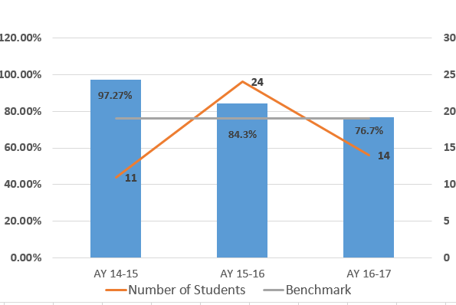  This assignment is the last assignment of the semester. The data indicates a drop in scores from AY 14-15 to the subsequent years. At this point in time, there was a change in instructors for this class and it is likely that grading styles and standards are different as nothing else about the class has changed. The department will further evaluate this data especially given that students in AY 16-17 fell below the 79% benchmark.
Competently prepare and interpret legal documents. | ACC-1210 LAW-1101 MAT-1120 PAR-1201 PAR-2302 PAR-2303 | 14-15  16-17  13-14  15-16 | Child Support Computation Worksheet | MAT 1120: Business Math  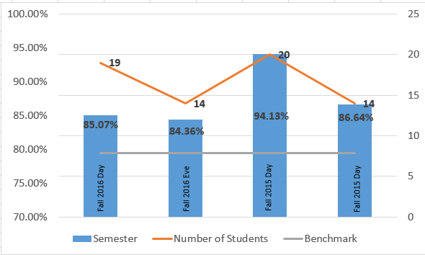  Students must complete a Child Support Computation as part of their Final Divorce Decree. Based on this data, it appears that students are taking the knowledge learned in MAT 1120 and adequately applying their math skills to complete this assignment as the class average exceeded the 79% benchmark.
Demonstrate competency in current technology. | BIS-1120 PAR-1102 PAR-1202 | 15-16  13-14; 16-17  14-15 | PowerPoint Assignment | PAR 1102: Legal Technology  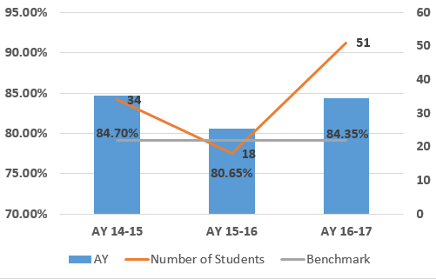  Students demonstrated competency in completing Lexis searches as the class average exceeded the benchmark of 79% each of the last three years.
Exemplify a high standard of ethical and professional behavior individually and as a member of a legal team. | PAR-1101 PAR-2304 PAR-2401 | 14-15, 15-16  removed  13-14, 16-17 | Ethics Role Play Assignment & Ethics Quiz | PAR 2401: Paralegal Internship  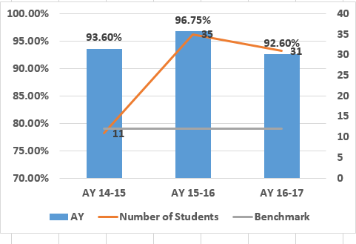  The students in internship class are rated on their professionalism. Internship supervisors rated our students far above the benchmark of 79% in the category “Professionalism – Ability to follow instructions” over the last three academic years.
Demonstrate correct and appropriate use of oral and written communication, mathematics, and computer technology in real estate activities. | BIS-1410 COM-2206 ENG-1101 ENG-1131 RES-1101 RES-2301 RES-2302 | RES 1101  RES 2301 Note RES 2301 was deactivated and replaced with RES 1301 and RES 1401 | In RES 1301 Real Estate Finance (which replaced RES 2301), the final exam includes questions related to mathematics, finance and computerized underwriting of mortgage loans. | The grade distribution for the pre-license courses:  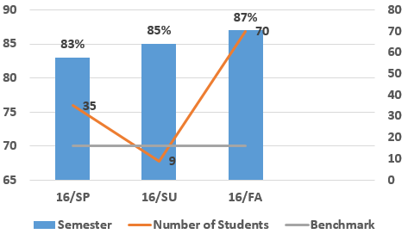  Grades for the final exam ticked upwards over the last three semesters. This can be attributed to a strong, stable core of instructors for this class.
Exemplify a high standard of ethics as a real estate professional. | RES-1201 RES-2401 | RES 1201 | In RES 1201 Real Estate Law, this exam includes ethics questions to prepare students for the real estate salesperson licensure exam. . | Average grade for the exam:  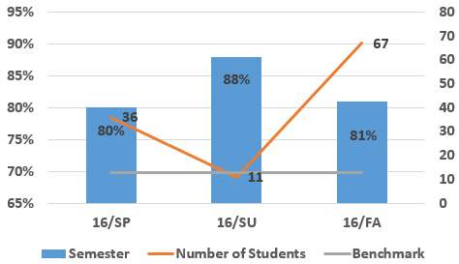  Grades peeked during the summer, but returned back to a normal range come Fall. With the Summer enrollment being smaller, the instructor was able to give more individualized attention to each student.
Demonstrate knowledge in managing real estate, investing in real estate, real estate contracts, valuing real estate and real estate financial instruments. | ACC-1210 ACC-1220 ECO-2180 LAW-1101 MAT-1120 PLS-1120 PLS-1232 PSY-1100 RES-1101 RES-1102 RES-2301 SOC-1145  Note RES 2301 and RES 2302 were deactivated and replaced with RES 1301 and RES 1401 | RES 1101 | In RES 1101 Real Estate Principles, the final exam tests students’ knowledge of all of these topics. | Average grade for the exam  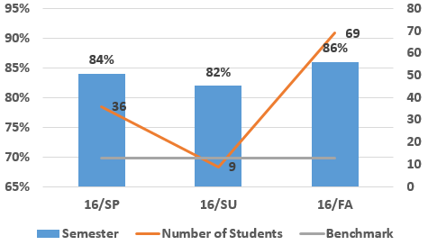  Grades for the final exam ticked upwards over the last three semesters. This can be attributed to a strong, stable core of instructors for this class.

Are changes planned as a result of the assessment of program outcomes? If so, what are those changes? | No changes are planned as a result of the assessment of program outcomes at this time. The Paralegal Program does plan to take the next few years to review all curriculum and assignments now that the American Bar Association review is over and there are six years until the next review. While we will keep this assessment data in mind, the impetus for change is to make sure that our curriculum adequately reflects the changes being made in the legal field.  The Real Estate Program is in a time of great change with the recent passage in legislation to allow Real Estate courses to be online. This will be implemented sometime in late Spring/early summer and assessment will be done on the online program’s success at that time.
How will you determine whether those changes had an impact?

OPTIONAL:

Please use the space below to keep track of any annual data that your department wishes to maintain. This section is completely optional and will not be reviewed by the Division Assessment Coordinators.

