Department/Program Review
Self-Study Report Template

2016 - 2017

Department: 0330-English
Section I: Annually Reviewed Information

A: Department Trend Data, Interpretation, and Analysis

Degree and Certificate Completion Trend Data – OVERALL SUMMARY
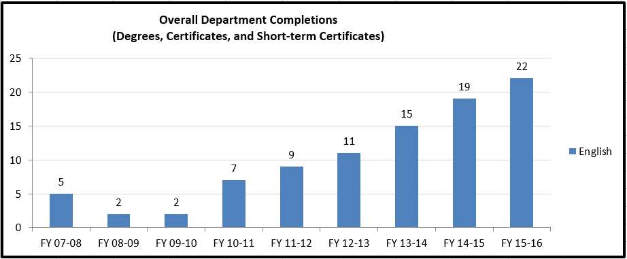
Please provide an interpretation and analysis of the Degree and Certificate Completion Trend Data: i.e. What trends do you see in the above data? Are there internal or external factors that account for these trends? What are the implications for the department? What actions have the department taken that have influenced these trends? What strategies will the department implement as a result of this data?

Please be sure to address strategies you are currently implementing to increase completions of degrees and certificates. What plans are you developing for improving student success in this regard?

We have two programs and a short-term certificate with about 150 majors. Our two programs, ENGE.S.AA (literature) and CRWE.S.AA (creative writing) comprise most of the 150 students. As the chart above illustrates, we have seen an increase in degree and certificate completions since the last program review – over two times the number of completions, in fact. While 22 student completions is still a modest number, we continue to build on this number and gain momentum with completions through the Pathways 2.0 Grant (as described near the bottom of the next page).

The creation and distribution of program literature for the ENGE.S.AA and the CRWE.S.AA may have influenced the upward trend in student completions. The department has distributed these marketing pieces at open houses and career fairs, as well as to advisors, during the last two years.

Further, the short-term certificate in professional writing has launched anew this academic year thanks to revised financial aid requirements. Because this certificate is based upon courses many students are already required to take (ENG 1101, ENG 1201, ENG 1131 and ENG 1199), plus a BIS and COM course, it is an easy add-on for students.

To support student completion of our programs, the chair has met with the LASS advisors at least once each term to discuss our program offerings and answer questions about substitutions. We also make sure that when advisors ask for course substitutions for students nearing graduation, we seriously consider the requests.

To personally connect with our majors, we started contacting them by phone and email beginning in the spring of 2015. Each faculty member has taken responsibility for contacting between 9-12 majors as assigned. Contacting these students provides support for their English studies and gives them a personal contact in the department.

Another strategy we implemented that may have influenced the rate of completions is connecting with our program majors through a student survey in 2014, led by Kate Geiselman. Thirty-six students replied to the survey, and the majority of respondents, 58.33%, indicated that their short-term goal as an English major was to transfer to a four-year institution to earn a degree in English. We plan to follow-up with this group over the next review period to determine their level of preparation for their coursework at their transfer institutions.

During this academic year, we began work on the Pathways 2.0 initiative. For the first time, we had a program orientation for our Creative Writing and English majors in the Library Loggia. Almost all faculty were in attendance, as well as one advisor. The orientation kicked off our observation of the National Day on Writing (Oct. 20), and at least 50 majors attended.

Also as part of the Pathways 2.0 work, we created a postcard to solicit suggestions from our majors, and from those responses we are creating a book club, a writing group, and a cadre of student volunteers for the annual Writers’ Workshop and Jack Bennett Young Writers’ Festival.

We anticipate continuing this work on a larger scale in the coming academic years. During spring semester 2017, we will hold an open forum for program majors at the start of the Writers’ Workshop with guest faculty from transfer institutions.

Course Success Trend Data – OVERALL SUMMARY
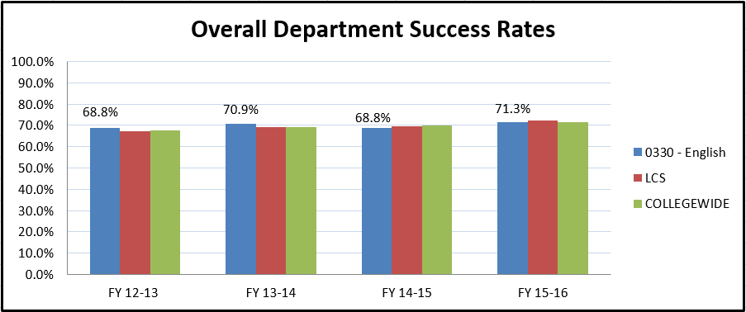

Please provide an interpretation and analysis of the Course Success Trend Data. Please discuss trends for high enrollment courses, courses used extensively by other departments, and courses where there have been substantial changes in success. Please be sure to address strategies you are currently implementing to increase course success rates. What plans are you developing for improving student success in this regard? OPTIONAL - Please provide any additional data and analysis that illustrates what is going on in the department (examples might include accreditation data, program data, benchmark data from national exams, course sequence completion, retention, demographic data, data on placement of graduates, graduate survey data, etc.)
The whole department course success rate has not risen or fallen a statistically significant amount since the last program review. However, we count the preservation of the success rate as an accomplishment. Several of the English courses have maintained very high levels of student completion (i.e., ENG 1131 and ENG 1199).
It should be noted that in spite of placement changes with the WritePlacer, which was adopted in 2013, we have maintained success rates in ENG 1101 at about 68%. We constantly monitor the success of those students on the cusp of the cut score, which is a 4 out of 8, and if those numbers should drop, we are prepared to re-visit our cut score. Academic integrity requires us to set the cut score at the lowest possible number to allow the highest number of students to attempt ENG 1101. Although the 4 cut score is aggressive, it benefits students. In fact, now other colleges in Ohio are also adopting a 4 as a cut score, making Sinclair a leader in the effort to complete more students.

The most current data from RAR regarding ENG 1101 success rates as they pertain to the cut score is below (September 9, 2016).
Score | N | %
0 | 3 | 0.1%
1 | 21 | 0.4%
2 | 157 | 3.3%
3 | 488 | 10.2%
4 | 2,012 | 42.3%
5 | 1,506 | 31.6%
6 | 454 | 9.5%
7 | 94 | 2.0%
8 | 27 | 0.6%

Among the 2,012 students who earned a 4:
- 1,337 (66.5%) subsequently enrolled in ENG-1101 during AY2015-16.
- 912 (68.2%) of them successfully completed the course on their first attempt.

Among the 1,506 students who earned a 5:
- 1,049 (69.7%) subsequently enrolled in ENG-1101 during AY2015-16.
- 791 (75.4%) of them successfully completed the course on their first attempt.
A few notes: The population considered in this analysis includes students who enrolled as new in AY2015-16 and who had an active WritePlacer score on file. Success rates are based on the student’s first ENG-1101 attempt.

To address the success rates of our high-enrollment composition courses, ENG 1101 and 1201, faculty analyze their own success rates each academic year. If a faculty member’s success rates are more than 20% lower than the collective department average, those numbers are addressed in FPRs and targeted as an area of improvement for the coming year. Faculty temperament, pedagogy, syllabus tone, assignment sequence, variance in policies, and variance in assessment practices all contribute to success rates. The adjunct faculty continue to receive their success rates each term, and the rates are taken into consideration when scheduling adjuncts. In certain cases, improvement plans have been implemented for adjuncts with low success rates.

Another means of maintaining consistent success rates with both adjunct and full-time instruction is professional development. Each academic year, we have an adjunct in-service in August to orient adjuncts to the coming year and provide any necessary curricular adjustments. We have developed a repository in eLearn for both of our high enrollment composition courses – ENG 1101 and 1201 – and those repositories serve as excellent resources for assignments and classroom activities geared to meet the outcomes of those courses.

Our creative writing courses in the CRWE.S.AA enjoy high success rates: fiction writing, poetry writing, and novel writing have success rates close to 80%. This high success rate can be attributed to the quality of creative writing faculty, the quality of creative writing students at Sinclair (i.e., one of our CRWE majors received second place in the 2016 League for Innovation’s Writing Contest), and the innovative curriculum of our creative writing courses. The faculty who teach creative writing courses, all tenured professors, are award-winning, widely-published authors. Retaining this high level of creative writing faculty has allowed our program to flourish and will encourage growth. As evidenced by national contest winners, our creative writing students are talented and primed to succeed both inside and outside of Sinclair. The innovative curriculum of our creative writing courses has allowed our students to thrive and develop professional skills.

The literature courses in the ENGE.S.AA are equally successful. Many of them enjoy success rate percentages of 90% or more, which again is attributable to the quality of our faculty, students, and curriculum. The faculty who teach LIT courses, again all tenured faculty, are avid writers and scholars in their fields. We have cultivated a group of studious and committed majors.
B: Progress Since the Most Recent Review
Below are the goals from Section IV part E of your last Program Review Self-Study. Describe progress or changes made toward meeting each goal over the last year.
GOALS | Status | Progress or Rationale for No Longer Applicable
The department’s goals and rationale for expanding include continuing to offer sections of composition at all locations and at all times (WPAFB, Courseview, Englewood, and Huber Heights Learning Centers, Centerville High School, Prisons, etc.). | In progress  Completed  No longer applicable | At this point, we have met the goal of offering courses at all locations for the last five academic years. We have developed and offered a hybrid version of ENG 1101, 1201, and 1131 for delivery at CVCC, ELC, and HLC at the request of the LCs. In addition, we are offering a section for FESTO apprentices at CVCC this fall 2017, which is a new initiative.  We are moving toward offering a fully-online ENGE.S.AA degree with the development of LIT 2202, 2211, and 2212 online on the schedule with distance learning. Because our offerings in LIT courses are one section per course per academic year, in most cases, students need the opportunity to take the higher-level literature courses online. We often hear this exact feedback from our advisors. An online program will boost our completion numbers by at least half.
We plan to explore new courses after we convert to semesters, including a class on writing/publishing in the electronic media. | In progress  Completed  No longer applicable | We regret that this plan is really no longer applicable as our programs are maxed at 60-61 credits and we do not have the latitude to propose 2297s or other new courses for consideration at this time.  However, our faculty are interested in teaching more literature courses and should that mandate change or the community need increase, we will be ready to meet the challenge of offering new classes.
We plan to continue to modernize our curriculum to serve students as they transfer and graduate in greater numbers. | In progress  Completed  No longer applicable | We continue to modernize our curriculum, which will be a task that likely will not reach an end as improvements can always be made to reflect current and innovative writing pedagogies. In the summer of 2016, we adopted an Open Educational Resource (OER) as a textbook for the ENG 1101 and 1201 courses. This text is faculty-developed and is accompanied by a teacher’s guide in eLearn to assist faculty as they implement the new textbook. A conservative estimate of savings to students during this first year is around $300,000 in textbook costs.  Developing the OER has given us the opportunity to re-think and re-visit our department mission statement, which has led to a cohesive vision for our writing program. (Our writing program is comprised of our composition courses, ENG 1101 and 1201.) One of the more modern developments of the text has been the addition of the multi-modal composing unit, which we will start teaching this summer 2017.
The department is working through the AQIP initiative to build stronger connections with ACA (NOW DLA) and area high schools. | In progress  Completed  No longer applicable | Although not currently part of the AQIP project, the English department has tried to work with the DLA department to align writing curricula. Grammar instruction, quizzes, and MyConnect work continue to populate the curriculum of some DLA courses, which makes the alignment difficult. At the heart of resistance to alignment is a fundamental disagreement about what constitutes successful college-level writing.  We have built stronger connections with area high schools through the CCP courses that we offer, and also through the Dayton Public Schools (DPS) Alignment Program, which ended in the spring of 2016. In addition, we have partnered with Dayton Public Schools for two of our four National Day on Writing Celebrations with the goal of aligning high school and college writing expectations. The results of these collaborations have been encouraging and we plan to continue to strengthen these relationships with area high schools.
In the next five years, we plan to establish a stronger assessment program for students and faculty by exploring e-Portfolios and routine assessment norming for faculty. | In progress  Completed  No longer applicable | An assessment program has been instituted and course SLO assessments have been distributed and collected each term. Our assessment coordinator, Aaron Moyer, calculates the results and shares them with the department during a department meeting each term.  Based on the trends of the assessments performed each term since spring 2012, student writing samples demonstrated the weakest control in working with writing conventions, control over essay format, and relating to personal experience. Since last year, student scores have improved in audience awareness.  In ENG 1201, students are weakest in in-text citations and control over conventions. By running the ENG 1101 and 1201 assessments each semester, we have been able to track the strengths and weaknesses of our program.  During the spring and fall of 2016, we began to close the loop by addressing strategies to improve the weakest areas in the assessments. We will then analyze subsequent assessments for improvement results. We had our first meeting to accomplish this work on April 29, 2016. We will continue with grade norming and develop strategies to close gaps in our outcomes. Our next meeting to grade norm and develop strategies will be Feb. 4, 2017.  In addition, the English Department partnered with the Provost’s Office and College-Wide Assessment to pilot a Written Communication Gen Ed Rubric for the college. In the fall of 2015, several online 1101 courses piloted the rubric. In spring 2016, we have continued that work with a larger number of sections. The results of this general education assessment are included in this program review and can be utilized by other departments. Starting with fall of 2017, all ENG 1101 faculty will be required to complete this assessment at the end of each term in order to assist the entire college in assessing written communication.
We plan to take action on the “opportunities” list presented in Section IV A of the FY 2011-12 Program Review. | In progress  Completed  No longer applicable | - We have established an improvement plan for faculty with poor success rates in ENG 1101 and 1201, including the distribution of individual success rates, the discussion of the factors contributing to the rates, and the mentoring of faculty with low rates.  - As stated above, we have developed stronger linkages with area K-12 programs and the DLA department.  - Secretarial and staffing needs have been addressed, but administrative and office concerns are still being addressed.  - Communication between faculty and departments through the LCS bullets has been accomplished.  - Department workload, resources, and communication have been more equitably spread.  - An advisory board has been established.  - Musings, and/or updates regarding department accomplishments, has not been published regularly due to lack of faculty interest in producing the newsletter. But, we have participated in LCS News and Notes regularly.  - The Writing Center completed a study with RAR to institute positive change.  - ENG 1131 (business communication) is more closely aligned with other schools as the result of the work of an 1131 coordinator.  - Student evaluations are routinely used and are taken into consideration to inform us of global weaknesses.
Below are the Recommendations for Action made by the review team. Describe the progress or changes made toward meeting each recommendation over the last year.
RECOMMENDATIONS | Status | Progress or Rationale for No Longer Applicable
From the self-study, it was not apparent that there was a lot of feedback being collected from other academic departments regarding how well the English Department is meeting their needs. The department is encouraged to dialogue to a greater extent with other departments at the college for the purpose of seeking feedback. | In progress  Completed  No longer applicable | To address this recommendation, an advisory committee, led by Adrienne Cassel, was established in the spring of 2013 to advise the department, and an introductory luncheon was held on May 1, 2013. The advisory committee met again in March 2015, April 2016, and will meet in March 2017.  The main goals for the advisory committee include:  - Review features of program outcomes to meet business, industry, government, and stakeholder needs  - Ensure readiness to support dual enrollment offerings  - Establish process for soliciting annual feedback from academic departments  - Dialogue about student writing across the college and how ENG can better support the growth and development of a culture of writing on campus.  Members of the advisory committee include internal stakeholders from BIS, NSG, the Provost’s Office, advising, and external stakeholders from Wright State’s English Department.
The department should seriously consider reviewing the Program Outcomes, incorporating a greater focus on outcomes specific to English and the skills and outcomes associated with English courses. | In progress  Completed  No longer applicable | We are currently reviewing the outcomes for the CRWE and ENGE programs to target more program-specific skills. We submitted a new course for approval in the fall of 2016, “Writing for Publication,” to add to our CRWE program to better meet the needs of our student population.
It appears that there may be room to create more of a climate of expectation with adjuncts in terms of professional development. Adjuncts should be made explicitly aware of the expectations involving workshops, attendance at in-service meetings, etc. | In progress  Completed  No longer applicable | All adjuncts are made aware of expectations and concerns about professional development at the interview during which they are hired. Further, through the leadership of an adjunct faculty coordinator, currently Dair Arnold, adjunct faculty have clear and direct contact with the department. We have instituted monthly adjunct coffees, as well.  In addition, fall and spring in-services are provided for adjuncts and CCP instructors. An adjunct faculty outreach team comprised of four full-time professors (Charles Freeland, Dair Arnold, Furaha Henry-Jones, Jamey Dunham and adjunct Whitney Larson) meets to address adjunct concerns and plan in-services. This work is also vital to the English adjunct community.  The English department nominated Whitney Larson, who received the award for “Adjunct Faculty of the Year” for the LCS division in 2015. In addition, we were so proud that Joseph Foster, an adjunct instructor for the prison program for ENG, received 2016 “Adjunct Faculty of the Year.”  Over the last academic year, our Adjunct coordinator, Dair Arnold, has observed eight adjuncts and provided feedback regarding their teaching. At the summer 2016 in-service, she selected several adjunct projects to highlight as an informal “showcase” prior to the meeting. Further, as a department, our faculty continually mentor new adjuncts (4 in 2015-16, 11 in 2016-17).  In addition, we have instituted a teaching portfolio requirement for adjunct faculty and CCP faculty (see requirements in Appendix II). At the end of the spring 2016 term, adjuncts and CCP teachers submitted their teaching portfolios, which included a reflective memo on challenges and successes, as well as syllabi and graded student work. Each adjunct received constructive, narrative feedback on his or her portfolio, which was well-received. Through these portfolios we were able to identify inconsistencies in the delivery of our curriculum and the assessment of student work. We are now addressing those inconsistencies in a positive manner.  Finally, we have surveyed adjuncts regularly at our in-services to discover their interests in professional development in order to include them in our monthly teaching discussions and bi-annual in-services. We also have been able to gauge what their general concerns are through these surveys.
Dual enrollment is being strongly encouraged by the state. Some of the challenges regarding dual enrollment arrangements were discussed in the review meeting, and the department should proactively discuss strategies for dealing with these challenges and overseeing the offering of dual enrollment sections with area high schools. | In progress  Completed  No longer applicable | College Credit Plus (CCP) offerings continue to expand each semester.  CCP offerings have grown to over 53 restricted sections at high schools and 1,240 students in non-restricted sections just between the 15/SU-16/SU academic terms. We are meeting those demands by hiring adjuncts when high schools do not have qualified faculty. We are also acclimating several of our own Sinclair adjuncts to teaching CCP courses both at high schools and online, as teaching CCP students requires a different skill set. For instance, Butler Tech has developed a relationship with adjunct Whitney Larson and Miamisburg High School has developed a relationship with adjunct Link Schreiber. We believe, as does the CCP office, that maintaining consistency with instruction will benefit our students and help to build relationships with area schools.  All ENG faculty have been given at least one CCP mentee in 2015-16 and in 2016-17 and are providing guidance and support to those high school faculty as needed. This academic year, we are mentoring 14 CCP teachers.
The Writing Center appears to be a valuable resource for students, but the benefit to students has not been documented to the extent that it could be. The department is encouraged to find ways to strengthen assessment of the Writing Center, demonstrating how students benefit from using the resources there. This may entail capturing more data than is currently captured from users of the Writing Center. Research, Analytics, and Reporting (RAR) may be a resource the department could use in its efforts to better assess the impact of the Writing Center. | In progress  Completed  No longer applicable | At this point, the Writing Center is not under the umbrella of the English department. In fact, the English department has never had a budget line for the Writing Center –Tutorial Services holds the budget. Elizabeth Scarborough, as director of Tutorial Services, has been tasked with the maintenance of Writing Center staffing and resources. We have a few release hours for faculty consulting to the Writing Center every term, which are now assigned to Whitney Larson, who also receives an SSA from Tutorial Services. She works as a liaison to the center and provides tutorial guidance on content and other tutoring issues that arise. However, she is not in any way managing the center. We have noted that traffic to the Writing Center has dropped since Tutorial Services started daily management of the center and stopped hiring the appropriate number of master-level tutors in the fall of 2015. If the college believes that the English department should take a larger role in the operations of the Writing Center, then a requisite budget and authority will have to be granted. At this time, we are merely consultants.  Writing Center Noteworthy Activities, Accomplishments, or Outcomes for 2015-16  - As of fall 2015, about 50% of the coverage is now provided by student employees. In the last reporting cycle, only 10% of the hours were covered by student workers. Four professional tutors from the prior year did not return in fall 2015 and were replaced with student employees. This was due in part to a budget goal set in the prior year.  - As of fall 2015, all ESL and DEV students are being serviced by Tutorial Services.  - For fall 2015, schedule adjustments were made to cover peak times. This met a goal from the prior year. Scheduling adjustments were not made in the spring to cover peak times.  - As of spring 2016, all operational responsibilities were overseen by the Director of Tutorial Services.  - In spring 2016, two student workers were hired to help direct students using the center. This allowed tutors to continue working with students uninterrupted.  - In spring 2016, students could make appointments for the first time in the Writing Center’s history.  - Student usage of the Writing Center has dropped by 32% in comparison to the prior year, which we attribute to the lack of master tutors employed by Tutorial Services because of budgetary constraints.  Students were surveyed at the end of the Fall 2015 term in relation to the outcomes of using the Writing Center.  - When asked if they had used the Writing Center for multiple assignments, 83% responded, “Yes.” This group was also asked as to why they had used the Writing Center multiple times: 84% responded that the service had improved their grades and the remaining 16% responded that it lessened their anxiety.  - When asked if they had recommended using the Writing Center to another student, 34% responded, “Yes.”  - When asked if they use the services of any other centers or labs, 72% responded, “No.”  Faculty from several departments such as Sociology, Psychology, Communication, Medical, and Engineering continually refer students to the Writing Center. Approximately 50% of the students using the Writing Center come from courses outside of English.
Work has been ongoing in the department to find more ways to help students succeed – it is strongly recommended that the department continue and enhance these efforts. The department is encouraged to explore the implementation of an attendance policy to determine whether that might increase student success, and is generally encouraged to generate additional innovative strategies designed to impact success. There are some faculty in the department who have consistently higher success rates than the average - it is recommended that strategies used by these instructors be identified and scaled up for use in other sections of English to increase student success. | In progress  Completed  No longer applicable | A “Success Team” comprised of the faculty with the consistently highest success rates in the department was formed. These teachers met to determine policies that would encourage student persistence and presented those policies to the department. A suggested attendance policy was established and distributed.  In addition, the tone of all syllabi has been reviewed, and faculty have been encouraged to revise their language to encourage student completion. Those faculty with completion rates 20% lower than the department average have been asked to reconsider their policies, especially, and have written goals on their FPR to increase student completion in their courses. We have scaled up the strategies used by our most successful instructors.  In addition, in January of 2016, the chair started faculty-led, one-hour “Teaching Discussions.” These discussions are held each month before department meetings. They are meant to inspire strategies for increasing student success in composition courses. So far, topics have included teaching with critical pedagogy, responding to student writing, working with ESL students, teaching with empathy, and dealing with student mental health issues.
While some data is being collected and the Assessment Team has done some initial work Spring 2012, it is recommended that the department increase its work on assessment of student learning. Further development of the assessment approached piloted in Spring 2012 is encouraged, and the department should work to expand any successful efforts to as many sections as possible. The department is strongly encouraged to develop an assessment plan that clearly lays out what they are going to measure, how they are going to do it, who is going to do it, and how they will process, analyze, report, and use the data that is collected. | In progress  Completed  No longer applicable | We have developed an assessment plan, and are revising it continuously. Aaron Moyer leads the assessment efforts for the department each semester and reports the results to the chair and department. As mentioned earlier in this report, we are using the results to target our shortfalls in ENG 1101 and 1201 and develop teaching strategies to remediate the weaknesses, particularly in the areas of audience awareness and in-text citation.

C: Assessment of General Education & Degree Program Outcomes

For the past two years, departments have been asked in their Annual Update submissions to identify courses and assignments where General Education Outcomes could be assessed for mastery (with the exception of Oral and Written Communication – for those two outcomes the College is piloting a process to collect data, no data need be reported for those two outcomes in this self-study). Please report any assessment results you have for the first four General Education outcomes based on the courses and assignments that were identified by your department in the previous two Annual Update cycles. (The last two are optional).

General Education Outcomes | Courses identified by the department where mastery could be assessed | Assessment Methods  Used | What were the assessment results?  (Please provide brief summary data)
Critical Thinking/Problem Solving | ENG1101 - English Composition I | Assessed through departmental artifact assessment of ENG1101 and ENG1131 exam data. | Since Spring 2012, ENG1101 artifacts have been assessed for “relating topic to personal experience” as part of the critical thinking component. On a Likert scale of 1-4, the 2012 samples scored 3.06 and have been declining to the current 2015 score of 2.43. ENG1131 exam data shows that critical thinking questions are missed at the highest rate in comparison to all other outcomes.
Cultural Diversity and Global Citizenship | LIT 2234 - Literature of Africa, Asia, and Latin America | Assessed in spring 2012 by reviewing the department artifact pool of ENG1101 papers. Assessed again for the annual report in 2015-16 through LIT2234: Literature of Africa, Asia, & Latin America. | Students are asked to write about their understanding of other cultures and social issues. This requirement forces them to recognize and articulate understanding of interdependence of world cultures.
Computer Literacy | ENG1101 - English Composition I | Assessed through departmental artifact assessment of ENG1101 and ENG1201. | Every term, “control over electronic environment” scores above 3.0 on a Likert scale of 1-4. Every term of assessment has shown computer skills to be the highest ranking out of all outcomes.
Information Literacy | ENG1201 - English Composition II | Assessed through departmental artifact assessment of ENG1201. | Since Fall 2013, critical analysis of source material has been evaluated each year. On a Likert scale of 1-4, the score has averaged 2.84 with a department goal of 3.0 or higher.
Oral Communication | OPTIONAL | Assessed through college-wide data provided by the Assistant Provost. | English program students scored 100% on 12 out of 14 components (85% passing rate). The two areas of weakness pertain to formulating clear questions for exploration.
Written Communication | OPTIONAL | Assessed through departmental artifact assessment and college-wide data provided by the Assistant Provost. Since Spring 2012, ENG1101 and ENG1201 artifacts are assessed each term by all full-time English faculty. | Both assessments show similar weaknesses in the areas of sentence conventions, using external sources, and following a publication format. The college-wide data shows English program students scored a 100% on 4 out of 6 components. The two areas of weakness, organization and clarity, were passed by 80% of those assessed.
Are changes planned as a result of the assessment of general education outcomes? If so, what are those changes? | We plan to focus on strategies to address organization and clarity in our ENG 1101 and 1201 courses, as well as sentence conventions. Mini-lessons and modules for the ENG 1101 and 1201 repositories will be developed and we will continue to measure any progress through SLO assessments.
How will you determine whether those changes had an impact? | To assess those strategies, we will add another question to our semester SLO assessment that addresses clarity, organization, and sentence conventions in more depth.

The Program Outcomes for the degrees in our department are listed below. All program outcomes must be assessed at least once during the 5-year Program Review cycle, and assessment of program outcomes must occur each year.
Program Outcomes for  CRWE.S.AA | To which course(s) is this program outcome related? | Year assessed or to be assessed. | Assessment Methods  Used | What were the assessment results?  (Please provide brief summary data)
Demonstrate ability to think logically and solve problems using analysis, synthesis and evaluation. | ENG 1201 | 2013-14 | Written assignments | Based on the ENG 1201 assessment from AY 2014-2015, the student writing samples demonstrated that students were “proficient” in their critical thinking skills in relation to the critical analysis of source material in their writing. On a Likert Scale of 1-4, this outcome scored a 2.79/4.00.
Achieve group goals in a variety of social contexts. | ENG 1101, 1201 | 2013-14 | Written assignments | In a syllabus review of all faculty, it was determined that at least 80% of faculty use group work and workshops to accomplish classroom and program goals.
Demonstrate responsibility and accountability in accomplishing goals. | ALL | 2013-14 | Written assignments | The responsibility for accomplishing goals is perhaps best reflected in the success rate of the courses, which remains consistent at near 80%.
Communicate effectively in a variety of ways with varied audiences through writing skills, oral communication skills, listening skills, reading skills, computer literacy and information literacy. | ENG 1101, 1201, ENG 1131 | 2013-14 | Written assignments | Students are required to communicate within various genres to achieve proficiency in this outcome. On a Likert Scale of 1-4, students scored 2.74/4.00 in the audience awareness area.
Demonstrate skills in multiple creative writing genres. i.e.: poetry, script writing, fiction writing. | ENG 2255, 2256, 2259 | 2013-14 | Written assignments | This outcome is achieved through following the course outlines and requiring students to write in a variety of genres.
Create works that are polished enough to submit for consideration of publication. | ENG 2255, 2256, 2259 | 2013-14 | Written assignments | This outcome is essential to students in our CRWE program, and assignments are assessed with the goal of eventual publication.
Are changes planned as a result of the assessment of program outcomes? If so, what are those changes? | Same as above
How will you determine whether those changes had an impact? | Same as above

Program Outcomes for  ENGE.S.AA | To which course(s) is this program outcome related? | Year assessed or to be assessed. | Assessment Methods  Used | What were the assessment results?  (Please provide brief summary data)
Analyze literary works of American, British and world cultures in terms of major literary themes and devices. | LIT 2211, 2212, 2201, 2202, 2230, 2234 | 2013-14 | Written assignments | The outcome of analysis is achieved through writing assignments pertaining to analyzing the reading material.
Identify and discuss major authors and works in American and British literature. | LIT 2211, 2212, 2201, 2202, | 2013-14 | Written assignments | This outcome is targeted by assigning forums and writing assignments regarding major works in British and American Literature.
Recognize and articulate an understanding of the increasing interdependence of world cultures and their consequences. | LIT 2234 | 2013-14 | Written assignments | Students are asked to write about their understanding of other cultures and social issues. This requirement forces them to recognize and articulate understanding of interdependence of world cultures.
Achieve group goals in a variety of social contexts. | ENG 1101, 1201 | 2013-14 | Written assignments | In a syllabus review of all faculty, it was determined that at least 80 percent of faculty use group work to accomplish classroom and program goals.
Demonstrate ability to think logically and solve problems using analysis, synthesis and evaluation. | ENG 1201 | 2013-14 | Written assignments | Based on the ENG 1201 assessment from AY 2014-2015, the student writing samples demonstrated that students were “proficient” in their critical thinking skills in relation to the critical analysis of source material in their writing. On a Likert Scale of 1-4, this outcome scored a 2.79/4.00.
Demonstrate responsibility and accountability in accomplishing goals. | ALL | 2013-14 | Written assignments | The responsibility for accomplishing goals is perhaps best reflected in the success rate of the courses, which remains consistent.
Are changes planned as a result of the assessment of program outcomes? If so, what are those changes? | Same as above
How will you determine whether those changes had an impact? | Same as above

Comparison of ENG1101 & ENG1201 Assessments

The following tables compare the ENG1101 and ENG1201 assessment results from the past four years. The tables show the results in reverse chronology with the movement of the most recent averages noted as “up” or “down” based on the comparison to the prior year. The three lowest rankings for each period are indicated in bold and the asterisk shows SLO’s that were toward the bottom on all assessments. All scores (averages) are based on a Likert Scale of 1-4 with 4 being best.

ENG1101 Assessment Comparisons for FA 15, SP15, SP14, SP13, & SP12
Student Learning Outcome | FA15 Rank | FA15 Avg | SP15 Rank | SP15 Avg | SP14 Rank | SP14 Avg | SP13 Rank | SP13 Avg | SP12 Rank | SP12 Avg
#1a: Logical Structure | 3 | 2.76 up | 4 | 2.64 | 3 | 2.54 | 5 | 2.73 | 6 | 2.92
#1b: Intended Purpose | 2 | 2.86 down | 2 | 2.92 | 2 | 2.79 | 2 | 3.08 | 3 | 3.06
#1c: Audience Awareness | 4 | 2.59 down | 3 | 2.74 | 4 | 2.36 | 4 | 2.8 | 3 | 3.06
#2: Relate to Personal Experience | 6 | 2.43 down | 6 | 2.51 | 7 | 2.05 | 7 | 2.31 | 3 | 3.06
#3a: Control over Conventions* | 7 | 2.1 down | 7 | 2.48 | 6 | 2.26 | 6 | 2.53 | 7 | 2.4
#3b: Control over Essay Format | 5 | 2.5 down | 5 | 2.55 | 5 | 2.32 | 3 | 2.88 | 1 | 3.32
#4: Control of Electronic Environment | 1 | 3.05 up | 1 | 3.0 | 1 | 3.0 | 1 | 3.25 | 2 | 3.2
Note: SP12 was the pilot assessment.

ENG1201 Assessment Comparisons for SP16, FA14, FA13
Student Learning Outcomes | SP16 Rank | SP16 Score | FA14 Rank | FA14 Score | FA13 Rank | FA13 Score
#1a: Logical Structure | 3 | 2.96 | 5 | 2.97 | 5 | 2.85
#1b: Intended Purpose | 2 | 3.17 | 3 | 3.03 | 2 | 3.02
#1c: Audience Awareness | 8 | 2.73 up | 8 | 2.67 | 4 | 2.86
#2: Critical Analysis of Source Material | 5 | 2.79 | 6 | 2.79 | 3 | 2.92
#3a: Control over Conventions* | 9 | 2.71 down | 7 | 2.72 | 7 | 2.75
#3b: Control over MLA Format | 5 | 2.79 | 4 | 3.0 up | 5 | 2.85
#3c: In-text Citations* | 7 | 2.77 up | 9 | 2.62 | 8 | 2.21
#3d: Works Cited Entries | 3 | 2.96 | 2 | 3.05 up | 9 | 1.96
#4: Control of Electronic Environment | 1 | 3.25 | 1 | 3.33 up | 1 | 3.08

Next Step: Closing the Loop
Closing the loop means that the weak areas are addressed by dissemination of information and implementing strategies to improve the outcomes. This becomes part of the assessment: note instructional changes and analyze subsequent assessments for improvement in results

Section II: Overview of Department
- Mission of the department and its programs(s)
What is the purpose of the department and its programs? What publics does the department serve through its instructional programs? What positive changes in students, the community and/or disciplines/professions is the department striving to effect?
ENG 1101 is required across most programs at the college and is the number one, Top 45 course, with ENG 1201 also in the top five. Because the curriculum reaches almost every student, it is imperative to have a strong mission and philosophy that is reflected by our OER and in our pedagogy. Therefore, since the last program review, we have developed a mission statement to guide us in creating our curriculum for 1101 and 1201, which we call the English Department Writing Program. Both the mission statement and philosophy statement can be found on our department web page, in the OER, and in other published materials. The statements have also been reviewed by our advisory committee.

English Department Mission Statement:
The English Department’s Writing Program introduces students to the complexities of twenty-first century literacies and provides traditional and innovative approaches to writing, reading, and thinking critically.

English Department Writing Program Philosophy Statement:
The English Department’s Writing Program focuses on developing rhetorical literacy, which undergirds all academic disciplines and is highly valued by employers. Rhetorical literacy includes practices of reading, writing, and critical thinking. Literacy enriches personal lives; empowers students to become responsible, contributing members of a democracy; increases both self-expression and the understanding of others in our global society; and encourages resiliency and life-long learning.

In the English department we meet students as individuals and believe in culturally-responsive teaching. We maintain high standards to challenge students to grow to their full potential. Students leave our writing classes with improved literacy skills that help them reach their personal and professional goals in the twenty-first century.

Does your department have any departmental accreditations or other form of external review?
________ Yes ____x____ No

Section III: Overview of Program
- Analysis of environmental factors
This analysis, initially developed in a collaborative meeting between the Assistant Provost of Accreditation and Assessment and the department chairperson, provides important background on the environmental factors surrounding the program. Department chairpersons and faculty members have an opportunity to revise and refine the analysis as part of the self-study process.
How well is the department responding to the (1) current and (2) emerging needs of the community? The college?
The Assistant Provost Jared Cutler met with our department and conducted an environmental scan, which he then distributed to us. Through analysis of that scan, we have concluded that we are meeting the current and emerging needs of the college and wider community. The results are summarized below.
Students: In our ENGE and CRWE programs, as well as in our composition and business writing courses, faculty meet students’ needs in an effort to prepare them for writing in their future classes and for writing in their current/future workplace. To learn how well we are accomplishing this work, we administer end-of-course surveys, and we ask students to complete informal surveys in class. Each year we spend time completing student learning outcome assessments and have collected data from these assessments to better inform our work. In addition, the OER has a student survey that students complete at the end of their composition courses to let us know how to better develop the text.
To better meet students’ needs in our programs, we are participating in a Pathways 2.0 grant that has allowed us to develop program orientation materials and connect with our students. Through this grant, as described in Section 1A of this review, we are addressing the needs of our program students.
The 2015 Recent Graduate Survey Results distributed by RAR demonstrated that students are employed in the field of English and they did feel prepared for work in their field upon graduation. While the number of students surveyed was small, our graduates revealed that they are interested in pursuing graduate work, which gives us a better understanding of development activities to offer them. (See Appendix IV for Recent Grad Survey results.)
College: We are serving the college’s assessment efforts by using a general education rubric in many sections of English 1101 to assess written communication outcomes. We will be pushing that assessment into all sections of ENG 1101.
As a department, our goal is to participate and sponsor campus activities as much as possible. We have a robust (and ambitious) calendar of events that we sponsor, including the Annual Jack Bennett Young Writers’ Festival (in its fifth year) and the National Day on Writing (in its fourth year), and the Writers’ Workshop (in its 46th year!). Each year, about 100 students from grades 6-12 join us on a Saturday for the Young Writers’ Festival, and the spoken word group “Metaphorically Speaking” performs. Our faculty volunteer their time to lead writing workshops for the students and share lunch with them. On October 20, The National Day on Writing is celebrated across the United States, and Sinclair’s English department has sponsored celebrations over the past four years ranging from workshops with Dayton Public Schools to writing stations scattered around campus. The Writers’ Workshop is open to the college and community and features keynotes and workshops designed for a wide range of students and writers.
Further, we host the Poem in Your Pocket Annual Poetry Reading in April each year. As part of this reading in the Library Loggia, faculty and staff are invited to participate in an annual poetry video recording, which is also available online.
To create a more writing-friendly academic culture on campus, faculty have worked through the CTL and Sinclair Talks to offer workshops on plagiarism, incorporating writing into non-liberal arts courses, using MLA and APA formats, and evaluating and assessing student writing. The workshops and discussions have been well-attended and feedback on them has been strong.
Last year, we partnered with Diversity Officer Michael Carter to connect award-winning author Wil Haygood with students in our composition courses through his book, The Butler. Our students were able to meet Haygood and have a Q & A with him about his research methods and writing habits.
Along with the articulation agreements with local universities, we have worked closely to develop course equivalencies to the courses designated as TAG courses for English Literature majors in the state. Sally Lahmon has served on the state-level TAG since its inception. Our LIT survey courses align to state outcomes and are a part of the TAG.
Our work with university partners and transfer institutions is developing – we have a faculty member from WSU on our advisory committee. At the 2017 Writers’ Workshop, we plan to have faculty from our transfer partners present to interface with our ENGE and CRWE majors. Students will have the opportunity to learn about four-year degree options. These meetings will help to create easily navigable pathways for students exploring their options at local universities.
Community: The Sinclair English Department has always been closely connected to the culture of Dayton and the surrounding areas. The department annually publishes Flights, a literary journal that receives submissions from students, local writers, and nationally recognized writers. The number of submissions received from across the nation is evidence of the quality of that publication.

Sinclair hosts a number of writing competitions as well which are open to the public and offer a range of prizes and scholarships. Our faculty organize and judge the contests.
- Annual Writing Contest – awards fiction, poetry, and creative nonfiction for both adult and high school categories. (Winners attend the Antioch Writers’ Workshop.)
- The Paul Lawrence Dunbar Poetry contest
- The Spectrum Awards for excellence in student writing in Sinclair classes
- The League for Innovation Awards in Writing
- The Gary Mitchner Prize in Poetry
We sponsor an annual awards ceremony called “The Spectrum Awards” at the end of each academic year to recognize the winners of these contests and to celebrate our majors.
Our department works with the College and University Consortium of the Dayton Literary Peace Prize, partnering with several local colleges and universities to present an array of student activities that support the Dayton Literary Peace Prize. These events include writing contests, public reading and writing events, classroom curriculum, as well as DLPP author visits. For example, Wilbert Rideau (In the Place of Justice: A Story of Punishment and Deliverance), Gilbert King (Devil in the Grove), and Susan Southard (Nagasaki: Life After Nuclear War) have conducted speaking engagements with our students, faculty, and staff members.
Several faculty have served as faculty board members for the Antioch Writers’ Workshop (AWW). AWW provides monthly mini-workshops, two seasonal retreats, and an annual week-long event that brings together writers of all genres from across the nation. In addition to serving in administrative posts for the workshop, English Department faculty members have led workshops as part of that event. The quality of that work can be viewed in the number of returning participants and the evaluations received at the end of the week.
Our faculty are consistently asked to judge various writing contests in the area: for example, the Dayton Metro Library Poetry Contest, and the Dottie Yeck Good Life Award Contest at the Washington-Centerville Public Library. Several of our faculty have served as first readers for the Dayton Literary Peace Prize, including Dair Arnold, Kate Geiselman, Adrienne Cassel, Lisa Tyler, and Vicki Stalbird.
Faculty members in the English department also engage in Service Learning projects with their students that serve the community in a variety of ways. In one ENG 1199 course, the class edited the newsletter for a local prison program. Another service learning project partnered third graders from Fairborn with ENG 1101 students in writing activities. Another class worked with the City of Dayton and the Aviation Heritage Alliance to write text for maps (created by Sinclair GIS students) that marked routes for urban hikes in downtown Dayton. The project, Walk Dayton, promoted community involvement in the downtown area by highlighting historical, culinary, and cultural treasures in the heart of the city. The quality of these projects can be determined by the student evaluations submitted at the end of the term and the positive feedback received from community partners.

Section IV: Department Quality

PLEASE REFER TO THE DATA BELOW IN RESPONDING TO THE QUESTIONS IN THIS SECTION OF THE SELF-STUDY. DATA INCLUDES:

- Number of registrations (also known as seat count or duplicated headcount) for the budget code by fiscal year
- Full-time Equivalents (FTE) (credit hours divided by 15) for the budget code by fiscal year
- Average Class Size (ACS) (average section size with appropriate adjustments) for the budget code by fiscal year
- Full-time/Part-time Ratio (percent of payload hours taught by full-time and adjunct faculty) for the budget code by fiscal year

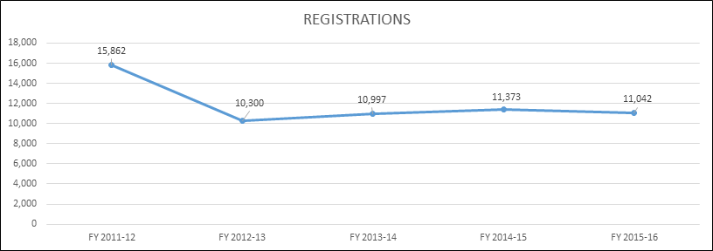

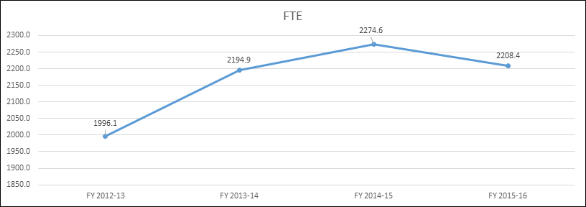
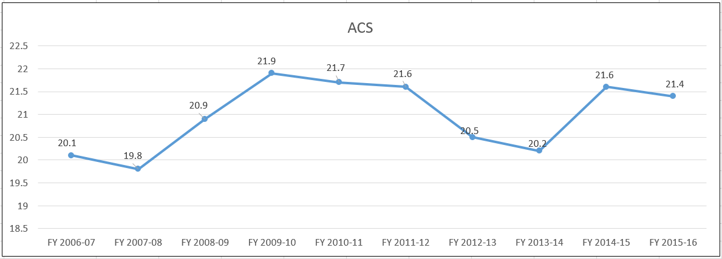

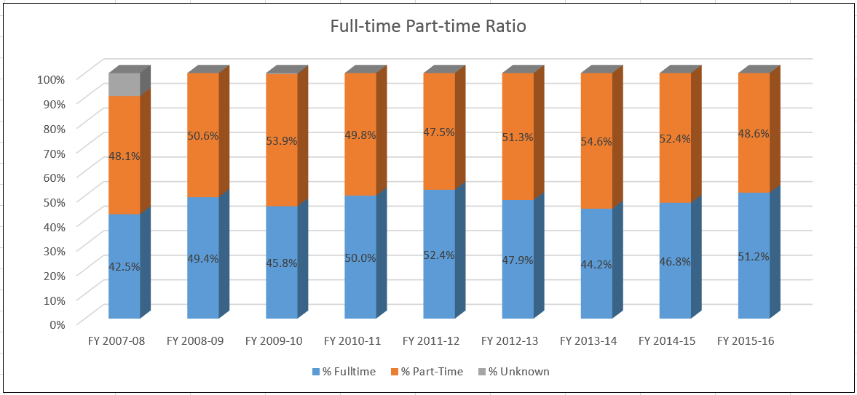

- Evidence of student demand for the program
How has/is student demand for the program changing? Why? Should the department take steps to increase the demand? Decrease the demand? Eliminate the program? What is the likely future demand for this program and why?
While the demand for our English and Creative Writing Programs does not appear to be changing, the demand for the skills we teach is increasing. According to a May 2016 Forbes Magazine article, employers ranked “proficiency in writing” as the number one lacking skill of recent college graduates, and critical thinking skills were also cited as a serious deficiency in recent grads. Employers in the Dayton area cite similar deficiencies in college grads, according to several recent news articles. We hear these sentiments echoed in our advisory committee meetings and from our colleagues around campus. Given this information, the demand for the kinds of writing and thinking required in our courses is increasing. It will be important for our department to find new and innovative ways to meet these demands.

- Evidence of program quality from external sources (e.g., advisory committees, accrediting agencies, etc.)
What evidence does the department have about evaluations or perceptions of department/program quality from sources outside the department? In addition to off-campus sources, include perceptions of quality by other departments/programs on campus where those departments are consumers of the instruction offered by the department.
In response to the recommendations from the last program review, the English Department formed an English Department Advisory Committee to solicit feedback and guidance from key members of the campus and community. That committee is comprised of eight members from different departments including Psychology, Accounting, Provost’s Office, BIS, and Nursing. One of the members is a faculty member from Wright State, our top transfer university, and the other is an individual from the private sector. We meet annually and use the feedback from these meetings to inform curriculum and instruction. Perceptions of program quality from our partners at WSU is strong.

As part of the advisory committee work, we surveyed all chairs on campus to determine how to best support student writing across campus. The survey revealed that documentation and the use of sources is a primary concern for faculty. To this end, faculty have offered a plagiarism workshop at fall faculty development day and will continue to offer it in future semesters.

- Evidence of the placement/transfer of graduates
What evidence does the department/program have regarding the extent to which its students transfer to other institutions? What evidence does the department have regarding the rate of employment of its graduates? What data is available regarding the performance of graduates who have transferred and/or become employed? What data is available from RAR graduate surveys?
We need to do a better job of collecting data about our graduates. We need to be more aggressive with the graduate survey, which resulted in very minimal responses last year. To that end, we have created a goal for the next program review regarding this issue.

The data we do have indicates that our graduates are actively employed using the skills they gained in our program, and they are transferring to four-year and graduate institutions (see Appendix IV).

- Evidence of the cost-effectiveness of the department/program
What is the department doing to manage costs? What additional efforts could be made to control costs? What factors drive the costs for the department, and how does that influence how resources are allocated? What has the Average Class Size been for the department since the last Program Review, and what are steps that the department could take to increase Average Class Size? Has the department experienced any challenges in following the Two-Year Course Planning Guide?
Our Average Class Size (ACS) is above the average for the LCS division and the college overall. For example, this spring (2017), the LCS ACS is 18.07, and the ENG ACS is 21.98, which exceeds English’s ACS “target” of 21.41. This ACS has been accomplished by careful enrollment management that balances student need against best instructional practices. The ACS of 21.98 also exceeds the 16.61 overall ACS of the college this spring (so far). In fact, the ACS for the department has risen since the last program review
The ACS for ENG 1101, the highest enrolled course in the college, is 23.42 this spring, while maintaining the course cap of 27. We have been asked to increase our course cap in composition classes to 28, and we did so in the fall of 2016. However, the higher cap is clearly detrimental to students and teaching (see Appendix III). Therefore, we have maintained our course cap at 27, which is still too high and out-of-line with national and state norms.
The ACS for LIT courses overall in the spring of 2017 is 23.45, despite the lower-enrolled classes that are running in order to serve our program majors and our community (LIT 2234 and LIT 2236).
Office of Budget and Analysis Chart from January 17, 2017
Cost per FTE from FY2013 to the present has consistently shown that the cost per FTE is lower for the English department in comparision to the division average and has decreased while the division cost per FTE has increased.

Cost per FTE | FY 2013  Actual | FY 2014  Actual | FY 2015  Actual | FY 2016  Actual | FY 2017  Projected | FY2013 – FY2017  Change
Department  Division | $ 3,065  $ 3,500 | $ 2,902  $ 3,410 | $ 2,942  $ 3,726 | $ 2,941  $ 3,972 | $ 2,731  $ 3,865 | -10.9%  +10.4%
The FT/PT faculty ratio has hovered around the 50/50 point for several academic years, but has fallen steadily since 2014. While we are still maintaining a FT/PT ratio lower than the division (ENG: 51/48; LCS: 53/47), we attribute the increase in the FT number to the increased number of Developmental Language Arts faculty teaching ENG courses. Ten of the twelve faculty in DLA are teaching for us this term, for instance, and this number will likely not drop as we merge in the fall of 2017. Therefore, the maintenance of our FT/PT faculty ratio is a concern for the cost-effectiveness of the department as the number of available courses for adjuncts shrinks.
Another way English has been a good fiscal steward of the college is by adopting more cost-effective textbooks. The English Composition at Sinclair OER was adopted summer 2016 as the primary textbook for ENG 1101 and face-to-face ENG 1201 courses. (ENG 1201 online still uses the Norton Field Guide, but will be moving to the OER in coming semesters). While the work on this text was laborious, we have saved our students over $300,000 in textbook costs over the course of the pilot year and this first semester of implementation. In addition, in fall 2015, ENG1131 adopted a customized text that cost $68 in comparison to $209 for the full text. I don't know if that is relevant to anything. To date this has saved students approximately $141,000.

Section V: Department/Program Status and Goals
- List the department’s/program’s strengths, weaknesses, opportunities, and threats (SWOT analysis).
SWOT Analysis
Strengths:
- Community Focus
  - The depth and breadth of our involvement in Sinclair programs, in campus events and communities, and in our community is a strength.
  - Our CCP program: We mentor, assess, and support high school teachers to ensure that college-level standards for work are being maintained.
  - Connections with Dayton Public Schools: We hosted three workshops in 2015-16 with Dayton Public Schools teachers to create alignment in expectations for college-level writing.
  - The publication of Flights, the annual Spectrum Awards, and our various community writing contests continue to engage the community.
- Excellent Instruction
  - We have high-quality, diverse faculty, with strong academic preparation and real-world experience.
  - Faculty have strong awareness of current theoretical and research developments in the field, including trends in teaching pedagogies, technology, and student engagement.
  - Faculty have strong participation in professional organizations and high publication rates.
  - Our department has two recent Roueche Teaching Excellence Award winners (Sally Lahmon and Rebecca Morean) as well as a SOCHE Teaching Excellence Winner (Lisa Mahle-Grisez), and a SOCHE Faculty Excellence Award and Sinclair’s Distinguished Faculty Scholar Award (both Tim Waggoner).
  - Our adjuncts are highly qualified; all have graduate degrees, many have “real world” experience outside academia
  - Our assessment of student learning outcomes is strong and has provided us with data for improving our programs and composition courses.
- Innovative and Transferable Curriculum
  - We are completely aligned with Ohio Board of Regents Transfer Assurance Guide (TAG) program. All of our courses that are eligible have been approved for the TAG in their discipline.
  - ENG and LIT courses provide a strong basis in writing and critical thinking strategies, which prepare students for both academic and career goals.
  - The creative writing course sequence draws students who otherwise might not take classes at Sinclair.
  - The ENG and LIT courses align with Gen Ed requirements and successfully transfer to area colleges.
  - We pioneered an OER to save students the cost of a textbook.
  - We offer a robust series of writing-centered activities: National Day On Writing, Jack Bennett Young Writers’ Workshop, Poem in Your Pocket Readings, Annual Writers’ Workshop, Spectrum Awards, Creative Writing Contests, Flights.
Weaknesses:
- It can be difficult to find faculty to take on new projects and initiatives because we are expected to do more with fewer human resources.
- Department has heavy reliance on adjunct instruction in the composition sequence; while support and training for adjuncts is improving, it is still an area that will need constant attention.
- Class sizes continue to grow; Sinclair’s composition courses have the highest caps in the state of Ohio, which negatively impacts success rates and the ability of sections to be placed into computer labs. (See Appendix III)
- Computer classroom availability for our composition courses is limited; the configuration of computer classrooms we do have is not conducive to collaborative learning nor to the OER.
Opportunities:
- Focus on upcoming DLA merger to improve overall quality of our curriculum alignment.
- Investigate how the increased demand for English classes from CCP students may allow us to grow enrollment in courses other than the composition sequence.
- Continue to work with academic advising to ensure that students have accurate, up-to-date information on our ENG/LIT courses.
- Collaborate with Tutorial Services to improve our ESL tutoring and support.
- We need to work to build more articulation agreements with area colleges.
- Many of our CCP partner high schools are outside of the greater Dayton area, (i.e., Cincinnati Christian HS, Badin HS, Eaton HS, etc.). This extended radius requires an extended amount of travel time for faculty during the day to the high schools for mentoring and observation. While our faculty do receive compensation of $75 or $150 per course, this amount is not commensurate to the amount of work required for mentoring.
Threats:
- The college’s continued focus on STEM, Allied Health, and workforce development may make the value of good, old-fashioned writing and thinking less apparent.
- The college’s emphasis on job training devalues the importance of the liberal arts.
- Disappearing tenure-track positions and annual concerns over ACF positions have created a climate of uncertainty, mistrust, and decreased morale in our department.
- Cuts to our curriculum based on transferability and program needs (e.g. Shakespeare classes and others) affect other departments and non-degree-seeking students.
- The uncertain college funding environment threatens opportunity for growth and innovation.
- The eventual loss of private office space may cause faculty to spend less time on campus, spend less time in private conferences with students, and have difficulty complying with records retention policies (limited storage) and FERPA.
- The loss of TURNITIN software makes detecting plagiarism harder.
- Our budget for printing and copying does not take into account our OER savings nor the large adjunct population in our department.
- Cuts to LIT courses have likely caused missed opportunities to keep some courses alive.
- List noteworthy innovations in instruction, curriculum and student learning over the last five years (including student awards, faculty awards, etc.).
Since the last department review, the college converted to semesters, which spurred many changes to our curriculum. The English department’s composition sequence was given a wholesale revision upon semester conversion. We accommodated programs who wanted enhanced source use and information literacy in English 1101 so as to reduce their requirement of our research writing course, English 1201. At the time, we added English 2220, Introduction to Literature, and deleted low-enrolled and infrequently offered courses.

Since then, we’ve added several courses online and are working towards an English degree fully online. In terms of the received curriculum of ENG 1101 and ENG 1201, we are now facing the challenge of even more adjuncts teaching, many of whom teach at multiple other colleges and universities, as well as CCP teachers in high schools. Intense orientation, full-time faculty mentorship that includes syllabi review, classroom observation, as well as adjunct teaching portfolios help ensure adherence to our outcomes and acceptable variation/personalization from our teaching syllabi that match OBOR standards for pages produced and assignment types. These materials are distributed to adjuncts and readily available to them on a community group in eLearn.

Since semester conversion, we’ve been in a period of classroom innovation, particularly with the composition sequence, as we’ve found our feet with pacing, rhythm, and engagement of students over the long (for most Sinclair students) 16-week terms. We’ve shared teaching strategies and sample assignments via teaching discussions in the hour prior to our department meetings as well as through adjunct in-services where full- time faculty attend. Our diversity has been a strength here as successful strategies and assignments, as well as sharing of approaches from adjuncts fresh from composition programs, has invigorated our curriculum and helped individual faculty members increase personal success rates.

The introduction of themed ENG 1101 courses for career communities this academic year, as well as an ENG 1101 section devoted to ESL students, has also created interest and relevance to students with various majors.

Student Awards for 2015-16
Paul Laurence Dunbar Poetry Contest
Elementary School Zariah Young
Middle School Haneefah Jones
High School Maria Scaccia
Adult Donna Riddlebarger
The League for Innovation Writing Contest
Fiction Autumn Lala (also 2nd place National Winner)
Non-Fiction Sheila Filler
Poetry Ann Snively
The Sinclair Community College Creative Writing Contest
Poetry, Adult Michael Daughtery
Stephanie Coates
Christine Pudvan
Creative Non-Fiction, Adult Kyrie’ Owen
Fiction, High School Sarah Benson, Grace Jackson, Andrew Rohnkol
Poetry, High School Owen Horner
Antioch Writer’s Workshop Scholarship Winner
Michael Daughtery
The Gary Mitchner Prize for Formal Poetry
Gwen Ashby Sparrow Elizabeth
Autumn Lala Nathaniel A. Seymour
Sinclair Spectrum Awards for Excellence in Student Writing
Expository Essay Anonymous
Research Essay Madison Schroeder
Literature Essay Micaela Gerace
Creative Writing Autumn Lala
Legacy Award for an English Major Autumn Lala

Faculty Awards: See Appendix V

- What are the department’s/program’s goals and rationale for expanding and improving student learning, including new courses, programs, delivery formats and locations? Are there unmet goals from the most recent Program Review? Please note that the department goals listed in this section will be reviewed for progress on Annual Updates and in your next Program Review.
- Develop fully online CRWE.S.AA and ENGE.S.AA programs. Offering our two programs online will enable more students to complete their degrees in a timely manner.
- Continue to revise and develop the Composition I and II OER, making affordable textbooks for our students a priority.
- Address inconsistencies in College Credit Plus instruction in restricted high school locations, including consistency in the assessment and evaluation of student writing.
- Ensure a positive merger between ENG and DLA by creating community and distributing workload equitably.
- Track and monitor the progress of ENGE, CRWE, and PRW grads over the next five years to develop a fuller picture of how we can better meet the needs of our graduates.
- Pursue professional development for our faculty specifically regarding teaching students in the age ranges of CCP students. In addition, provide help for faculty in addressing students with mental challenges in the classroom.

- What resources and other assistance are needed to accomplish the department’s/program’s goals?
- Distance Learning resources are needed to develop our online programs. We are in the queue for several of our courses to be developed at this time.
- Revising the OER is time and labor-intensive. Resources required include help with graphic design and proofreading.
- Inconsistencies with CCP grading and instruction require resources and support from the college and CCP office in order to address these problems.
- A positive merger requires the leadership of faculty and the division.
- We need help with RAR and we need to develop a plan to track our majors.
- Professional development regarding students in younger age ranges and students with mental challenges can happen through our monthly departmental teaching discussions and/or the CTL.

Section VI: Appendices: Supporting Documentation

Appendix I
Environmental Analysis
Who are your key internal stakeholders?
English 1101 and English 1201 are essential general education courses, and the English Department plays a crucial role in supporting other courses through the skills developed in English Composition. Hence, all departments on campus are internal stakeholders for the English Department. Since all students must take English composition courses, most student support services act as internal stakeholders as well. These services include:
- Students
- All Sinclair programs requiring our courses
- Tutoring
- The Writing Center
- Academic Advising
- Office of Disability Services
- Distance Learning
- Library
- Counseling Services
- Career Services
- Registration
- Our Dean, Provost, President and other administrative offices
- Bookstore
Section 2
How do you know if you are meeting their needs?
- Students: Our faculty offer a wide range of instructional skills to meet students’ needs in the classroom in an effort to prepare them for writing across the curriculum and their current/future work. We administer end of course surveys, and informal surveys in class are completed regularly, as well. Faculty use a general education rubric in online sections of English 1101 to assess written communication outcomes. Each year we spend time completing student learning outcome assessments, and have collected data from these assessments to better inform our work. Faculty regularly conference with students, and spend a significant amount of time having informal discussion with students during their time with us and after they have graduated. Course successes are tracked by each faculty member every semester.
- The department receives informal feedback from all departments and conducts annual advisory committee meetings to receive feedback from campus stakeholders.
Sections 3-4
Who are your key external stakeholders? How do you know if you are meeting their needs?
- The English Department has established an important relationship with Dayton area school teachers. Anchoring Student Writing Program with Dayton Public Schools was a collaborative effort with Dayton high school teachers which worked to establish guidelines on definitions of college-level writing and appropriate assessment. Last year the department provided three opportunities for teachers to come to Sinclair to meet for a meal and discuss writing standards and challenges for writing instructors on and off campus. During those meetings, English Department professors and high school teachers participated in grade norming sessions. These sessions resulted in a better understanding of how criteria for evaluating writing differs between the high school and college instructors. Further, it provided an opportunity for both groups to brainstorm ways to address the challenges of teaching writing when state standards that teachers are required to meet do not necessarily line up with best practices for teaching writing as determined by professional teaching and writing organizations.
- CCP is both an internal and external stakeholder as many CCP students take ENG courses on campus, in addition to the restricted sections offered at high schools. The chair of the department maintains a close relationship with the CCP coordinator at Sinclair to facilitate a seamless interface between the respective departments, faculty members, and students. She is on the CCP Advisory Committee at the request of the CCP office and the CCP Policy and Practice Committee.
- Full-time faculty members work closely with these teachers, as well, delivering widespread curriculum support. Along with this support, we travel to CCP high schools to observe high school faculty in their classrooms and offer feedback to ensure high quality delivery of our curriculum.
- University Partners/Transfer Institutions: Our work with university partners is developing – we have a faculty member from WSU on our advisory committee. At the 2017 Writers’ Workshop, we plan to have faculty from our high transfer partners present to interface with our ENGE and CRWE majors. Students will have the opportunity to learn about course offerings and four-year degree options. Students will have the chance to meet faculty members and ask specific questions about course requirements and degree completion expectations. These meetings will help to create easily navigable pathways for students exploring their options at local universities.
- General Community Outreach: Faculty members conduct a variety of workshops and other literacy events in the community at elementary and high schools, book stores, conferences, and area colleges and universities. Flights Literary Journal publishes poetry, fiction, and nonfiction from a wide variety of writers: Sinclair students, faculty and staff; local authors; and writers from all over the country. The magazine is distributed locally and published online.
- Faculty members serve their community by presenting workshops at local schools. For example, Lisa Mahle-Grisez presents a Citation and Documentation learning session each year at a Beavercreek Elementary School. Rebecca Morean has volunteered to serve on various panels in local schools that focus on young black students. Kate Geiselman offered a workshop on crafting the personal essay at Thurgood Marshall High School. Students from DPS have attended the National Day on Writing events, planned and hosted by Dair Arnold.
- Faculty frequently present writing workshops at book stores, colleges, and area conferences. Rebecca Morean offers readings of her published work at local bookstores. Kate Geiselman has presented workshops at Books and Co. on preparing manuscripts for publication and has been a Saturday Seminar presenter at Antioch Writers’ Workshop on crafting personal essays. Tim Waggoner has volunteered in a variety of capacities at the following local events: Saturday Seminar Fiction Presenter, Antioch Writers Workshop; AcadeCon Workshop leader; and Fiction Instructor, Antioch Writers Workshop.
- Faculty members also engage in general community outreach: For example, Tim Waggoner answers questions about writing and publishing on his Facebook page and writes a blog about writing and publishing called “Writing in the Dark.” He also serves as a mentor for the Horror Writers Association, and works with one writer for the course of an entire year, providing guidance and feedback on writing. Caroline Reynolds sponsors The Poem in Your Pocket Poetry reading, which has been held each year in the library loggia and is an open reading attended by Sinclair students, faculty, staff, and the Dayton area community.

Section 5
What challenges or support concerns do you have?
- Staffing: ACF positions are being threatened and tenure lines are not being renewed despite the increased enrollment and demands of CCP. A shrinking full-time faculty makes it difficult to accomplish the important work of the department outside the classroom: curriculum development, collection of assessment data, community outreach, writing workshops, professional development, college wide committee work and more.
- Classroom space: department-wide use of an online OER textbook makes scheduling classes in well-equipped and properly configured computer labs a top priority. Software in labs should be up-to-date with timely tech support available. We also need our labs to be configured to be consistent with our methods of instruction.
- Class-size needs to be small enough to align with best practices in our discipline, and to fit in computer labs.
Who feeds your program?
- Our program(s) are fed by Developmental Language Arts and the College
Which courses/departments outside of your own are you reliant on for educating students in your programs?
- We rely heavily on Developmental Language Arts to prepare students for our composition sequence.
- English as a Second Language is increasingly necessary with the influx of international students.
- The library, its staff and resources offer vital support for our courses.
- The Writing Center is a critical support service for our students.
- Advising, testing, IT, DL, Disability Services, Tutoring, and other student support services.

Section 6
What opportunities exist to help your stakeholders that you are not currently exploring?
- We could better serve our students if our offices were more centrally located. A shared conference space for faculty to meet and collaborate would also be helpful.
- We need to conduct tenure-track searches to ensure that the work of the department is getting done. Curriculum work, assessment, college-wide service, special projects and the other important work we do outside the classroom is spread among too few people, who are also burdened with full course loads and oversized classes.
How do you know?
- We know this thanks to our advisory board, student EOC surveys, faculty discussion and input gathering, soliciting feedback from our majors.

7. What data are you currently using to inform your decision-making? Where is your data weakest?
- Data informs the improvements we are making in the curriculum, targeting faculty who need to improve their success rates.
- Assessment of ENG1101 and ENG1201 using student artifacts has been ongoing each term beginning with spring 2012. Samples are randomly selected from a pool of papers that is collected every term and all full-time faculty assess the papers based on a course outcome rubric that follows the Likert scale from the State of Ohio of 1.0 meaning lacking skill to 4.0 meaning mastery. Results have consistently shown that students excel in structuring their writing and using electronic environments with scores that exceed 3.0 that indicate proficiency. Weaknesses have been sentence structure and incorporating source material with scores around 2.0 that mean improvement is needed. The department has engaged in a series of workshops and developed materials to close the loop beginning with spring 2016. Future assessments will be monitored closely to see if these efforts have any impact.
- We need more information about how to find education majors who want to teach language arts in order to include them in our Pathways 2.0 grant activities.
8. If you had this info, what actions would you take as a result of collecting this data?
- We would be able to use this data in designing initiatives that our majors are interested in participating in instead of our guessing what they would like.

Appendix II

Teaching Portfolios

Requirement for Adjunct Faculty beginning spring 2016
  - One course portfolio for each course taught (1101, 1201, 1131)
  - Due Date: On or before Friday, April 29, 2016
  - Submit to: Dair Arnold, Adjunct Faculty Coordinator

The Teaching Portfolio is an asset because it…
- describes and documents your teaching ability
- illustrates the design of your course
- connects your teaching to student learning
- provides evidence of your teaching activities and outcomes
- requires honest reflection of your own teaching and learning

Components of the ENG Department Teaching Portfolio
- A syllabus, assignments and assignment guidelines, including a course calendar
- Examples of graded essays with your written feedback
  - Should include at least 4 graded essays (A, B, C, and D or F)
- Honest one-page reflection on your teaching:
  - Strengths and areas for improvement
  - Pedagogical issues and innovations
  - Lessons learned
  - References to teaching development activities through the CTL
  - Assessment of your overall effectiveness

WHY?
- Ensures quality teaching is recognized, valued, and rewarded
  - Adjunct Teaching Awards given at Adjunct In-Service in August
- Provides a space for reflection on pedagogical issues:
  - how you promote student engagement,
  - how you accommodate diverse learning styles,
  - how you offer flexibility,
  - how you empower students
- Documents your best practices for teaching writing at Sinclair
- Provides a meaningful, creative, and reflective activity
- Ensures teaching quality, consistency, and re-direction when necessary

Appendix III

Course Caps in Ohio
**Information from 2017 survey of Post-Secondary Institutions by TYCA—only participating colleges are included
Institution Name | State | type of institution (2 year or 4-year) | First semester/101 or equivalent course cap
Capital University | Ohio | 4-year | 20
Case Western University | Ohio | 4-year | 17
Lakeland Community College | Ohio | 2 year | 25
Miami University | Ohio | 4-year | 22
Ohio State University | Ohio | 4-year | 24
Ohio University | Ohio | 4-year | 20
Shawnee State University | Ohio | 4-year | 20
Sinclair Community College | Ohio | 2 year | 27
University of Akron | Ohio | 4-year | 24
University of Cincinnati Blue Ash College | Ohio | 2 year | 20
University of Cincinnati Main Campus | Ohio | 4-year | 23

**From Conference on College Composition and Communication (CCCC), October 1989, Revised November 2013, Revised March 2015

“Position Statement on the Principles for the Postsecondary Teaching of Writing”
http://www.ncte.org/cccc/resources/positions/postsecondarywriting

“11. Sound writing instruction is provided by instructors with reasonable and equitable working conditions.
Writing instructors perform most effectively—and students writers learn best—when instructors are treated as professionals and provided with resources that allow them to focus on their students’ development as writers. Instructors should be recognized as professionals regardless of their position—tenured, tenure-track, emeritus, non-tenure-track, full-time, or part-time—and granted the respect due to any contributing member of a department or program. This recognition should include the opportunity to participate in the governance of the department, program, and college or university and the opportunity to contribute to the development of writing curriculum and instruction. Instructors also require adequate resources—including (but not limited to) time, reasonable class sizes, and physical surroundings—to provide sound writing instruction as outlined in this document. Instructors should also earn a living wage and receive health coverage and other benefits in line with the recommendations of professional organizations.
Institutions can provide reasonable and equitable working conditions by establishing teaching loads and class sizes that are consistent with disciplinary norms. No more than 20 students should be permitted in any writing class. Ideally, classes should be limited to 15. Remedial or developmental sections should be limited to a maximum of 15 students. No English faculty members should teach more than 60 writing students a term. Institutions can also provide these conditions by paying instructors a reasonable wage and providing access to benefits. Institutions should provide resources necessary to effective instruction, including office space to meet with students individually, computers and network access, and office technologies (such as photocopiers). Institutions should also facilitate instructor access to personnel and units that can inform their practices and offer helpful efficiencies such as librarians, writing centers and directors, and teaching and learning centers. Institutions should also foster department and program cultures that recognize instructors, whether in appointments that emphasize research and scholarship or in those that focus fully or primarily on teaching or administration, as scholars and full members of the discipline. Institutions should ensure that all members of a department or program have the opportunity to participate in shared governance.
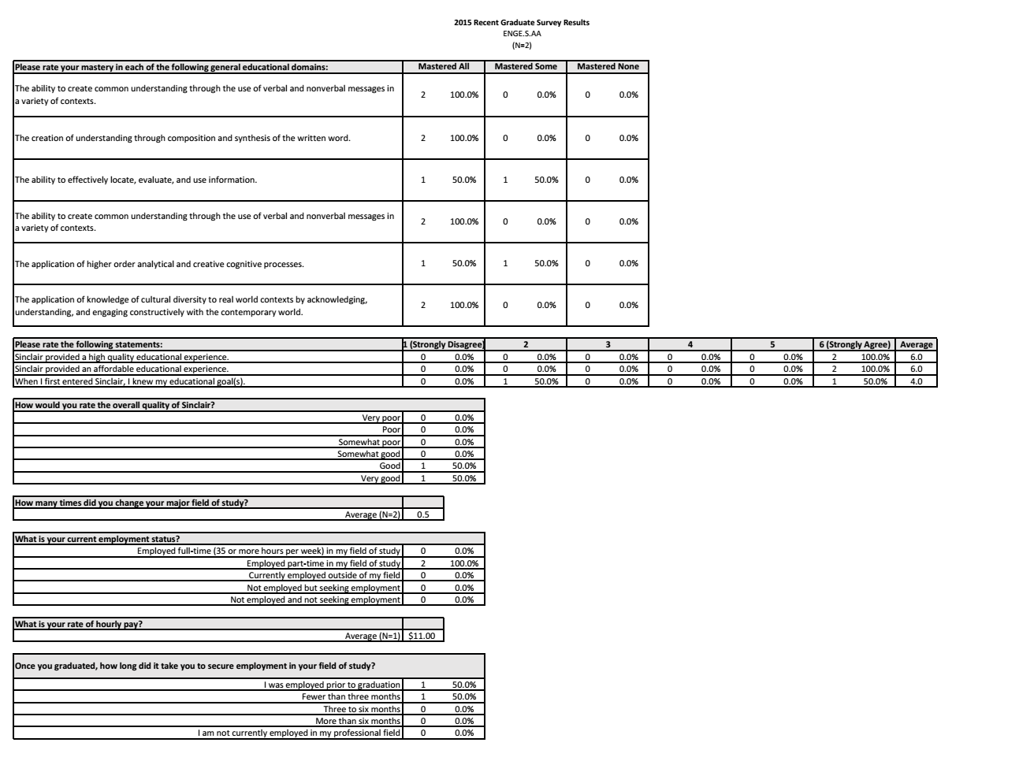
Appendix IV
Recent Graduate Survey for ENGE and CRWE
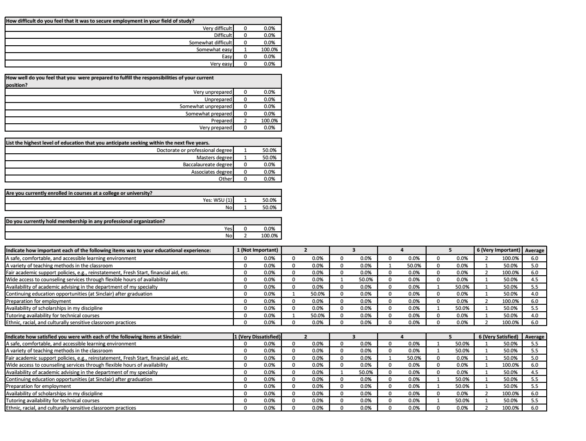
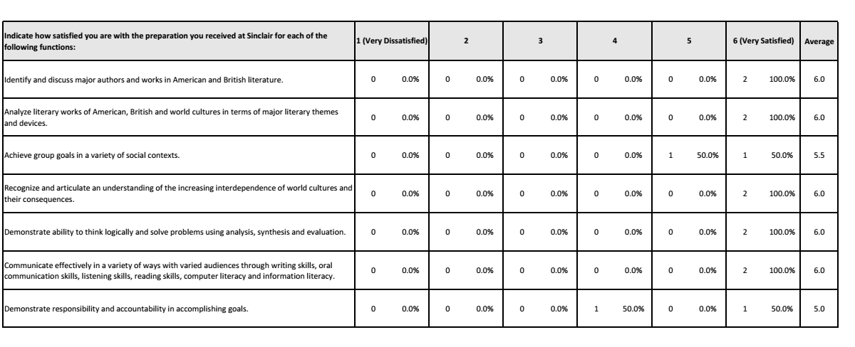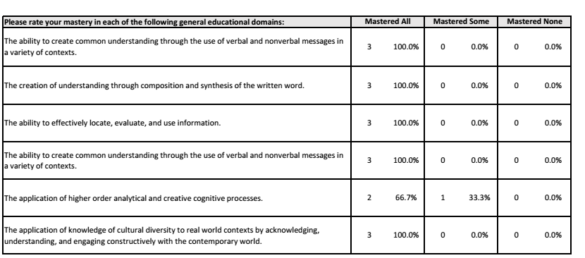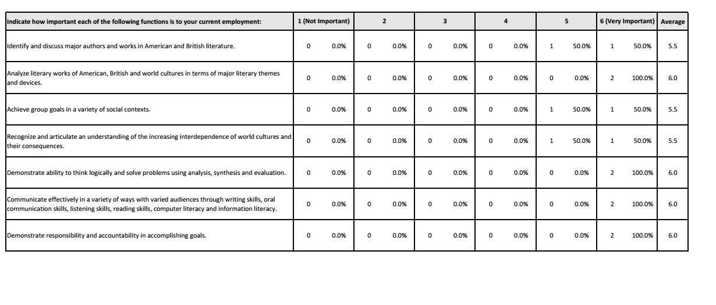
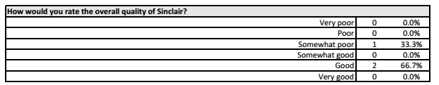
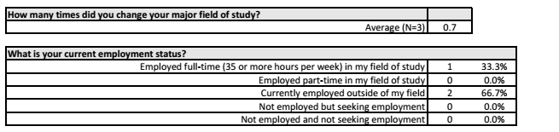

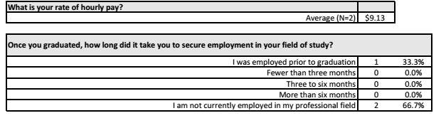

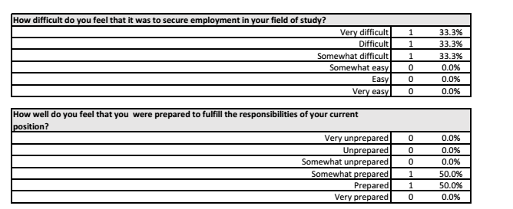
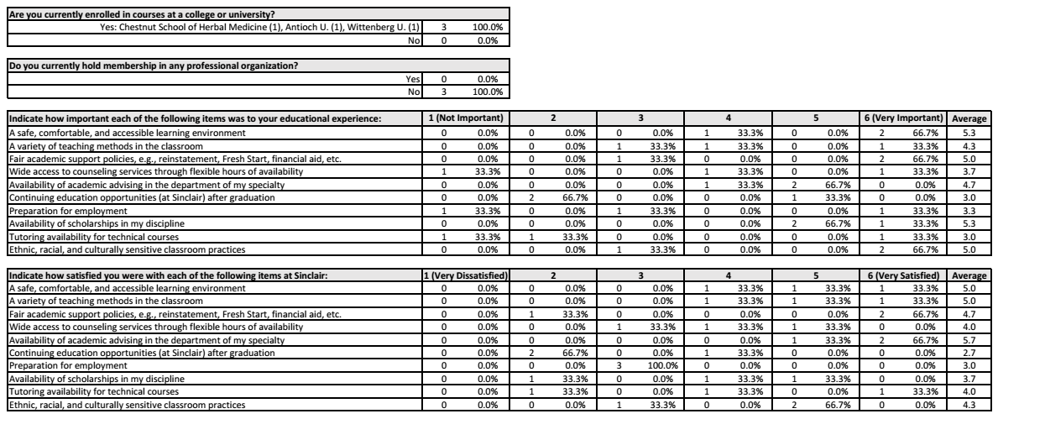

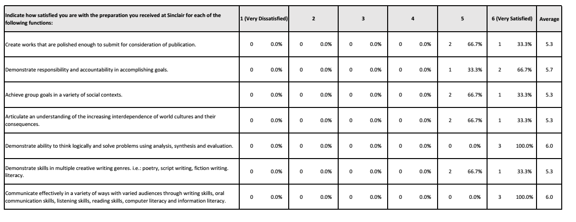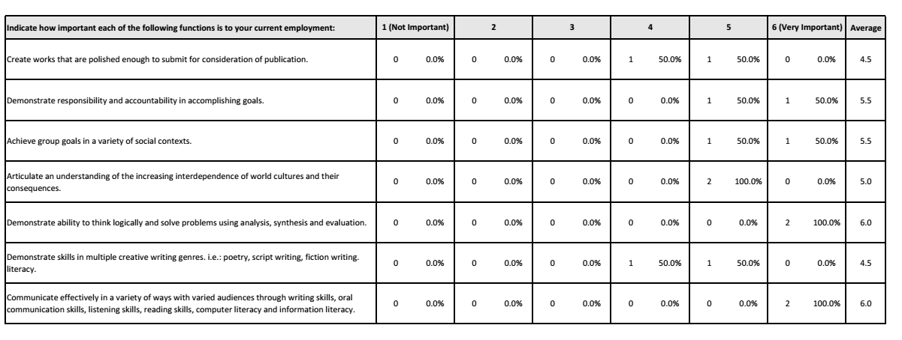

Appendix V
Faculty Bios and Awards

Dair Arnold has coordinated Sinclair's National Day on Writing celebration since she joined the English Department three years ago. Since 2014, she has also facilitated several workshops for Fall Faculty Professional Development Day and the Jack Bennett Young Writers’ Festival. In 2016, she conducted the Teaching Discussion on Paolo Freire's Pedagogy of the Oppressed. Actively involved as a reader for the Dayton Literary Peace Prize, Dair also serves as the Adjunct Coordinator for the English Department.

Susan Callender serves on the college-wide Curriculum Committee and Wellness Committee and has taught all levels of composition. She volunteers at the Jack Bennett Young Writers’ Festival each year.

Adrienne Cassel serves as Chair of the English Department Advisory Committee, Chair of the college-wide Faculty Scholars Committee. She is treasurer and board member of the Ohio Association of Two Year Colleges. She presented (with Geography Professor Dr. Jacqueline Housel) at the 2016 Annual League of Innovation STEMtech Conference on STEM Meets the Liberal Arts: Creating Community Through Service Learning and the 2015 AASHE (Association for the Advancement of Sustainability in Higher Education) Conference on Researching Water Issues in First Year Composition: A Multi-Perspectives Approach.

Lisa Cook teaches ENG 1101, 1201, and 1131 and is the online coordinator for ENG 1131. She is the liaison for ENG College Credit Plus teachers and attends the OCTELA Conference every year to maintain her secondary teaching license.

Jamey Dunham serves on the college-wide RESPECT team and teaches poetry and composition for the ENG department. He works as a member of the adjunct team, as well.

Chuck Freeland has been a member of the college-wide Assessment Committee for many years and currently serves as its chair. He is active on the departmental Adjunct Team, helping to organize the English Department’s annual In-Services and frequently presenting at them as well. In 2014 his thirteenth book of poetry, Albumen, was published by press rappel.

Kate Geiselman served as LCS division liaison for the eLearn conversion, has been on the college wide Online Teaching and Learning Advisory Committee since its inception, and served on the Academic Policies Committee. She is editor of Flights (Sinclair’s literary publication), and President of the Antioch Writers’ Workshop board of trustees. She has presented sessions on essay writing at AWW and the Sinclair Writers' workshop. Her essays have appeared at the Washington Post, Salon.com, and elsewhere.

Furaha Henry-Jones has served as co-chair of CTL Diversity and Inclusion steering committee which included collaborating to design, implement and facilitate the CTL Diversity and Inclusion track. She has also participated in the RESPECT pilot designed to address the need for increased African American student completion and success. She has also served as the Writers’ Workshop director since 2011. She has been selected “Daytonian of the Week” and has performed in Sinclair theatre productions, including the upcoming Coretta.

In the past five years, Professor Sarah Kiewitz has continued her work with curriculum, helping with semester conversion, developing online teaching materials for English 1101 (which got her a Who’s Who in Education award from Ohio Magazine in 2014), and developing a new online course Introduction to Literature. She also chaired Fall Faculty Professional Development Day in 2014, helped organize for Sinclair’s advancement for past three years on Bike to Work Day (as well as contributed to other health/wellness presentations), and gave a reading at Bard College’s Institute for Writing and Thinking, July 2016.

Sally Lahmon's career highlights include representing the college as a Roueche Teaching Excellence Award winner, Fall Faculty Professional Development Day committee member, CTL workshop presenter, and state-level TAG for Literature committee member.

Dean Leonard has taught on the college level for thirty years. In addition to his seven years at Sinclair, he has taught classes, as a full-time and part-time instructor, at Wilberforce University—the nation’s first historically Black college—Wright State University, Clark State Community College, and the Ohio Institute of Photography and Technology. He has taught a variety of liberal arts subjects and has published essays on film studies topics. At Sinclair, in the past five years, he has contributed to curriculum development by taking part in the ReVisioning program and has successfully created a Composition II course in the hybrid model that incorporates visual literacy as a springboard for written work.

Lisa Mahle-Grisez currently serves as chair of the English Department and Assistant Dean of the Liberal Arts, Communication, and Social Sciences Division. She researches in the field of composition and regularly attends national conferences presenting her research on the teaching of writing. She serves on several college-wide committees and works as part of a state of Ohio panel on placement and transfer. She was awarded the SOCHE Teaching Excellence Award in 2012.

Rebecca Morean was awarded the John & Suanne Roueche Excellence Award for 2017. She also was awarded a sabbatical for the fall of 2015 and traveled to England giving presentations, conducting interviews for short films, and visiting Tresham College, SCC's sister institution where she studied similarities between their 6th form and our own dual enrollment. Finally, she published three novels in the last two years as well as over a dozen short stories and twice as many essays in publications like Salon and The Jabberwock Review.

Aaron Moyer has consistently maintained the assessment of ENG1101 and ENG1201 each term, provided assessment information related to the English programs annually, and facilitated the college-wide assessment of the general education written communication outcome.

Over the past five years, Caroline Reynolds has been involved in several initiatives with the Center for Teaching and Learning, most notably a course ReVisioning project for English 1101, and the creation of the English Department Open Educational Resource. She has served on college-wide committees, including college-wide Merit, Promotion and Tenure, as well as Academic Petitions and Faculty Grievance. She created the annual Poem In Your Pocket poetry reading, which is now in its tenth year, and she also coordinates the annual Dayton Literary Peace Prize essay contest.

Vicki Stalbird took part in a week-long—40 hour--CTL workshop on mindfulness in the summer of 2014 and she has implemented mindfulness practices into her classroom. She has promoted diversity in her classroom and has been a first reader and has continued involvement with the Dayton Literary Peace Prize.

Lisa Tyler was elected in 2015 to the board of the Jane Austen Society of North America and was appointed to a five-year term on the Editorial Advisory Board of the Hemingway Review, the journal of the International Hemingway Society. Since fall 2012 she has presented at nine academic conferences, organized three conference sessions, and published articles in two edited collections and the Journal of Modern Periodical Studies. This is her fourth year as secretary of Faculty Senate, and she was awarded a year-long sabbatical during the 2015-16 academic year to write a book on Pulitzer Prize-winning American playwright Marsha Norman for the University of South Carolina Press.

Between 2012-2017, Tim Waggoner received the Mentor of the Year Award from the Horror Writers Association, was the Author Guest of Honor at Animekon VII in Bridgetown, Barbados, and published twelve novels, two collections, five novellas, and forty-seven short stories.

Over the past five years Adam Williams has published over twenty poems in national literary journals, including Meridian, Silk Road Review, Painted Bride Quarterly, White Stag, and Pine Hills Review. He co-judged the 2016 Dayton Metro Library Poetry Contest & was an invited performer at the 2016 WYSO Serious? fundraising event to benefit the local public radio station. He led a workshop at the 2013 Sinclair Writer’s Workshop, as well as at the Jack Bennett Young Writers’ Workshop from 2013-2015. From 2015-2016 he served on the Sinclair RESPECT committee.

Strauss, Karsten. These Are the Skills Bosses Say New College Grads Do Not Have. Forbes. 17 May 2016. Web. 10 Jan. 2017.

