Department/Program Review
Self-Study Report Template

2017 - 2018
Department: 0230-Music
Section I: Innovations and Accomplishments
Please list noteworthy innovations in instruction, curriculum and student learning over the last five years (including student awards, faculty awards, etc.).

Most noteworthy of accomplishments is the continued full accreditation by and membership in the National Association of Schools of Music (NASM). Sinclair’s music program is one of only 24 community college music programs in the country to have achieved accreditation through NASM. This was awarded after an on-site visit in 2014. Our experienced full-time faculty have continued to contribute to the field professionally, including composing (Professor Parcell) and performing (Professors Kohlenberg, Long and Greene.) Dr. Parcell is recognized as an outstanding composer and arranger and has collaborated with many professional musicians including the United States Air Force Band of Flight. Dr. Kohlenberg has continued to lead Sinclair’s Community Bands in several Concerts each semester, earning high praise by invited, internationally known guest artists. In 2017 the Wind Symphony was featured as an outstanding ensemble from a “small music program” at the national convention of the College Band Directors National Conference (CBDNA). Mr. Long has continued to direct the Sinclair Choirs in performances of significant choral literature and each year features a performance with a full chamber orchestra providing a unique educational experience for the program’s vocal students. Mr. Greene’s continued work with the Creative Arts Career Community has greatly benefitted all students in our program. Throughout the last five years, many students of Mr. Long and Mr. Greene have successfully auditioned for and participated in honor choirs and have placed in singing competitions, including the Junior Women Voice Competition, the Classical Singer Vocal Competition, and the National Association of Teachers of Singing (NATS) vocal competition. The music program is an integral part of Sinclair’s Ohio Transfer Module (OTM) Humanities offerings. Department faculty designed and began offering MUS 1123 – World Music as an on-line course a few years ago. It continues to be offered and run every semester.

Section II: Annually Reviewed Information
A: Department Trend Data, Interpretation, and Analysis

Degree and Certificate Completion Trend Data – OVERALL SUMMARY

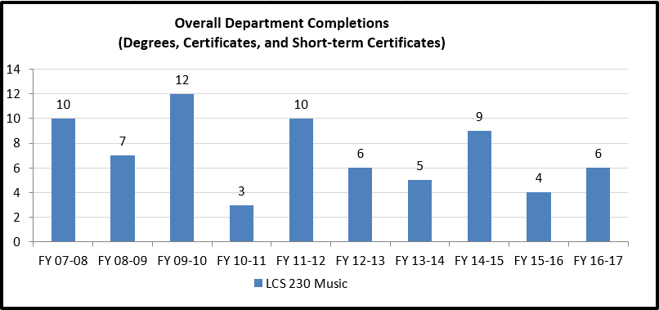

Please provide an interpretation and analysis of the Degree and Certificate Completion Trend Data: i.e. What trends do you see in the above data? Are there internal or external factors that account for these trends? What are the implications for the department? What actions have the department taken that have influenced these trends? What strategies will the department implement as a result of this data?

Please be sure to address strategies you are currently implementing to increase completions of degrees and certificates. What plans are you developing for improving student success in this regard?

Sinclair’s music program has a history of averaging 6 graduating students each academic year. Faculty Mentoring is a strategy that has been found to be successful in its use over the past many years in retention and completion. Every music major who is active in the program is assigned a mentor from the full-time faculty. Each faculty meets individually with each assigned student at least once per term to counsel, encourage and advise the student. Additionally, music students are all required to see the academic advisors prior to registration. This system has helped students stay on track to complete the music program’s requirements. There are several students each year who complete the many music program requirements for graduation but transfer to another institution to finish a Bachelor’s degree prior to completing all OTM requirements at Sinclair. Sinclair’s Academic Advisors and the music program have been working with such students to enable a “retroactive” graduation when possible. Recently, the music faculty have been scheduling regular student assemblies during which the importance of OTM completion has been emphasized. The faculty anticipate that these meetings will have a positive influence.
Course Success Trend Data – OVERALL SUMMARY

Please provide an interpretation and analysis of the Course Success Trend Data. Please discuss trends for high enrollment courses, courses used extensively by other departments, and courses where there have been substantial changes in success. Please be sure to address strategies you are currently implementing to increase course success rates. What plans are you developing for improving student success in this regard?
Sinclair students in the music program exhibit very good success rates. The four full-time faculty, along with almost 30 adjunct faculty, are highly dedicated to helping the music students learn and succeed. By design, through applied lessons and faculty mentoring, music students receive a wealth of individual attention.
All music majors are evaluated, “pre-assessed”, prior to starting the music major curriculum. In August, entering majors take a music theory and aural skills exam. Additionally students are required to perform an audition on their instrument or voice. The faculty decide on the proper placement of each student either in a developmental-level course or the majors-level sequence. This strategy has helped ensure retention and completion since it was instituted decades ago.
Please provide any additional data and analysis that illustrates what is going on in the department (examples might include accreditation data, program data, benchmark data from national exams, course sequence completion, retention, demographic data, data on placement of graduates, graduate survey data, etc.)
The music program has several required course sequences. There are four semesters of Music Theory, four semesters of Aural Skills, four semesters of Piano/Voice, and two semesters of Music Styles (History). Each course of each sequence is offered only once per academic year. Being very cognizant of the importance of completion, the music faculty undertake whatever steps are necessary to help guide each student through each level of the sequence.
Nothing was changed from the original 2013 Program Review Template provided by Jared Cutler for pages 4 thru 9, as all previous Program Review recommendations and goals had been addressed by the time of the most recent 2017 Annual Update.

B: Progress Since the Most Recent Review
Below are the goals from Section IV part E of your last Program Review Self-Study. Describe progress or changes made toward meeting each goal over the last year.
GOALS | Status | Progress or Rationale for No Longer Applicable
Long-term goals for the department in terms of student learning will be to expand online offerings. (0230 MUSIC) | In progress  Completed  No longer applicable | The department will be offering for the first time this spring semester an online World Music course, a course specifically developed to be offered online only. Next year, we expect to add a Jazz Appreciation online course.  Jazz Appreciation has not been developed and will not be offered.
Add an Introduction to Music Education course to the music major curriculum. (0230 MUSIC) | In progress  Completed  No longer applicable | This course will be offered for the first time in spring 2014.
Initiate an orchestral ensemble. (0230 MUSIC) | In progress  Completed  No longer applicable | Although this has been a long term goal for many years, the department finally has given up attempting to do this. Space issues and personnel challenges, as well as too many competing community orchestras, while not insurmountable obstacles, are nevertheless challenges that we cannot meet at the moment. It is not impossible that this issue may be revisited at some point in the future.
Offer applied lessons at the satellite sites. (0230 MUSIC) | In progress  Completed  No longer applicable X | We offer applied music lessons at Courseview, and are willing to do so at Huber and Englewood, providing a room with a piano is present. There has not been any demand for applied lessons at any of the satellite sites.

Below are the Recommendations for Action made by the review team. Describe the progress or changes made toward meeting each recommendation over the last year.
RECOMMENDATIONS | Status | Progress or Rationale for No Longer Applicable
The department should find new ways to promote their performances – since additional advertising dollars specifically for the department are not likely to be forthcoming in the foreseeable future, the review team recommends that the department explore other means of increasing the visibility of upcoming performances. There may be opportunities to collaborate with instructors of Marketing courses to use students to develop new approaches for marketing the department’s performances. An expanded social media presence could be considered, or there may be other new ways of marketing programs. It is recommended that any efforts in this regard be primarily done by students rather than faculty, to provide students a learning opportunity regarding the promotion of musical events. Someone in the department should be given the responsibility for pursuing these efforts - if no one is responsible for it, it is less likely to get done. (0230 MUSIC) | In progress  Completed  No longer applicable | The department recently met with the Marketing staff to address the general goal of making the music department's presence more widely known. We have secured quotations and photos of successful music alumni to feature in brochures, which should be printed this semester. As part of our re-accreditation effort, we are in the process of expanding our departmental website, which already includes information about our program season. Separately linked information on the site--concerning auditions, scholarships, transfer, our performance ensembles, and every other aspect of our music department--will be valuable and informative information for students as well as community members--or whoever searches for us online.  As with other comments by our reviewers about our program, however, a certain amount of naiveté exists. The "someone" in the department who can do these marketing/PR things is the department chair--as it would be in any community college music department--and the chair is already overburdened. Our feeling in the department is that Marketing itself should be proactive with each department, particularly those like Music which for many people in the community, serves as a window--a first acquaintance--with the school in general. While engaging students who are current Marketing students to do the work sounds like a good idea, if the idea of promoting concerts to the community in a professional way is the goal, then our own Marketing professionals--we feel--would do the job in the most impressive manner. Our connection with those folks, we are hoping, will now pay impressive dividends.  As of S 2016 the department’s webpage has been redesigned along with the College web presence. The department created a high-quality brochure but the college is not using these marketing materials at this time.
The department may want to consider hosting a Fine Arts Night or Fine Arts Showcase or some other activity similar to the Wright State University Arts Gala as a means of increasing the visibility of the program. (0230 MUSIC) | In progress  Completed  No longer applicable | The galas put on by Wright State and U.D. require budgets that Sinclair's music department does not have. Marketing for Wright State's gala requires months of preparation and publicity--by non-music department personnel--and tickets for the event itself sell for $150. Even if these challenges were not obstacles, Sinclair's music department does not have the breadth of offerings necessary to pull off an entire evening of entertainment, done by students, to create an impressive, open-to-the community arts funding event at the Schuster or some similar venue.
While charging admission for the department’s performances would likely decrease attendance, the department may want to consider allowing donations at performances as a revenue source to help fund student activities in the program. (0230 MUSIC) | In progress  Completed  No longer applicable | Donations at collegiate concert events are simply not done--or at least they are something no one in the music department has ever seen. Forgetting the tax-deductibility of donations that patrons would want to document--and forgetting the fact that, technically, donations to the department should occur through Advancement--the small amounts of money that would be donated--say, in a donation box or something similar--would be miniscule in relation to the kind of funds that the department needs. WSU and UD do not charge admission for their concerts or faculty recitals, as these are considered reaching-out, good-PR events.
Since a substantial number of the full-time faculty are facing retirement in the coming years, succession planning and resource planning should be a priority. The department emphasized the decades of experience senior faculty members have, which is a plus, but which also means that inevitably there are retirements on the horizon. Steps should be taken to ensure that much of their knowledge is documented and communicated to subsequent faculty hires so it is not lost to the institution as they retire. In addition, there are new federal laws that will affect the employment of adjunct faculty nationwide that will require the department to consider resource planning in regards to part-time instructors. (0230 MUSIC) | In progress  Completed  No longer applicable | Everyone in the music department is aware of what is likely to occur regarding fulltime personnel in the next five years. Assuming good health on the part of the five fulltime faculty, the current department chair will retire in the next two years, and two senior-most faculty members will retire in the next five to ten years after that. When the current chair retires, there is abundant talent among the remaining faculty to fill the chair's position and conduct a search for a new faculty member.  The 11-hour cap on adjunct hours is a completely separate issue, and the department is meeting this challenge. It has meant finding and adding some additional adjunct instructors while cutting back on the hours (and usefulness to the department) of a number of senior adjunct instructors.  Unfortunately there was not a “subsequent faculty hire” after the retirement of the senior faculty member. The collective knowledge is now concentrated in even fewer full time music faculty. The department has undergone restructuring. From 6 F-T faculty just five years ago to 4 at the present, from a separate department with a dedicated chair position to a program within a department with a director, one can only hope there will be subsequent hires in the future.
.  While the quality of the faculty in the department is outstanding, there are currently no female full-time faculty members. The department is strongly encouraged to consider gender diversity when it comes time to fill openings created by retiring faculty in years to come. (0230 MUSIC) | In progress  Completed  No longer applicable | What can we say about this? We will, of course--out of desire and common sense--seek to fill any new position we are offered with a female instructor. Our current FT/PT ratio is something like 35%/65%. The department lost af FT line when Bruce Jordan retired five years ago, and this ratio has been problematic ever since. We would love to have the opportunity to address the issue by hiring a fulltime female musician/instructor.  There is no opening created by retiring faculty.
The department has developed a limited number of online music history and appreciation courses for non-music majors – it is recommended that the department explore development of more of these courses, with the caveat that any courses developed should be Transfer Assurance Guideline (TAG) courses or part of the Ohio Transfer Module (OTM). (0230 MUSIC) | In progress  Completed  No longer applicable | This suggestion seems to reflect a lack of understanding about the current curricular process at Sinclair. The slogan that used to characterize the institution--finding the need, etc--has largely been replaced, for understandable reasons, with a need to produce graduates and establish course success rates. Adding courses that might generate student interest and involvement--whether they are online offerings or not--is no longer part of our departmental or institutional philosophy unless such courses are part of a degree or certificate.  The department would love to offer many online offerings, and we will try our best to do so. Getting World Music offered this coming spring--which is not a required course in our or any curriculum--was a long, uphill struggle because such courses are not currently seen as being necessary. The same thing may happen with Jazz Appreciation, which we hope we will be allowed to offer some time next year. These courses WILL, per the reviewer's suggestion, be OTM compatible, and that, for the present time, seems to be the only avenue through which the department can offer new and interesting courses.  The chair of the music department is Sinclair's representative to the OBR TAG group for Music. TAG courses in Music are required, core curriculum courses, not peripheral, personal-interest courses that might also serve as OMT electives. Personal interest courses are, by definition, not TAG courses.
Better tracking of students who leave the Music department is recommended whether students graduate or simply move on from the program. Information on whether these students enroll in other institutions can be obtained from Research, Analytics, and Reporting, as can data regarding employment statewide. The department may want to consider partnering with RAR to do a comprehensive analysis of outcomes for Music majors, both those who graduate from their programs and those who don’t. (0230 MUSIC) | In progress  Completed  No longer applicable | This is truly an area the department needs to become efficient and proficient in. It may take the involvement of RAR, or some combination of RAR and department-initiated surveying, but we will definitely benefit by attempting to track our grads as well as those who transfer (or just leave). The Choral Music Association, a department-sponsored club, has a web presence on Facebook. Part of our plans involve utilizing Facebook (and social media in general) to connect with alumni. Nolan Long, faculty advisor to the CMA, will be taking the responsibility for overseeing this.
Many review team members noted that there wasn’t a great deal of data presented in the self-study. It is important that the department track data at a high level and monitor trends across years. There may be additional data that the department wants to track that may be available from RAR. A recommendation in the previous Program Review was that the department seek support from RAR in tracking retention and graduation, and that recommendation is echoed here. In some cases the department collects data, but it is not well documented – improvements in how data is maintained and reported may allow the department to provide a more detailed picture of the movement of students through their programs and the eventual outcomes in the next Program Review. (0230 MUSIC) | In progress  Completed  No longer applicable | Because our enrollment is relatively small, it has not been problematic for us to observe our own retention and graduation rates. Our graduation rate, as already mentioned, is something like 10%. The department initiated a mandatory, two-tiered advising system some ten years ago, and as a result, has a very high level of retention from first year to second year among music majors. Generally speaking, the department has about 100 music majors at any given time, which indicates to us that we are retaining students continually over the long term. While we do not formally collect data, we have a reasonably accurate idea. The department is certainly not averse to "data" as a generality, nor is the chairperson--the individual who would be responsible for all data collection--averse to adding this to his list of responsibilities, particularly if it benefitted the department and ultimately, music students. This suggestion might have been more useful, however, if the missing "data" had been specified--what data would have been helpful to see, etc. This suggestion seems to have been more about form (data) than content. Nevertheless, the department will be gathering more data about itself than it has in the past, from RAR and DAWN, in this school year and in years to follow.  Following the last Program Review, the long-time Chair retired and was not replaced. It is now difficult for many details to be provided.

C: Assessment of General Education & Degree Program Outcomes

Sinclair General Education Outcomes are listed below. Please report assessment work that has been done in these areas since the last Program Review. It is recommended that General Education assessment work that has been reported in department Annual Updates for the past several years form the basis for this section, although departments are strongly encouraged to include any General Education assessment that was not previously reported in Annual Update reports.

General Education Outcomes | To which degree(s) is this program outcome related? | Assessment Methods  Used | What were the assessment results?  (Please provide brief summary data)
Critical Thinking/Problem Solving | All programs | MUS 1111, 1112, 2111, 2112 program requirement
Cultural Diversity and Global Awareness | All programs | MUS 2231, MUS 2243, MUS 2117-2118 program requirements
Computer Literacy | All programs | MUS 1110 program requirement
Information Literacy | All programs | MUS 2117-2118 program requirement
Oral Communication | All programs | COM 2211 program requirement
Written Communication | All programs | ENG 1101, 1201 program requirement
Are changes planned as a result of the assessment of general education outcomes? If so, what are those changes? | Students pass courses after completing course work with final grades of C or better.
How will you determine whether those changes had an impact?
The Program Outcomes for the degrees are listed below. All program outcomes must be assessed at least once during the 5 year Program Review cycle, and assessment of program outcomes must occur each year.
Program Outcomes | To which course(s) is this program outcome related? | Year assessed or to be assessed. | Assessment Methods  Used | What were the assessment results?  (Please provide brief summary data)
Articulate the historical style characteristics of Western European music as they changed from medieval to modern times. (0230 MUSIC) | MUS 2217, 2218 |  | Summative written test at the conclusion of two semesters. | 85% pass rate.
Identify and describe aural, analytical and compositional techniques used by composers from 900 AD to present time; demonstrate computer literacy with interactive music theory software. (0230 MUSIC) | MUS 1110, 1111, 1112, 1113, 1114, 2111, 2112, 2113, 2114 |  | Summative written tests (4) at the conclusion of each year of Music Theory and Aural Skills. | 85% pass rate.
Perform standard level solo and ensemble repertoire. (0230 MUSIC) | MUS 1119, 1131, 1133, 1135, 1137, 1141, 1143, 1145, 1147, 1149, 1153, 2231, 2243, 2251, 2261, 2500, 2501, 2502, 2503, 2504, 2505, 2506, 2507, 2508, 2509, 2510, 2511, 2512, 2513, 2514, 2515, 2516, 2517, 2518, 2519, 2520, 2521,  2522, 2523, 2524, 2525, 2526, 2527, 2528, 2529, 2530, 2531, 2532, 2533, 2534, 2535, 2536, 2537, 2538, 2539, 2600 |  | Board Exam is given at the end of each semester of Applied Study. Capstone graduation recital is presented after 4 semesters of Applied study. Concerts are presented at least once each semester. | Nearly 100% pass rate.
Sight-read (on piano), harmonize, perform in ensembles, improvise and demonstrate piano technique equivalent to established sophomore levels. (0230 MUSIC) | MUS 1115, 1116, 2115, 2116 |  | Summative performance test given at the end of four semesters. | Nearly 100% pass rate.

Section III: Overview of Department
- Mission of the department and its programs(s)
What is the purpose of the department and its programs? What publics does the department serve through its instructional programs? What positive changes in students, the community and/or disciplines/professions is the department striving to effect?
The mission of the Sinclair music department is threefold:
1. To create an environment that fosters an appreciation of the musical heritage of mankind.
2. To provide leadership for cultural development of students and community members.
3. To initiate musical programs and activities involving faculty artistry for the benefit of the greater community.

This mission is carried out by serving five constituencies:
1. a population of music majors: students in the A.A. degree program who plan on transferring to baccalaureate institutions to complete their educations and find employment
2. the general student population: students who elect to take music courses as a fulfillment of their OTM general education requirements
3. community musicians: adult singers and instrumentalists who wish to participate in music ensembles
4. senior citizens: members of the community who desire to start or continue their involvement with music by taking appreciation courses, in person or on-line, or by taking applied music lessons
5. the greater public: generally, residents of the greater Dayton area who attend Sinclair concerts but are not otherwise involved in Sinclair courses or ensembles

Does your department have any departmental accreditations or other form of external review?
____X____ Yes ________ No

If yes, please briefly summarize any commendations or recommendations from your most recent accreditation or external review. Note any issues that the external review organization indicated need to be resolved.
The music program has been accredited by NASM since 1998. The most recent reaccreditation was granted in 2015 after a self-study and external review. It is highly commendable that Sinclair’s music program is one of only 24 community college music programs out of 1300 community colleges in the United States to have achieved NASM accreditation. The continued lack of adequate space, most specifically a second rehearsal room large enough and with proper acoustics for a large ensemble, and proper storage spaces, have been cited by the NASM commission on accreditation as problems that need to be resolved.

Section IV: Overview of Program
- Analysis of environmental factors
Based on your discussion with the Assistant Provost in the Environmental Scan process, how is the department responding to the (1) current and (2) emerging needs of the community? The college?
The music program finds itself as being successful in meeting the needs of both its internal and external stakeholders. There is consistent high quality in performances by students in recitals, board exams and ensembles. We find high success rates in course assessment results and in graduation recitals. The last few collaborations with the theatre program (2016 Collaborative Moves, 2015 The Wiz, 2013 Spamalot) were extremely successful. There are many sections of MUS 1121-Music Appreciation, MUS 1122-History of Rock, MUS 1123-World Music, both Jazz and Bluegrass Ensembles, and some applied study that enroll many non-music major students every semester. Additionally, concert attendance at ensemble performances is generally quite high. Service performances for the College, including providing annual Commencement music and music for special events such as the opening of Building 14 continue to be much appreciated by the College administration. The music program has articulation agreements with Wright State University, the University of Dayton, and Bowling Greene State University. These agreements indicate a strong relationship and a respect for the high quality of Sinclair transferring students.

- Department Completion Plans
Below are five milestones that are highly predictive of students graduating in a timely manner.
- Students solidify their choice of major within the first or second term
- Students receive a MAP to completion within the first or second term
- Students complete a college-level Math and English class within the first year
- Student take 30 credits within the first year, including summer
- Students take 9 credits in their major area of interest within the first year, including summer
Please describe any work the department has done over the past five years which may have impacted these milestones.

Students in the music program are required to meet with an academic advisor prior to registering for music major courses. The academic advisors create a MAP during the initial meetings and appropriate math and English courses are assigned. Students who are initially assessed to enroll in developmental music courses take at least 13 credits of music in their first year. Students who begin in major level courses take at least 16 credits of music in their first year.
What specific strategies or plans does the department have to help more students achieve one or more of these milestones?
Students in the music program seem to be achieving these milestones.

Section V: Department Quality

PLEASE REFER TO THE DATA BELOW IN RESPONDING TO THE QUESTIONS IN THIS SECTION OF THE SELF-STUDY

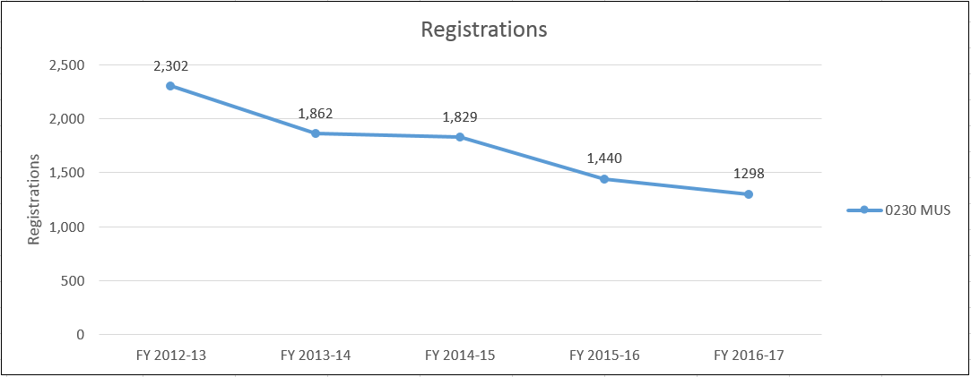

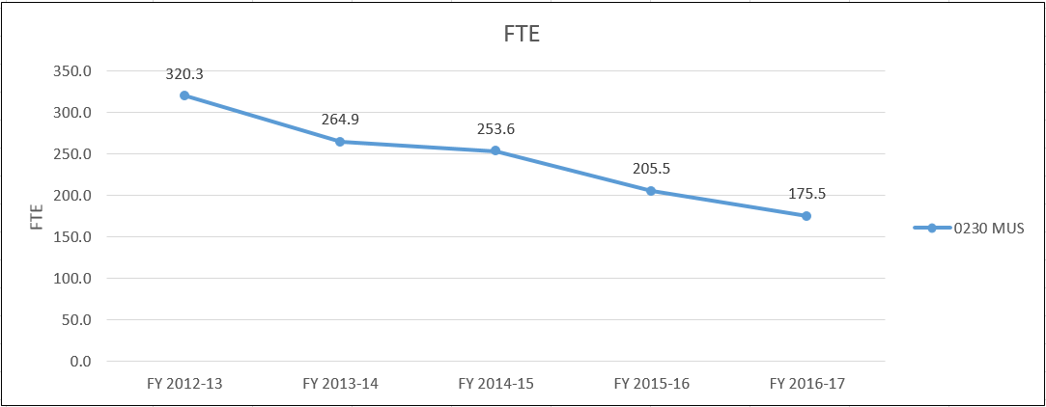

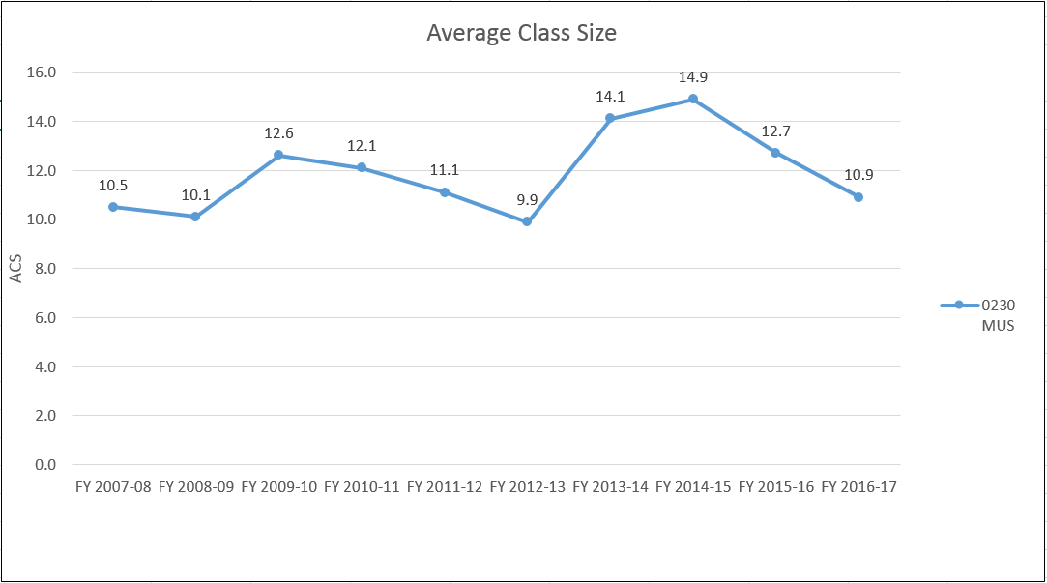

- Evidence of student demand for the program
How has/is student demand for the program changing? Why? Should the department take steps to increase the demand? Decrease the demand? Eliminate the program? What is the likely future demand for this program and why?
Enrollment in the music program has, in general, fluctuated according to the overall enrollment patterns of the Downtown campus. The evidence for student demand is reflected in the numbers of new students who enroll in August of each year. Those numbers have held steady over the last few years. External factors such as availability of financial aid and the perception of a career in education are out of this program’s control. Enrollment decreased dramatically when federal financial aid rules changed so that non-music major Sinclair students were either very highly discouraged from taking music courses as electives or they were simply not allowed to take any music electives. The numbers in Applied Voice, Applied Guitar and Applied Piano diminished greatly. Recently the state mandated that degree requirements be capped at 65 hours. The music program was forced to reduce the number of music credits required by eliminating 4 hours. Additionally, a successful Youth Wind Ensemble program, enrolling 50-60 students every year, was eliminated because of rule changes in financial aid and scholarship awards. These several points had an adverse effect on enrollment and FTE. Regardless of any trends in Registrations and FTE, having four Full-time faculty responsible for nearly 1300 registrations is remarkable for the program. The Full-time Part-time Ratio (currently 36:64) is a great help in achieving the College’s goal of 50:50.

- Evidence of program quality from external sources (e.g., advisory committees, accrediting agencies, etc.)
What evidence does the department have about evaluations or perceptions of department/program quality from sources outside the department? Who are your stakeholders, and what feedback are you receiving from them about program quality?
-please see above in Section IV A-

- Evidence of the placement/transfer of graduates
What evidence does the department/program have regarding the extent to which its students transfer to other institutions? What evidence does the department have regarding the rate of employment of its graduates? What data is available regarding the performance of graduates who have transferred and/or become employed? What data is available from RAR graduate surveys?
As part of the music program’s Mentoring process, music students are guided to apply for transfer because of institutions’ audition requirements. The faculty work closely with students to make sure plans are concrete so that matriculation is successful. The faculty are involved with public and private schools in the region, institutions at which many of Sinclair graduates have jobs. Several Sinclair music graduates perform in the music program’s ensembles. RAR graduate surveys do not seem to address departments with graduates that transfer into another institution and do not get a job in the field for at least 3 years after leaving Sinclair.
- Evidence of the cost-effectiveness of the department/program
What is the department doing to manage costs? What additional efforts could be made to control costs? What factors drive the costs for the department, and how does that influence how resources are allocated? What has the Average Class Size been for the department since the last Program Review, and what are steps that the department could take to increase Average Class Size? If Average Class Size has decreased, what is the explanation?

Since the last department review, 2 Full-time faculty have retired and were not replaced. What was formerly the Music Department was eliminated and became the music program in the Music, Theatre & Dance Department. The position of Music Chair was eliminated. These 3 events have resulted in saving the college a large sum of resources.

Section VI: Department/Program Status and Goals
- List the department’s/program’s strengths, weaknesses, opportunities, and threats (SWOT analysis).
Strengths
- Well-qualified, dedicated fulltime and adjunct faculty committed to success, with a diversity of backgrounds
- Several excellent, well-attended concerts presented each semester
- Student advising – a two-tier, time-tested system ensuring student retention and completion
- Successful transfer of students to a variety of institutions and their continued success at those institutions – reputable local schools (WSU, UD, BGSU) and noted national schools (Manhattan School, Belmont, CCM-University of Cincinnati, Berklee)
- Strong curriculum accredited by National Association of Schools of Music
- A great diversity of music styles presented in the classrooms and in performances including band music (both large and chamber), choral music ( from large choir with orchestra to small chamber), Gospel, Jazz, Bluegrass, Guitar and Handbells
- Community involvement from musicians who participate in ensembles and programs to those in the audiences of concerts
- Strong institutional financial support to help maintain equipment and build the music library
- A relationship with the college administration and the opportunities for the music program to provide music for college functions
- Institutional scholarships available to qualified students through Sinclair Foundation and individual donations
- Good facilities include computer lab, piano lab, practice rooms, band and percussion equipment, concert grand pianos
- Guest Artists including internationally renowned performers and composers who regularly appear with and collaborate with students
Weaknesses
- The need for more space is a major concern
- This music program needs to have at least two separate ensemble rehearsal rooms. With only one ensemble rehearsing at a time – and not having rehearsals during Theatre performances (because of sound bleed) – scheduling of rehearsal is very inconvenient and growth of ensembles is impossible.
- The Community Bands are limited in participation because the rehearsal and performance spaces are too small. Room 2L15 is filled to capacity in rehearsals with players and equipment. Some rehearsals have percussion players standing and playing in closets. Interested players are turned away from participating only because the rehearsal room and performance stage are not large enough.
- There is no room or space dedicated to the many adjunct instructors. Many are on campus moving from room to room with no place to store personal belongings.
- Storage space for printed music is desperately needed. The band and choral ensembles have 40 years of music accumulated that needs to be safely stored and remain easily accessible.
- The pianos used in classroom teaching and for rehearsals are old, worn and need to be replaced. Some of the keys on the pianos do not work. The rooms include 2L15, 2020, 2022.
- Marketing assistance for recruiting and for promotion of the many fine concerts is needed. The program has suffered from a lack of the development of good posters, letters, signs and other materials that are used by music departments in the area and around the country that enhance recruitment for the program and college and for concert attendance.
- Student involvement in the music program and the program FTE would undoubtedly increase if the college could institute a process by which non-music majors could register for music classes (applied lessons and ensembles) without incurring financial aid penalties.
- The Music Program should be returned to a Department with a Department Chair. The Program Director performs the functions of a Department Chair in addition to tasks specific to music, e.g. scheduling and preparing for recitals and concerts, but does not receive the Chair stipend.
- The part-time position for the administrative assistant should be a full-time position Three hours of a closed office every afternoon hinders effective communication with students and faculty for scheduling, registrations and preparing for recitals, performances and meetings.

Opportunities
- Addressing any of the weaknesses listed above will provide for many opportunities.
- New rehearsal facilities could involve more students in the ensembles and could create opportunities for additional ensembles like an “Honor Choir” for area high school students (similar to the current Youth Wind Ensemble), jazz combos that include Sinclair students, high school students and other community members.

Threats
- The program will probably lose accreditation without addressing the space issues.

- What are the department’s/program’s goals and rationale for expanding and improving student learning, including new courses, programs, delivery formats and locations? Are there unmet goals from the most recent Program Review? Please note that the department goals listed in this section will be reviewed for progress on Annual Updates and in your next Program Review.
Obtaining an additional rehearsal space and performance space is a priority. With the acquisition of the facilities in Centerville/Washington Township, the Community Bands, including the Jazz Ensemble, could move out of the too-small, not-sound-proofed 2L15. The vocal ensembles will be able to schedule rehearsals for any time of day or evening, greatly enhancing the part of the program. With a new rehearsal/performance space in Centerville/Washington Township, concert performances can be scheduled on any day at any time of the year, rather than relying on just a few selected available dates for the Blair Hall stage.

The faculty position of the soon to be retiring Voice Professor/Chorale Director must be retained and filled. The public and our students saw a vibrant Music Department with six full-time faculty just a decade ago. Area schools and teachers and their students (our potential students) will notice if Sinclair no longer has a Music Department with six specialized fulltime faculty but is, instead, a music program with only three fulltime faculty.

It should be obvious that in any respectable music program, all classrooms and rehearsal rooms need to have reliable, working pianos.

The Department needs a fulltime Administrative Assistant along with a fulltime Marketing Expert. Recruitment, promotion and image are extremely important for programs in the performing arts.

There should be a Jazz Education Program that is self-sustaining (through the establishment of a Foundation Endowment) that will support a full-size Jazz Ensemble of professional-level players (currently offered by our program) along with supporting smaller jazz combos for students of all ability levels. This could be a very attractive recruiting tool for our program.
- What resources and other assistance are needed to accomplish the department’s/program’s goals?
Moving an additional rehearsal space to a venue away from the Downtown campus would require the purchase of a few pieces of music equipment.

Section VII: Appendices: Supporting Documentation
Appendix 1: Personnel lists of Spring 2017 Music Ensembles
Appendix 2: Audience Counts for Blair Hall Theatre Events (does not include off
campus performances)
Appendix 3: NASM accreditation responses and annual updates and commission
action letters

