Sinclair Community College
Continuous Improvement Annual Update 2014-15

Please submit to your Division Assessment Coordinator / Learning Liaison for feedback no later than March 1, 2015

After receiving feedback from your Division Assessment Coordinator, please revise accordingly and make the final submission to your dean and the Provost’s Office no later than May 1, 2015

Department: 0322 – Biology
Year of Last Program Review: FY 2012-2013
Year of Next Program Review: FY 2017-2018

Section I: Department Trend Data, Interpretation, and Analysis

Degree and Certificate Completion Trend Data – OVERALL SUMMARY

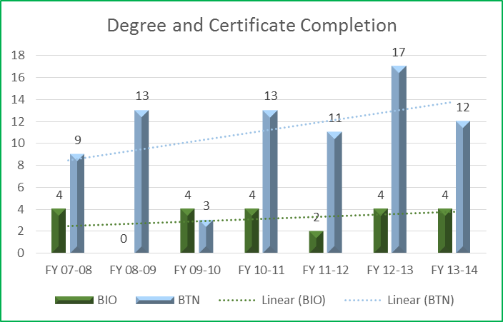

Please provide an interpretation and analysis of the Degree and Certificate Completion Trend Data (Raw Data is located in Appendix A): i.e. What trends do you see in the above data? Are there internal or external factors that account for these trends? What are the implications for the department? What actions have the department taken that have influenced these trends? What strategies will the department implement as a result of this data?

Although the completion rates for both the BTN.S.AAS and BIOE.S.AS degrees fluctuate year to year, the overall trend indicates an increase in completion rates over time. We have increased our efforts to market these programs to both traditional and non-traditional prospective students by attending various career fairs and community outreach programs. In addition, Biology/Biotechnology students also participated in some of these community outreach programs. This in addition to their involvement in the Biotechnology Club gives students a sense of belonging and responsibility which may enhance the likeliness of degree completion. We have had multiple discussions with SCC STEM Advisors to clarify the purpose of our programs and to raise awareness of what our programs have to offer to prospective students. These discussions will hopefully ensure students are placed in the appropriate degree programs thereby increasing the completion rates of the degrees.

Course Success Trend Data – OVERALL SUMMARY

Please provide an interpretation and analysis of the Course Success Trend Data (Raw Data is located in Appendix A). Looking at the success rate data provided in the Appendix for each course, please discuss trends for high enrollment courses, courses used extensively by other departments, and courses where there have been substantial changes in success.
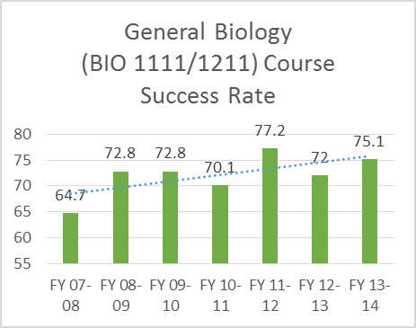
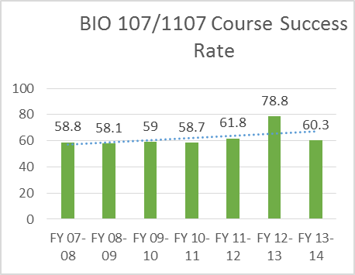

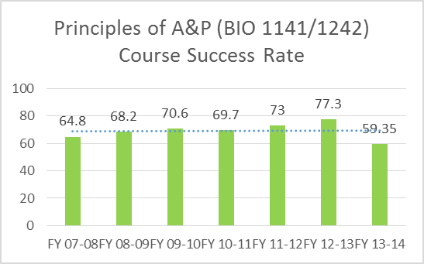
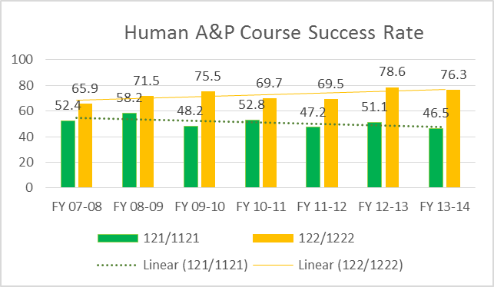

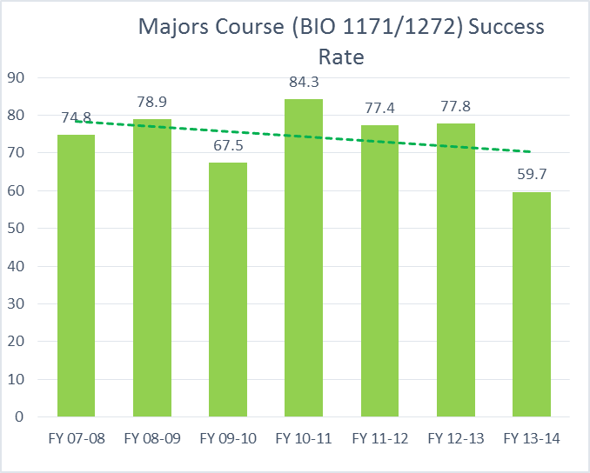

Although the success rates are variable year to year for most of our courses, the overall success rate trend over seven years of data for Biology and Biotechnology courses has remained stationary for some courses (BIO 1141) while showing a slight improvement in other courses (BIO 1107 and BIO 1111). We have made changes to our curriculum to improve success rates, particularly the A&P lab sections, by implementing weekly lab quizzes. These quizzes will allow students to assess their comprehension of the lab material and help better prepare them for the lab exams.

The success rate for BIO 1171/1272 Majors Biology has decreased since our switch to semesters. This downward trend may be due to the increased enrollment that we have seen in this course and the removal of prerequisites for the BIO 1171 course. The enrollment increased from 95 students 11/FA to 135 students 14FA. The increase in student numbers may be contributing to the decrease in success rates by having more underprepared students in the course. In addition, faculty have discovered through conversation with students that it may have been more advantageous for these students to enroll in BIO 1111 General Biology (non-majors). Based on preliminary information, some of these students did not need to take BIO 1171. As a result, our department has met with the STEM Advisors to provide detailed information regarding our general biology courses and the Biology A.S. degree program.

Our department is also investigating changes/improvements to the BIO 1121/1222 curriculum to improve success rates in this course. The decrease in the success rates over the last few years is also due to increase enrollment in these courses. There are more programs outside of the Biology Department that require these courses (or at least BIO 1121). In addition, the decrease can also be attributed to the offering of the hybrid version of this course. Data shows a higher attrition rate for the hybrid sections compared to the face to face or online sections of this course. One other contributing factor to the attrition rate may be the loss of contact hours in this course when we converted to semesters. The classroom course decreased from four lecture hours to two lecture hours starting Fall 2012. Although some content was condensed in this course to accommodate the loss of hours, we cannot make major deletions due to the nature of the course and the programs we support.

Please provide any additional data and analysis that illustrates what is going on in the department (examples might include accreditation data, program data, benchmark data from national exams, course sequence completion, retention, demographic data, data on placement of graduates, graduate survey data, etc.)

- We currently have several articulation agreements with WSU and continue to investigate articulation opportunities with other 4 year universities. The articulation agreements with WSU are as follows:
  - SCC BIOE.AS degree to WSU Biology B.A.
  - SCC BIOE.AS degree to WSU Biology B.S.
  - SCC BTN.AAS degree to WSU Biology B.S.
  - SCC BIOE.AS degree to WSU Biology B.S. Applied Physiology
  - SCC BIOE.AS degree to WSU Clinical Lab Science B.S.
- Biology faculty are collaborating with Distance Learning to develop BIO 2205/2206 Microbiology online course. The projected completion date for this course is Spring 2016.

Section II: Progress Since the Most Recent Review

Below are the goals from Section IV part E of your last Program Review Self-Study. Describe progress or changes made toward meeting each goal over the last year.
GOALS | Status | Progress or Rationale for No Longer Applicable
As our administration continues to define the goals for Sinclair at the YMCA and Warren County sites, the Biology department is committed to providing course offerings that support these efforts. The ability to offer hybrid classes at these YMCA/Warren county sites has saved the college $60,000 per location. | In progress  Completed  No longer applicable | Completed, the department offers numerous hybrid classes to meet the needs of the students at these various locations
At this time, our primary goal is to meet the established enrollment demand for Top 45 biology courses (and the semester versions), namely BIO 107 (1107)Human Biology, BIO 141-143 (1141/1242)Human Anatomy and Physiology I- III, BIO 111-113 (1111/1211) General Biology I-III (for non-majors). No new courses are planned at this time, as some were removed from the “books” in semester conversion. | In progress  Completed  No longer applicable | Completed

Below are the Recommendations for Action made by the review team. Describe the progress or changes made toward meeting each recommendation over the last year.
RECOMMENDATIONS | Status | Progress or Rationale for No Longer Applicable
While the department did an outstanding job of articulating which activities in programs and courses address each of the General Education outcomes, no data was provided regarding how well students are performing on these measures. The department has already laid the groundwork for increased assessment by identifying activities, it is recommended that the department take the next step in assessment and begin collecting, aggregating, and analyzing data from these activities so that the department can demonstrate students are achieving these outcomes. | In progress  Completed  No longer applicable | The department is in the process of identifying the courses and the assessment measures that will provide the best data for determining how well our students are achieving the General Education outcomes. The next step in completing this recommendation is to determine the best methods of collecting the data from these courses.
The current program outcomes for BIOE.S.AS were developed at a time when the degree was an emphasis area in Liberal Arts and Sciences. Now that the program has come into its own as an independent degree, additional outcomes should be developed that target BIO specifically. The existing outcomes can be kept, but they should be enhanced with additional targeted outcomes for BIO, and activities should be identified that are associated with these new outcomes similar to the specific activities have been identified that are associated with the current outcomes. Developing a small number of additional outcomes will be crucial to helping the BIOE.S.AS program develop its own identity as an independent program, rather than just as one option among many for Liberal Arts and Sciences program students. The department is encouraged to seek support from the division learning liaison in developing program outcomes and a system for collecting, analyzing and using outcomes data to improve the program. | In progress  Completed  No longer applicable | The department will begin the process of developing a small number of additional outcomes that are specific to the BIOE.S.AS degree. We will seek the assistance of our division learning liaison to help with this task.
Efforts were initially begun to articulate credit from the non-credit Biotechnology offerings that the department has developed with Workforce Development. The review team recommends that these efforts be pursued to completion to give students participating in non-credit education a head start on earning a credit-bearing credential. Having this may enable the department to recruit more students into the Biotechnology program. | In progress  Completed  No longer applicable | The department investigated the possibility of articulated credit with courses offered by Workforce Development, PLTW, and Tech Prep. The results of the investigation are as follows:  - WFD offers a short-term certificate in Bio-manufacturing which is a subdivision of Biotechnology. Although the coursework and learning outcomes are similar, to some extent, to the courses in our BTN program, there is not enough similarity to justify giving credit for one or more of the BTN courses after completing the short-term certificate. The information students learn in short-term certificate is very broad and does not encompass the learning outcomes for any of our BTN courses.  - We are currently discussing the possibility of developing a short term certificate that may bridge the gap between the WFD short term certificate and articulation with course(s) in our BTN program. We need to investigate the skill sets sought by our local biotechnology industry partners prior to developing this certificate to ensure that we are offering a viable certificate.  - Faculty in our department have reviewed the curriculum outcomes for the Biomedical Pathway in PLTW. This pathway does not correlate with the program outcomes and coursework for the BTN.S.AAS degree. However, there is a possibility of students enrolled in PLTW Biomedical to receive credit for one of our introductory courses, BTN 1110 Biotechnology and Bioethics.  - Biotechnology Tech Prep students currently receive credit for two of the courses in the BTN.S.AAS degree: BTN 1110 and BTN 1120. Also, Tech Prep students will now receive a letter grade for these courses instead of a “Y” or “N” on their transcripts upon completion of these courses at the high schools. The will afford the students the opportunity to receive credit for these courses at other institutions of higher education.
The department is encouraged to bolster its collection and use of data, particularly in regards to transfer and employment of graduates. Research, Analytics, and Reporting (RAR) has access to National Student Clearinghouse data that can provide comprehensive data on where students transfer to and what degrees they receive at their transfer institutions. In addition, RAR has access to Ohio Department of Job and Family Services data that can provide data on employment of graduates, which may be particularly beneficial for the Biotechnology students. Finally, RAR may be able to help find ways to document the benefits of the excellent work that is done helping students in the B.I.O.S.I.S. lab. | In progress  Completed  No longer applicable | We are currently working with RAR to revise the questions included in the online Recent Graduate Survey. We will continue to provide feedback to RAR regarding these surveys. Faculty involved in the BTN program developed a Facebook page utilized by current and past BTN students. Faculty are currently collecting data from recent BTN graduates using the Facebook page and via phone calls. They are also collecting employment data from the Ohio Department of Job and Family Services. Although, faculty are currently collecting this data, our department will investigate using RAR to help with this task.
Are there opportunities to move some of the resources provided in the B.I.O.S.I.S. lab into an online format so that students located some distance from campus who are taking online sections could benefit from these resources? | In progress  Completed  No longer applicable | BIOSIS is based on the campus, while students who take our classes are online. That being said, each angel shell tells the student(s) about using BIOSIS if they are local.
The department has experienced increased enrollment in recent years, and with the push nationally and regionally for more education in STEM areas, and with the possibility that more companies requiring STEM-educated employees will be moving into the area, it is important that the department monitor potential employment demand and the impact that might have on enrollment. If enrollment increases look likely, the department may need to be thoughtful and strategic in determining how those increased demands may be met, particularly in light of constraints of space and equipment. Some course offerings may need to be prioritized over others in the future, resources within the department may need to be shifted around, and options for increasing lab capacities may need to be considered, along with any other strategies that might be implemented to increase student capacity. | In progress  Completed  No longer applicable | The department continues to monitor the employment demands within the biotechnology industry by maintaining productive relationships with our Advisory Board members and reviewing employment data provided by BioOhio. BioOhio is a non-profit organization working to build the bioscience industry and education in Ohio. This organization is the liaison between the industry members and academia. According to data collected by BioOhio, Ohio currently has over 1,600 bioscience-related organizations, at over 3,000 facilities in 73 of 88 Ohio counties. In 2014, bioscience firms employed over 67,400 Ohioans, earning an average wage of $69,604. The Southwest region of Ohio, including Warren County, is one of the fastest growing regions for bioscience industry. In order to meet the demands of this growing industry we started the BTN.S.AAS program at the Courseview Campus.
Section IV.E of the self-study report addresses goals for the program, and the only goals listed were providing support for institutional goals and meeting increased enrollment demand. The department should give some thought to what other goals might be appropriate – where does the department see itself in five years? Ten years? What goals and related infrastructure will need to be put in place to get there? | In progress  Completed  No longer applicable | The department is currently developing additional short-term and long-term goals. However, one short-term goal is to develop a strategy for effectively offering dual enrollment courses at local high schools. Our department must maintain open communication with the department of School and Community Partnerships at SCC and the high school teachers to ensure quality instruction of these courses.
The department should monitor employment opportunities in Biotechnology carefully to determine whether we are offering the appropriate degree level to meet employment needs – if fewer jobs become available at the associate degree level and more jobs require higher levels of education, it may be appropriate to consider making the Biotechnology degree a transfer degree rather than a career program. | In progress  Completed  No longer applicable | As stated earlier in this update, the department continues to monitor the employment demands within the biotechnology industry by maintaining productive relationships with our Advisory Board members and reviewing employment data provided by BioOhio. We meet with our Advisory Board twice a year and have recently included new members from bioscience industries in the Southwest region of Ohio. We also collect information in regards to employment opportunities by maintaining communication with graduates of the BTN program. This is accomplished by phone calls, emails, and entries in the BTN Facebook page. Graduates working in the biotech industry will often post job openings from their place of employment on the BTN Facebook page. Current students network with recent graduates also using Facebook. In addition, we have an articulation agreement with Wright State University to allow students graduating from our BTN.S.AAS degree to get credit towards a B.S. in Biology from WSU.  We are also working with Chad Bridgman, Internship Coordinator at SCC, to offer more internship opportunities to our BTN students.

Please respond to the following items regarding external program accreditation.

Date of Most Recent Program Accreditation Review | Date of most recent accreditation review: _____________  OR  Programs in this department do not have external accreditation
Please describe any issues or recommendations from your last accreditation review (if applicable)
Please describe progress made on any issues or recommendations from your last accreditation review (if applicable)

Section III: Assessment of General Education & Degree Program Outcomes

The Program Outcomes for the degrees are listed below. All program outcomes must be assessed at least once during the 5 year Program Review cycle, and assessment of program outcomes must occur each year.

PLEASE NOTE – FOR THE NEXT TWO YEARS, GENERAL EDUCATION OUTCOME ASSESSMENT WILL BE TEMPORARILY POSTPONED. WE WOULD ASK THAT IN THIS ANNUAL UPDATE YOU IDENTIFY AT LEAST ONE COURSE IN YOUR DEGREE PROGRAM(S) WHERE ASSESSEMENT AT THE MASTERY LEVEL WILL OCCUR FOR THE FOLLOWING THREE GENERAL EDUCATION OUTCOMES:

- CRITICAL THINKING/PROBLEM SOLVING
- INFORMATION LITERACY
- COMPUTER LITERACY

NOTE THAT THERE WILL NEED TO BE AT LEAST ONE EXAM / ASSIGNMENT / ACTIVITY IN THIS COURSE THAT CAN BE USED TO ASSESS MASTERY OF THE COMPETENCY.

YOU MAY ALSO SUBMIT ASSESSMENT RESULTS FOR THESE GENERAL EDUCATION COMPETENCIES IF YOU HAVE THEM, BUT IT WILL BE CONSIDERED OPTIONAL.

 | General Education Outcomes | To which degree(s) is this program outcome related? | Year courses identified where mastery of general education competency will be assessed. | PLEASE INDICATE AT LEAST ONE COURSE WHERE MASTERY OF THE COMPETENCY WILL BE ASSESSED FOR EACH OF YOUR DEGREE PROGRAMS | What were the assessment results for this General Education competency?  (Please provide brief summary data)  NOTE: - THIS IS OPTIONAL FOR THE FY 2014-15 AND FY 2015-16 ANNUAL UPDATES
Critical Thinking/Problem Solving |  | All programs | 2014-2015 | BIO 2235 Genetics  BTN 1110 Biotechnology and Bioethics
Information Literacy |  | All programs | 2014-2015 | BIO 2235 Genetics  BTN 1110 Biotechnology and Bioethics
Computer Literacy |  | All programs | 2014-2015 | BIO 2235 Genetics  BTN 1110 Biotechnology and Bioethics
Values/Citizenship/Community |  | All programs | 2015-2016 | Due in FY 2015-16
Oral Communication |  | All programs | N/A | COM 2206/2211
Written Communication |  | All programs | N/A | ENG 1101
Are changes planned as a result of the assessment of general education outcomes? If so, what are those changes |  | OPTIONAL FOR FY 2014-15
How will you determine whether those changes had an impact? |  | OPTIONAL FOR FY 2014-15

Program Outcomes | To which course(s) is this program outcome related? | Year assessed or to be assessed. | Assessment Methods  Used | What were the assessment results?  (Please provide brief summary data)
Communicate effectively in a variety of ways with varied audiences through: writing skills, oral communication skills, listening skills, reading skills, and computer literacy. | BIO-1171 BIO-1272 COM-2206 COM-2211 COM-2225 ENG-1101 ENG-1201 | 2012-13 | The biology department offers a wide assortment of assessment methods concerning communication. These include, but not limited to, group discussions, essay questions, group project presentations, online discussion forums and 10 plus page reports and lab notebooks. | Brief assessment results are not the overall success rates, as students have a trend to do well in this particular assessment but overall success rates are lower than the following data.  For Biology 1171 and 1272, roughly 95% of the students who complete the 10 plus page genetics lab earn a C or higher.  For Biology 1171 and 1272, roughly 95% of the students earn a C or higher on written lab reports.  For our BTN students, assessment in communication is roughly 45% of the overall grade. Roughly 80% of those who complete the written and oral areas of the class receive a C or better on the assignment (s).  For Microbiology, a portion of the overall grade requires group reports and presentations. Roughly 97% of those who complete this work receive a C or better on the assignment.  For Physiology, the writing assignment includes a guide "Writing Biomedical Research Papers" and the class average on the assignment was 95 %  For our various A&P classes, discussion forums and group presentations alloted for a small portion of the overall grade, but those who successfully completed such assignments earned a C or better on the assignment.
Demonstrate a strong foundation in the natural sciences and the reasoning skills needed for successfully executing laboratory protocols. | BIO-1171 BIO-1272 CHE-1211 CHE-1221 | 2013-14 | Assessments are given in the form of exams. Besides basic knowledge questions, all full time and part time faculty include a variety of questions involving problem solving and critical thinking on such exams | Competency in laboratory protocols and skills in BIO 2205/2206 Microbiology are assessed by successful completion of weekly quizzes, multiple lab practicals and identification of three unknown microorganisms. On average, 95% of students earn a C or higher in the microbiology lab.  For BIO 1171 and BIO 1272 Majors Biology, competency in lab protocols are assessed using multiple laboratory practicals. On average, 59% and 52% of students earn a C or higher on the lab exams in BIO 1171 and BIO 1272 respectively.  For BIO 1107/1108, competency in lab protocols are assessed using multiple laboratory practicals. On average, 65% of students earn a C or higher on the lab exams.  For BIO 1141/1147 and BIO 1242/1248 Anatomy and Physiology, competency in lab protocols are assessed using multiple laboratory practicals. On average, 46% and 50% of students earn a C or higher on the lab exams in BIO 1141/1147 and BIO 1242/1248, respectively.  For BIO 1111/1117 and BIO 1211/1217 Non-majors Biology, competency in lab protocols are assessed using multiple laboratory practicals. On average, 54% and 50% of students earn a C or higher on the lab exams in BIO 1111/1117 and BIO 1211/1217, respectively.  On average, 78% of Biotechnology students earn a C or higher on the lab practicals in all Biotechnology lab courses.
Demonstrate the ability to think logically and demonstrate problem solving using analysis, synthesis and evaluation. | BIO-1171 BIO-1272 CHE-1211 CHE-1221 CHE-2111 CHE-2121 MAT-2270 MET-1131 | 2014-15 | Assessments are given in the form of exams. Besides basic knowledge questions, all full time and part time faculty include a variety of questions involving problem solving and critical thinking on such exams | On average, 66% of students enrolled in BIO 2205 Microbiology earn a C or higher on lecture exams.  For BIO 1111/1117 and BIO 1211/1217 Non-majors Biology, 69% of students earn a C or higher on the comprehensive exams.  For BIO 1121 and BIO 1222 Human Anatomy and Physiology, 56% and 63% of students earn a C or higher on the comprehensive exams, respectively.  On average, 55% and 54% of students enrolled in BIO 1141 and BIO 1242 A&P, respectively, earned a C or higher on lecture exams.  For BIO 1171 and BIO 1272 Majors Biology, 61% and 67% of students earn a C or higher on the lecture exams, respectively.  On average, 64% of Biotechnology students earn a C or higher on the comprehensive exams in Biotechnology courses.
Demonstrate knowledge of various experimental systems, including bacterial cultures, mammalian cell cultures and recombinant DNA technology. | BTN-1130 BTN-1140 BTN-1201 | 2015-16 | This outcome is specifically addressed in our biotechnology, microbiology and majors biology courses. Students are assigned and “unknown” bacteria. They are then required to culture the cells and design a series of experiments to determine the strain of bacteria. In all three courses (biotechnology, microbiology and biology majors), students perform a pGLO experiment in which recombinant DNA technology is used to transfer a bioluminescence gene of a jellyfish into a bacterial culture. Students are then required to develop a formal laboratory report detailing the steps and conclusions of the experiment.
Recognize and articulate an understanding of the increasing interdependence of world cultures and their consequences. |  | 2016-17 | This program outcome is addressed in our general biology and majors biology courses under the broad spectrum of evolution and population genetics. Students are taught how gene flow and increasing technology and mass transit have led to the gradual homogenization of once distinct human subpopulations. This concept can then be applied to the overarching theme of interdependence of world cultures in respect to genetics. Students in majors biology are required to complete a population genetics experiment as part of their normal course grade.
Are changes planned as a result of the assessment of program outcomes? If so, what are those changes? | Students enrolled in our anatomy and physiology courses often find the lab practicals very challenging as indicated by the success rates on these exams in which, on average, only about 50% of students earn a C or higher in the lab section. In response to these findings, the Biology Department developed Division Initiatives that included the implementation of weekly lab quizzes starting Spring Semester 2015. The lab quizzes were added to the lab curriculum and assesses students comprehension of lab material learned in the previous week of lab.  Lab quizzes are being administered on a weekly basis except for the days of a lab exam or the week following a lab exam. We are hoping that these weekly quizzes will better prepare students for the more encompassing lab exams, which covers aggregate material from several lab topics.
How will you determine whether those changes had an impact? | Anatomy and physiology faculty will continue to give quizzes, monitor the exam grades and discuss ways to modify the quizzes such as: adding multiple choice questions, increasing the number of questions on each quiz, or using different modes of question delivery to enhance lab exam grades. Lab quiz and lab exam scores will be collected from each section. Eventually, we will compare the overall success rate on the lab exams post lab quiz implementation with the success rate of lab exams prior to the use of weekly lab quizzes to determine if the lab quizzes are improving student comprehension.

APPENDIX – PROGRAM COMPLETION AND SUCCESS RATE DATA

Degree and Certificate Completion

Division | Department | Department Name | Program | FY 07-08 | FY 08-09 | FY 09-10 | FY 10-11 | FY 11-12 | FY 12-13 | FY 13-14
SME | 0322 | Biology | BIOE.AS | 4 | . | 4 | 4 | 2 | 3 | .
SME | 0322 | Biology | BIOE.S.AS | . | . | . | . | . | 1 | 4
SME | 0322 | Biology | BTN.AAS | 9 | 13 | 3 | 13 | 11 | 13 | .
SME | 0322 | Biology | BTN.S.AAS | . | . | . | . | . | 4 | 12

Course Success Rates
Department | Department Name | Course |  | FY 07-08 | FY 08-09 | FY 09-10 | FY 10-11 | FY 11-12 | FY 12-13 | FY 13-14
0322 | Biology | BIO-101 |  | 53.4% | 59.6% | 42.2% | 56.2% | 64.1% | 75.0% | .
0322 | Biology | BIO-104 |  | 70.7% | 69.5% | 67.0% | 61.9% | 72.4% | 57.1% | .
0322 | Biology | BIO-107 |  | 58.8% | 58.7% | 59.0% | 58.7% | 61.8% | 78.8% | .
0322 | Biology | BIO-108 |  | . | . | . | . | . | . | .
0322 | Biology | BIO-1101 |  | . | . | . | . | . | 53.4% | 60.2%
0322 | Biology | BIO-1104 |  | . | . | . | . | . | 50.8% | 48.8%
0322 | Biology | BIO-1107 |  | . | . | . | . | . | 60.3% | 60.3%
0322 | Biology | BIO-1108 |  | . | . | . | . | . | . | .
0322 | Biology | BIO-111 |  | 54.2% | 59.4% | 58.9% | 51.8% | 63.3% | . | .
0322 | Biology | BIO-1111 |  | . | . | . | . | . | 63.5% | 64.9%
0322 | Biology | BIO-1117 |  | . | . | . | . | . | . | .
0322 | Biology | BIO-112 |  | 64.8% | 82.3% | 78.1% | 73.4% | 82.9% | . | .
0322 | Biology | BIO-1121 |  | . | . | . | . | . | 45.3% | 46.5%
0322 | Biology | BIO-113 |  | 75.1% | 76.8% | 81.3% | 85.0% | 85.3% | 75.0% | .
0322 | Biology | BIO-1141 |  | . | . | . | . | . | 48.3% | 50.7%
0322 | Biology | BIO-1147 |  | . | . | . | . | . | . | .
0322 | Biology | BIO-117 |  | . | . | . | . | . | . | .
0322 | Biology | BIO-1171 |  | . | . | . | . | . | 56.7% | 49.6%
0322 | Biology | BIO-118 |  | . | . | . | . | . | . | .
0322 | Biology | BIO-119 |  | . | . | . | . | . | . | .
0322 | Biology | BIO-121 |  | 52.4% | 58.2% | 48.2% | 52.8% | 47.2% | 57.0% | .
0322 | Biology | BIO-1211 |  | . | . | . | . | . | 77.5% | 85.3%
0322 | Biology | BIO-1217 |  | . | . | . | . | . | . | .
0322 | Biology | BIO-122 |  | 65.9% | 71.5% | 75.5% | 69.7% | 69.5% | 83.1% | .
0322 | Biology | BIO-1222 |  | . | . | . | . | . | 74.0% | 76.3%
0322 | Biology | BIO-1242 |  | . | . | . | . | . | 76.7% | 68.0%
0322 | Biology | BIO-1248 |  | . | . | . | . | . | . | .
0322 | Biology | BIO-125 |  | 63.3% | 80.4% | 71.4% | 78.0% | 72.5% | . | .
0322 | Biology | BIO-127 |  | . | . | . | . | . | . | .
0322 | Biology | BIO-1272 |  | . | . | . | . | . | 76.7% | 69.8%
0322 | Biology | BIO-128 |  | . | . | . | . | . | . | .
0322 | Biology | BIO-132 |  | 48.7% | . | . | . | . | . | .
0322 | Biology | BIO-138 |  | . | . | . | . | . | . | .
0322 | Biology | BIO-141 |  | 50.9% | 58.0% | 62.9% | 62.7% | 67.9% | . | .
0322 | Biology | BIO-142 |  | 66.2% | 65.7% | 68.4% | 69.1% | 74.6% | 100.0% | .
0322 | Biology | BIO-143 |  | 77.4% | 80.9% | 80.6% | 77.3% | 76.4% | 84.1% | .
0322 | Biology | BIO-147 |  | . | . | . | . | . | . | .
0322 | Biology | BIO-148 |  | . | . | . | . | . | . | .
0322 | Biology | BIO-149 |  | . | . | . | . | . | . | .
0322 | Biology | BIO-162 |  | 76.9% | . | . | . | . | . | .
0322 | Biology | BIO-167 |  | . | . | . | . | . | . | .
0322 | Biology | BIO-171 |  | 61.6% | 56.0% | 60.7% | 73.6% | 60.9% | . | .
0322 | Biology | BIO-172 |  | 83.3% | 96.1% | 78.7% | 90.0% | 91.7% | . | .
0322 | Biology | BIO-173 |  | 79.5% | 84.6% | 63.0% | 89.3% | 79.6% | 100.0% | .
0322 | Biology | BIO-177 |  | . | . | . | . | . | . | .
0322 | Biology | BIO-178 |  | . | . | . | . | . | . | .
0322 | Biology | BIO-179 |  | . | . | . | . | . | . | .
0322 | Biology | BIO-205 |  | 87.2% | 88.2% | 87.8% | 82.4% | 82.5% | 80.4% | .
0322 | Biology | BIO-206 |  | . | . | . | . | . | . | .
0322 | Biology | BIO-211 |  | 75.0% | 70.0% | 64.1% | 65.1% | 75.2% | 75.0% | .
0322 | Biology | BIO-212 |  | . | . | . | . | . | . | .
0322 | Biology | BIO-2205 |  | . | . | . | . | . | 78.1% | 82.3%
0322 | Biology | BIO-2206 |  | . | . | . | . | . | . | .
0322 | Biology | BIO-2211 |  | . | . | . | . | . | 49.2% | 69.7%
0322 | Biology | BIO-2212 |  | . | . | . | . | . | . | .
0322 | Biology | BIO-222 |  | 93.3% | 91.7% | 85.7% | 69.2% | 73.7% | . | .
0322 | Biology | BIO-2222 |  | . | . | . | . | . | . | 73.3%
0322 | Biology | BIO-2225 |  | . | . | . | . | . | 88.9% | 64.0%
0322 | Biology | BIO-2235 |  | . | . | . | . | . | . | 70.8%
0322 | Biology | BIO-2236 |  | . | . | . | . | . | . | .
0322 | Biology | BIO-225 |  | 75.0% | 55.6% | . | 71.4% | 83.3% | . | .
0322 | Biology | BIO-226 |  | . | . | . | . | . | . | .
0322 | Biology | BIO-235 |  | . | . | . | . | 100.0% | . | .
0322 | Biology | BIO-297 |  | . | . | . | . | . | . | .
0322 | Biology | BTN-110 |  | 63.6% | 66.7% | 87.0% | 76.9% | 80.0% | . | .
0322 | Biology | BTN-1110 |  | . | . | . | . | . | 71.4% | 50.0%
0322 | Biology | BTN-1120 |  | . | . | . | . | . | 79.2% | 70.6%
0322 | Biology | BTN-1130 |  | . | . | . | . | . | 81.8% | 83.3%
0322 | Biology | BTN-1131 |  | . | . | . | . | . | . | .
0322 | Biology | BTN-1140 |  | . | . | . | . | . | . | 81.3%
0322 | Biology | BTN-115 |  | 81.8% | . | . | . | . | . | .
0322 | Biology | BTN-120 |  | 78.6% | 87.5% | 86.4% | 85.7% | 82.4% | . | .
0322 | Biology | BTN-1201 |  | . | . | . | . | . | 84.0% | 100.0%
0322 | Biology | BTN-130 |  | 38.5% | 71.4% | 59.3% | 88.0% | 78.3% | . | .
0322 | Biology | BTN-131 |  | . | . | . | . | . | . | .
0322 | Biology | BTN-140 |  | 71.4% | 60.0% | 79.2% | 80.0% | 83.3% | . | .
0322 | Biology | BTN-201 |  | . | 100.0% | 90.9% | 89.5% | 92.9% | . | .
0322 | Biology | BTN-210 |  | 86.7% | 100.0% | 100.0% | 87.5% | 88.2% | . | .
0322 | Biology | BTN-220 |  | 100.0% | 88.9% | 100.0% | 90.9% | 91.7% | . | .
0322 | Biology | BTN-2210 |  | . | . | . | . | . | 64.7% | 87.5%
0322 | Biology | BTN-2211 |  | . | . | . | . | . | . | .
0322 | Biology | BTN-2220 |  | . | . | . | . | . | 100.0% | 100.0%
0322 | Biology | BTN-2230 |  | . | . | . | . | . | 71.4% | 86.7%
0322 | Biology | BTN-230 |  | 86.7% | 88.9% | 57.1% | 92.3% | 77.8% | . | .
0322 | Biology | BTN-231 |  | . | . | . | . | . | . | .
0322 | Biology | BTN-235 |  | 100.0% | 57.1% | 100.0% | 100.0% | 88.2% | . | .
0322 | Biology | BTN-240 |  | 100.0% | 100.0% | 100.0% | 92.3% | 100.0% | . | .
0322 | Biology | BTN-270 |  | . | . | 100.0% | . | . | . | .
0322 | Biology | BTN-295 |  | 93.8% | . | . | . | . | . | .

