**Program Review**

**2017**

**Electronics Engineering Technology**

**(EET)**

**And**

**Automation and Control with Robotics**

**(ACT)**

**Section I: Annually Reviewed Information**

**A: Department Trend Data, Interpretation, and Analysis**

**Degree and Certificate Completion Trend Data – OVERALL SUMMARY**

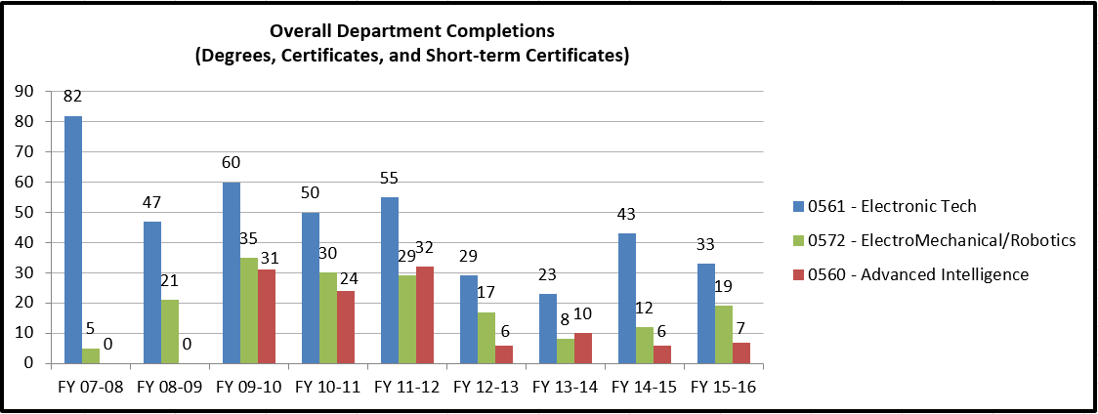

Please provide an interpretation and analysis of the Degree and Certificate Completion Trend Data: i.e. What trends do you see in the above data? Are there internal or external factors that account for these trends? What are the implications for the department? What actions have the department taken that have influenced these trends? What strategies will the department implement as a result of this data?

Please be sure to address strategies you are currently implementing to increase completions of degrees and certificates. What plans are you developing for improving student success in this regard?

**Advanced Technical Intellegence (ATI)**

This program started off very strong but enrollment has been weak for the last two year. Due to the issues with the HLC, the government’s policy change to only hire grads with bachelor degrees, and issues with our partners at the Advanced Technical intelligence Center ATIC Sinclair has suspended the program as of Fall 2016.

**Electronics Engineering Technology (EET)**

The data for completion follows enrollment. Enrollment for 09-10 was 270, for 10-11 was 250, for 11-12 was 250. The completions for 2012-2013 was 28 and for 2014-2015 was 23 which is well below expectation for that year. There are two factors that contributed to the completion decline for those years. First was the case where Miami Valley CTC discontinued its Electronic program. Each year we would enroll several students from that program. Second it was discovered that a number of our completions were not captured. It was found that if students do not declare their major properly (especially for certificates) they are not captured as completing. We identified some students that were missing and had them given credit for completing. Academic Advising is now capturing all the embedded certificates in the program. In the last couple of years the program enrollment has increased due to a stronger job market and the employment opportunities available to our graduates. The program needs to increase enrollment further through high school visits, Tech. Fest, Engineer day, and other venues reach young students.

|  |  |  |  |  |  |
| --- | --- | --- | --- | --- | --- |
| **EET ENROLLMENT TRENDS** | | | | | |
| **Semester** | **11/FA** | **12/FA** | **13/FA** | **14/FA** | **15/FA** |
| **Students** | **248** | **258** | **265** | **279** | **258** |

Our challenge is to get those students to completion through advising and student support. Faculty advisors are being assigned to students to support Student Advising. The EET Resource Center provides a place for students to work on class assignments and get help. A Lab assistant and all the equipment are available 10 hours a day 5 days a week to provide a place for students to complete their lab assignments and to receive tutoring for their classes.

**Automation & Control Technology w/Robotics (ACT)**

Over the past few years, the Automation & Control Technology w/Robotics (ACT) program (see Appendix A for program description) has seen a noticeable increase in the number of completions in degrees, certificates, and short term certificates. After three straight years of decreasing completions (FY10-11 through FY12-13), we have seen three straight years of increases, culminating in the highest number of completions in the past four years (19 in FY15-16). Before that, the highest number had been 35 in FY09-10 when we had a major push for completions prior to the semester conversion. The EET/ACT department is optimistic that the strong numbers in FY15-16 are indicative of the improving health of the manufacturing environment and that we will see sustained numbers in the future.

The increase in completions can be attributed to one external factor and one internal factor. Externally, we have seen an increase in the regional manufacturing activity of employers. This is supported by feedback provided by our advisory board members as well as the ever-increasing participation in our ACT internship program. Internally, we have seen an increase in the popularity of the Industrial Maintenance Technician short-term certificate.

Externally, it must be noted that manufacturing is cyclical by nature. After a slow period, highlighted by outsourcing and layoffs, the region’s manufacturing industry has bounced back. Many local manufacturers have reported “reshoring” or bringing back much of the work that had initially been sent overseas. Employers are once again hiring and investing in new technology. Much of this information comes from leveraging our relationship with the Dayton Regional Manufacturers Association (DRMA) which monitors the health of local manufacturing.

Looking at leading indicators, we knew the completion numbers would increase. Increased manufacturing activity leads to increased enrollment, which we saw in 2012. 15/FA saw an ACT enrollment of 106, which is the highest it has been in the last 5 years (see the table below). Increased enrollment leads to increased completion, which we see in these completion numbers above.

|  |  |  |  |  |  |
| --- | --- | --- | --- | --- | --- |
| **ACT ENROLLMENT TRENDS** | | | | | |
| **Semester** | **11/FA** | **12/FA** | **13/FA** | **14/FA** | **15/FA** |
| **Students** | **95** | **100** | **77** | **80** | **106** |

Internally, we have seen an increase in the popularity of the Industrial Maintenance Technician short term certificate (IMDMT.S.STC). 10 years ago, each maintenance tech had a specific trade, i.e. plumbers, electricians, tenors, millwrights, etc. Now manufacturers want one technician with this entire skill set. Thus, the demand for Industrial Maintenance technicians has exploded. Pursuit of this certificate is where many individuals wishing to become a skilled trade start.

Another factor contributing to the increase in ACT enrollment and completions is the constant effort that the ACT program has put forth in in terms of outreach and recruitment. In addition to being heavily involved in the College Credit Plus Program, ACT personnel play an extremely active part in high school events, college nights, Tech Prep events, and manufacturing-related conferences and competitions. These efforts have resulted in Sinclair being known as a high-quality provider of ACT and EET advanced manufacturing instruction.

**Course Success Trend Data – OVERALL SUMMARY**

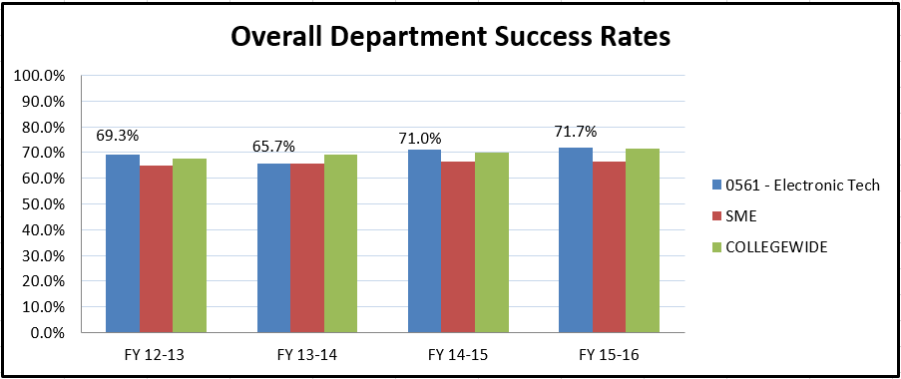

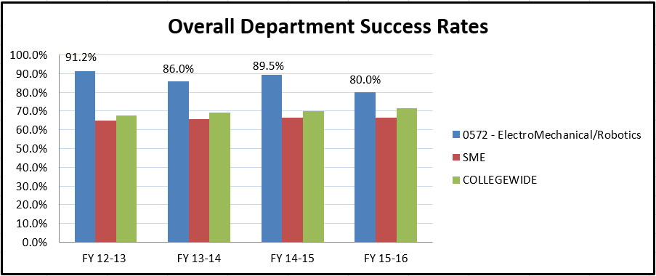

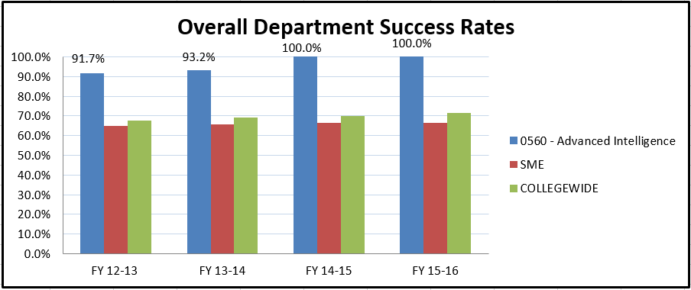

Please provide an interpretation and analysis of the Course Success Trend Data. Please discuss trends for high enrollment courses, courses used extensively by other departments, and courses where there have been substantial changes in success.

Please be sure to address strategies you are currently implementing to increase course success rates. What plans are you developing for improving student success in this regard?

**Electronics Engineering Technology (EET)**

The department needs to improve the completion percentage. An increase in individual course success rates in the lower level courses is really needed. There has been a special effort by the EET faculty to advise students every semester in order to make sure the students have a MAP and to provide access to a faculty member they can go to for guidance. We are working to reach the students who are self-advising.

The EET program has major sequences, EET 1116-1150-1155; EET 1131-2252 and EET 1164-2264, EET 2281-2282 culminating in the capstone course EET 2278. Advising student to complete a sequence in successive semesters really helps them retain knowledge and skills to be more successful in subsequent courses. Also there is a good deal of cross learning in EET 2259-2261. These observations are based on student feedback as well as analysis done using the SME/IEEE Test for the recent TAC/ABET* accreditation visit in October 2016. We believe that the slight increase in the success rates in 2014-2015 and 2015-2016 reflects the effort put forward by the faculty to improve completion.

**Automation & Controls Technology w/Robotics (ACT)**

The ACT department has maintained strong numbers in terms of success rates, consistently scoring above both the division and college wide averages. Since the quarter-to-semester conversion, the program has experienced overall success rates between 86 and 91%. It is important to note that the highest success rates have come in the upper level courses such as EET 2281 PLCs, EET 2282 Advanced PLCs, EGR 2252 Robotic Teach Pendant Programming, and the EGR 2278 ACT Capstone Course which encompass skill sets that are essential to regional employers in advanced manufacturing with respect to their required ACT technician skills. Success rates in these courses have consistently been above 90% since FY12-13.

The program did, however, experience an 9.5% decrease in the overall program success rate when it declined from 89.5% in FY14-15 to 80% in FY15-16. This decline can be attributed to several factors. Prior to FY15-16, participation in the ACT courses run under the College Credit Plus program at both Miami Valley Career Training Center (MVCTC) and Ponitz Career Training Center averaged between 8 to 10 students. As of FY15-16 this enrollment has increased to 18 to 24 students per course each semester. In the ACT CCP courses offered like EGR 1128 Computer Integrated Manufacturing, which is a lower level course in our program, CCP students historically perform 15 to 20 percentage points lower in terms of success rates when compared to their Sinclair counterparts which negatively affects the programs overall success rate. The result was a decrease from 90% to 77% in the success rate for this course. The ACT department chair and faculty held several meetings with officials from both institutions to address this issue. Officials at both locations expressed concern that these students were being enrolled in these courses in their first semester at these institutions and that they may need time to assimilate before introducing them to college level work. As result, the CCP courses at both training centers were “moved back” in the student’s curriculum with the objective to foster and promote better academic performance in Sinclair’s CCP course offerings. In conjunction with these changes, enrollment in ACT CCP courses at MVCTC has now been made optional while they are still mandatory under the Ponitz Engineering program.

In FY15-16, the ACT program experienced another phenomenon which contributed to the decline in the overall success rate in two other courses, these being EGR 1217 Fluid Power & Controls and EGR 1261 C++ Programming. University of Dayton (UD) senior engineering students who get “out of sequence in their curriculum are being advised to take EGR 1217 and EET 2281 to satisfy some of their technical elective requirements. They have been enrolling in these courses but then dropping prior to completion, often within 2 weeks of the start of the course. For example, in the summer of FY15-16 there were 10 students enrolled in EGR 1217, 7 of them being UD students. Within the first 2 weeks, these 7 students withdrew from the course which contributed to a decline in the success rate from 82.4% to 70% when compared with the previous year. These students re-enrolled in the Fall 16 semester and are completing the course but this activity type of activity does produce erroneous fluctuations in the program’s success rates. A similar thing occurred in FY15-16 in EGR 2261. In addition to ACT students taking this C++ programming course as a technical elective, Wright State engineering students are also taking this course and the same thing is occurring with these students in terms of withdrawals. There were 2 sections of this course run during the Spring 16 semester. One section started with 11 students and ended with 6 and the other section started with 18 students and ended with 12. Since students must adopt the ACT program to register for these events played a major role in the program’s overall success rate of 9.5% from 89.5& in FY12-15 to 80% in FY15-16.

**OPTIONAL -** Please provide any additional data and analysis that illustrates what is going on in the department (examples might include accreditation data, program data, benchmark data from national exams, course sequence completion, retention, demographic data, data on placement of graduates, graduate survey data, etc.)

**Electronics Engineering Technology (EET)**

**ABET**

In October of 2016 the Electronics Engineering Technology and other SME departments had an ABET visit for reaccreditation. The faculty and staff worked hard to make the visit smooth and successful. We will not get the official results until the middle of 2017 but the preliminary finding was that the department had two findings both related to the Program Educational Objectives. The first was that they could find no evidence that we reviewed our PEOs with our Advisory board and second was that they could find no evidence that we have a procedure that tells us to review the PEOs with the Advisory Board. Both findings have been rectified.

**SME IEEE Test**

This exam is a third-party nationally-normed proficiency examination specifically for two-year EET programs. It is intended to aid colleges to assess their program breadth and depth through a series of 120 multiple-choice questions covering all aspects of EET curricula. The tested body of knowledge is not tied to any specific accreditation program and exceeds in breadth that covered by a typical EET curriculum. At Sinclair, EET Capstone Project students take the exam, normally in their last semester at Sinclair. The exam has been given annually since 2013. The mean outcome is a raw score of 44% correct responses. Sinclair’s mean score to date is 45%. Last year we analyzed the data we had collected since 2013 and developed action plans to improve the department. See Appendix.

**Automation & Controls Technology w/Robotics (ACT)**

The most in-demand offering of the ACT program is the 2-year associate’s degree program in Automation & Control Technology with Robotics. Updated in 2015 to reflect current advanced manufacturing technology and academic requirements, this degree offering enjoys an outstanding reputation among regional employers. Many companies seek out ACT graduates and some like ASPM-Minco hire ACT graduates and interns to expand their growing maintenance and automation support staff. (See table below.)

* In 2014, ACT incorporated an ACT-based internship as a technical elective. It is important to note that not all students take advantage of the internship option. The reasons for this include the fact that some do not qualify academically, some do not want to delay their graduation, and some are already employed. However, for many students, an ACT internship is an excellent opportunity to gain real-world employment experience as electro-mechanical technicians. This also allows them to earn good money while “auditioning” for permanent employment upon completion. Internships are quickly becoming a cornerstone of the ACT degree. More than 65% of ACT graduates have gained permanent employment with the companies they had previously interned for within 60 days of graduation since 2014. While ACT participation is by no means where we would like it to be when compared with ACT enrollment, faculty is working diligently with the SME Internship Coordinator to increase awareness of and participation in ACT internships.

|  |  |  |  |  |  |  |  |
| --- | --- | --- | --- | --- | --- | --- | --- |
| **ACT Internship Numbers 2012 to 2017** | | | | | | | |
| **Academic Year** | **AY12-13** | **AY13-14** | **AY14-15** | | **AY15-16** | | **AY16-17** |
| **EGR-2270** | **27** | **5** | **7** | | **11** | | **12** |
| **Enrollment** | **100** | **77** | **80** | | **106** | | **95** |
| **% Participation** | **27** | **6** | **9** | | **10** | | **13** |
| **\*Data from SME Internship Course Enrollment from** | | | | | |  | |
| **RAR -SAS Stored Report, 11/14/2016.** | | | |  | |  | |

**B: Progress Since the Most Recent Review**

Below are the goals from Section IV part E of your last Program Review Self-Study. Describe progress or changes made toward meeting each goal over the last year.

|  |  |  |
| --- | --- | --- |
| **GOALS** | **Status** | **Progress or Rationale for No Longer Applicable** |
| Series of core courses were implemented in the winter of 2010. | In progress  Completed  No longer applicable | All the programs were converted to semesters for Fall 2012. |
| With the completion of program realignment special attention was paid to make adjustments to course materials to better match the program outcomes. | In progress  Completed  No longer applicable | This was accomplished when all the programs were converted to semesters |
| Realigned the program to teach less history and more up to date technology by offering new courses as electives, EET 156-Alternate Energy Sources, EET 256-Fuel Cells, EET 157- RFID Technology. EET 281-PLCs was made a required course for the program due to the changing needs of the local industry and as recommended by the EET Advisory Committee. | In progress  Completed  No longer applicable | This was accomplished when all the programs were converted to semesters. All courses were reviewed. The material that was not relevant today was removed and new material introduced. Technical electives continue to change. RFID and NANO technology are offered as well as Advanced PLCs. We will continue to recruit new members to our advisory committee to review our curriculum and to plan for the future. As technology changes we need to change with it. |

Below are the Recommendations for Action made by the review team. Describe the progress or changes made toward meeting each recommendation over the last year.

|  |  |  |
| --- | --- | --- |
| **RECOMMENDATIONS** | **Status** | **Progress or Rationale for No Longer Applicable** |
| No report or comments could be found for reporting. | In progress  Completed  No longer applicable | This report completes the requirement. |

**Automation and Controls Technology w/Robotics (ACT)**

**Progress Since Last Review**

Year of Last Program Review: FY 2010-2011

Year of Next Program Review: FY 2016-2017

Below are the goals from Section IV part E of your last Program Review Self-Study. Describe progress or changes made toward meeting each goal over the last year. Responses from the previous year’s Annual Update are included, if there have been no changes to report then no changes to the response are necessary.

|  |  |  |
| --- | --- | --- |
| **GOALS** | **Status** | **Progress or Rationale for No Longer Applicable** |
| Series of core courses were implemented in the winter of 2010. | In progress  Completed  No longer applicable | All the programs were converted to semesters for Fall 2012 and the students are now mapped to take the courses in a series. |
| With the completion of program realignment special attention was paid to make adjustments to course materials to better match the program outcomes. | In progress  Completed  No longer applicable | This was accomplished when all the programs were converted to semesters |
| Realigned the program to teach less history and more up to date technology by offering new courses as electives, EET 156-Alternate Energy Sources, EET 256-Fuel Cells, EET 157- RFID Technology. EET 281-PLCs was made a required course for the program due to the changing needs of the local industry and as recommended by the EET Advisory Committee. | In progress  Completed  No longer applicable | This was accomplished when all the programs were converted to semesters. All courses were reviewed. The material that was not relevant today was removed and new material introduced. Technical electives continue to change. RFID has been added to the ACT program. We will continue to recruit new members to our advisory committee to review our curriculum and aid in planning for the future. This is an ongoing process. As technology changes, we need to change with it. |

Below are the Recommendations for Action made by the review team. Describe the progress or changes made toward meeting each recommendation over the last year. Responses from the previous year’s Annual Update are included, if there have been no changes to report then no changes to the response are necessary.

|  |  |  |
| --- | --- | --- |
| **RECOMMENDATIONS** | **Status** | **Progress or Rationale for No Longer Applicable** |
| No report or comments could be found for reporting. | In progress  Completed  No longer applicable | This report completes the requirement. |

**C: Assessment of General Education & Degree Program Outcomes**

For the past two years, departments have been asked in their Annual Update submissions to identify courses and assignments where General Education Outcomes could be assessed for mastery (with the exception of Oral and Written Communication – for those two outcomes the College is piloting a process to collect data, no data need be reported for those two outcomes in this self-study). Please report any assessment results you have for the first four General Education outcomes based on the courses and assignments that were identified by your department in the previous two Annual Update cycles. (the last two are optional).

|  |  |  |  |
| --- | --- | --- | --- |
| **General Education Outcomes** | Courses identified by the department where **mastery** could be assessed | Assessment Methods  Used | What were the assessment results?  (Please provide brief summary data) |
| Critical Thinking/Problem Solving | Not reported in FY 2014-15 Annual Update.  Please list course(s) below:  For EET  EET 1116  EET 2278  For EGR  EGR 2231 | For EET  EET1116 worksheets.  EET 2278 weekly review of projects week 2-16  For ACT  Simutech troubleshooting industrial control assignment | For EET  No data at this time - will review after 16-17 year  80% student attainment is achieved consistently after the first week. Problems are project-specific. Initial problem identification and solving.  For the Fall 16 semester students averaged 8.9 out of 11 |
| Values/Citizenship/Community | **Cultural Diversity and Ethics in a technical world are discussed and assessed in EET 1116**  **We will also be adding MET 2711 to the EET and the ACT program to provide a more complete coverage of the topic in Fall of 2017** | For EET  EET1116 worksheets  MET 2711 assignments  For ACT  MET 2711 assignments | For EET  There has been one semester of data collected. The students averaged was 76%  First data will be collected for Fall 2017  For ACT  First data will be collected for Fall 2017 |
| Computer Literacy | Not reported in FY 2014-15 Annual Update.  Please list course(s) below:  For EET  EET 1116 and EET 1164  For ACT  EET2281 | For EET  EET 1116 assignment 1-7 for the use of Microsoft Word and Excel  EET 1164 PC topic paper  For ACT  EET 2281 12 labs | For EET  No data at this time - will review after 16-17 year  No data at this time - will review after 16-17 year  For ACT  EET 2281 Student Attainment 81%  Analysis has revealed that student performance relative to current lab structure adequately demonstrates PLC ladder logic programming skills. |
| Information Literacy | Not reported in FY 2014-15 Annual Update.  Please list course(s) below:  For EET  EET 2259  For ACT  EGR 1144 | For EET  EET 2259 Labview presentation  For ACT  EGR 1144 sensor research paper | For EET  No data at this time - will review after 16-17 year  For ACT  84 % is the class average for 15-16, will assess again for 16-17 |
| Oral Communication | **OPTIONAL** |  |  |
| Written Communication | **OPTIONAL** |  |  |
| **Are changes planned as a result of the assessment of general education outcomes? If so, what are those changes?** | Yes. For Values/Citizenship/Community it was determined that the subject was not thoroughly addressed in EET 1116. The corrective action was to add MET 2711 Ethics for Engineering Technology Professionals to both programs | | |
| **How will you determine whether those changes had an impact?** | MET 2711 assignment will be used in the next assessment | | |

**EET**

The Program Outcomes for the degrees are listed below. **All program outcomes must be assessed at least once during the 5 year Program Review cycle, and assessment of program outcomes must occur each year**.

|  |  |  |  |  |
| --- | --- | --- | --- | --- |
| **Program Outcomes** | To which course(s) is this program outcome related? | Year assessed or to be assessed. | Assessment Methods  Used | What were the assessment results?  (Please provide brief summary data) |
| Use various software packages to simulate, analyze and develop schematics and layouts of electronic circuits; technical communication skills for group work. | EET1116, EET1150,  EET1155, EET1131,  ENG 1101,  COM 2211 | 2012-2013 | Testing,  Graded lab reports, Group projects | In EET 1116 MultiSim software is introduced to the students and used on multiple assignments that are graded. In EET 1150 and EET 1155. In EET 1150 student attainment = 67% for the students completing the projects.  The analysis showed that a number of students did not complete the project. A continuous improvement plan will be developed to improve student success in this area. |
| Demonstrate a commitment to address professional and ethical responsibilities, including a respect for diversity; impact of engineering technology solutions in a societal and global context. | EET 1116,  EET 2278 | 2015-2016 | For EET 1116 student complete a worksheet. For EET 2278 there is a written report. | New in Spring 16 EET 1116 students attained class average of 76%. New in Spring 16 for EET 2278 |
| Apply principles of DC and AC circuits, analog and digital electronics, microcontroller fundamentals and circuit assembly for analysis, basic design, circuit simulation, problem solving, assembly, troubleshooting and repair of electrical and electronic systems. | SCC 1101, EET1150, EET1155, EET1131, EET2201, EET2261, EET 2270 | 2015-2016 | SME EET Proficiency Test in Capstone course | National average was 44% Sinclair students attained 45% class average |
| Apply principles of mathematics and physics to solve engineering technology problems. | EET1150, EET1155, EET2201,  MAT 1280,  MAT 1290,  PHY 1131 | 2014-2015 | Class assignments graded test, laboratory assignments and homework. | Assessment results: 80% master the various aspects of power of ten and engineering notation, 90% master Ohm’s law, 80% master series and parallel circuit analysis, 80% master Kirchoff’s voltage and current laws, 70% master basic complex circuit analysis. |
| Demonstrate programming skills using a graphical language, assembly language or ladder logic to create computer solutions of engineering problems. | EET 1164,  EET2259, EET2281,  EET2261 | 2014-2015 | For EET 2259 & EET 2261 Pre test and post test | EET 2259 Pre/Post  LabVIEW (VIs) 85.71/85.71%  Editing & debugging 14.29/100.00%  Datatypes 28.57/100.00%  Sub-VIs 28.57/57.14%  Structures 0.00/100.00%  Arrays & Clusters 42.86/85.71%  Charts & Graphs 2.86/71.43%  EET 2261 Pre/Post  Microprocessor arch. 7.69/75.00%  Assembly language prog. 0.00/83.33%  Bus structures and timing 7.69/50.00%  Input/output interface 0.00/66.67%  Interrupt-processed I/O 0.00/83.33%  Microcontroller appl. 38.46/83.33%  Microprocessor-based comm.7.69/66.67% |
| **Are changes planned as a result of the assessment of program outcomes? If so, what are those changes?** | Due to some low scores in the SME test we are changing the math pre-req for EET 1150 from MAT 1270 to MAT 1570. The test also identified areas of the curriculum that need more emphasis.  MET 2711 will be added to the EET program. | | | |
| **How will you determine whether those changes had an impact?** | We will look at the test results in two years. | | | |

Click here to enter text.

**Automation & Control Technology (ACT)**

**Program Outcomes**

|  |  |  |  |  |
| --- | --- | --- | --- | --- |
| **Program Outcomes** | To which course(s) is this program outcome related? | Year assessed or to be assessed. | Assessment Methods  Used | What were the assessment results?  (Please provide brief summary data) |
| Utilize computer software packages and write technical reports. | EGR 2278  EET 2282  EGR 1128  EGR 1144 | 2012-2013 | Software- Labs RoboGuide In  EGR 1128,  RSLogix EET 2282  Report- ERG 1144 and EGR 2278 | Software – Students attained 92% in the lab.  Reports- Students attained 83% on technical reports. |
| Conduct simple mechanical repairs on typical electromechanical systems, from replacing wiring, fluid power valving, piping, electromechanical devices, and other items that were original to the equipment, to installing new system modifications, then returning the system to operational specifications. | EGR 1128, EGR 1217, EET 1166, EGR 2231 | 2016 - 2017 | EGR 1217 Advanced Pneumatics assignment  EET 1166 Panel wiring project  EET 2231 SimTech Process Control | Collecting data at this time - will review after 16-17 year  Collecting data at this time - will review after 16-17 year  Collecting data at this time - will review after 16-17 year |
| Diagnose electronic system problems using appropriate test instrumentation, schematics, and technical reference manuals and determine if fault is electrical, electronic, software, or mechanical in nature. Recommend appropriate repair process and initiate repair. | EET 1120,  EET 1198,  EET 1139,  EET 1166,  EET 2281,  EGR 2231 | 2014-2015 | EET 1166 Project is to build a functioning electrical panel.  EGR 2231 SimTech Industrial Control | EET 1166: 65% of the time it does not work the first time. Students are given schematics, tools, test equipment, and spare part to make the required modifications after troubleshooting.  Three semester average 8.9 out of 11. All but 1 passed this section |
| Repair electrical and electronic systems, from devices, subsystems, wiring/cabling to circuit board level, and return to correct operation after testing. | EET 1166, EGR 2231, EGR 2244 | 2012-2013 | Tests, labs, recommendations for department’s advisory board. | Students needed better troubleshooting skills. The New software assesses the students speed and accuracy in troubleshooting virtual electric circuits, in all three courses “bugs” are placed in actual industrial panels, circuits, and equipment. |
| Integrate electronic control equipment into typical small CIM environment so that overall system performs to specification. Equipment includes: discrete devices, PLCs, sensors, robot application programming, communication hardware/software, and computer related hardware. | EET 1198, MAT 1280, MAT 1290, EET 1166,  EET 2281,  EET 2282, EGR 2278 | 2016-2017 | Quizzes, exams, labs, team-based projects | EET 1166: 80% complete the panel build after troubleshooting techniques are applied. Students are given schematics, tools, test equipment, and spare part to make the required modifications after troubleshooting |
| Integrate into work cell the appropriate Fanuc robot for the application. Select necessary end-of-arm tooling, and develop/edit motion control program for the application, using available software features and/or options. | PHY 1131,  EGR 1144, EGR 2252,  EGR 2270, EGR 2278 | 2016-2017 | Quizzes, labs, projects, presentations | EGR 2278 (Capstone): Students are given five independent control systems to integrate to produce a simulated manufacturing process. 90% of students satisfy all course and project requirements. |

|  |  |
| --- | --- |
| **Are changes planned as a result of the assessment of program outcomes? If so, what are those changes?** | MET 2711 to be added to the program |
| **How will you determine whether those changes had an impact?** | MET 2711 assignments will be used for assessment and evaluated in two years. |

**Section II: Overview of Department**

1. **Mission of the department and its programs(s)**

What is the purpose of the department and its programs? What publics does the department serve through its instructional programs? What positive changes in students, the community and/or disciplines/professions is the department striving to effect?

**Electronics Engineering Technology (EET)**

The mission of the Electronics Engineering Technology department (EET) is to prepare students for successful careers in related engineering technology fields. The faculty endeavors to challenge each student to reach their potential, enhance their ability to think critically, develop the required skills, and master the fundamentals of the technical curriculum. While some students take courses to enhance skills, others prepare to enter directly into the labor force (Projects Unlimited, IBEW union Local 82, L3, Copp Communication) and still others prepare to transfer to a four-year institution (University Dayton, Miami University, University Cincinnati) for further study. To maintain the quality of the program and continue to ensure our graduates exceed the expectations of regional employers, the department is committed to lifelong learning, anticipating industry needs, incorporating leading edge technology and techniques for instruction and supporting professional development for both faculty and staff.

The EET program has 2 fulltime faculty with master’s degrees or doctorates and over 20 years of experience. There is also two full time technicians. The fulltime to part-time ratio has fallen in the past two years with the loss of 3 fulltime faculty. The fulltime ratio is now about 37 percent. The department is in the process of hiring a new tenure track faculty in 2017.

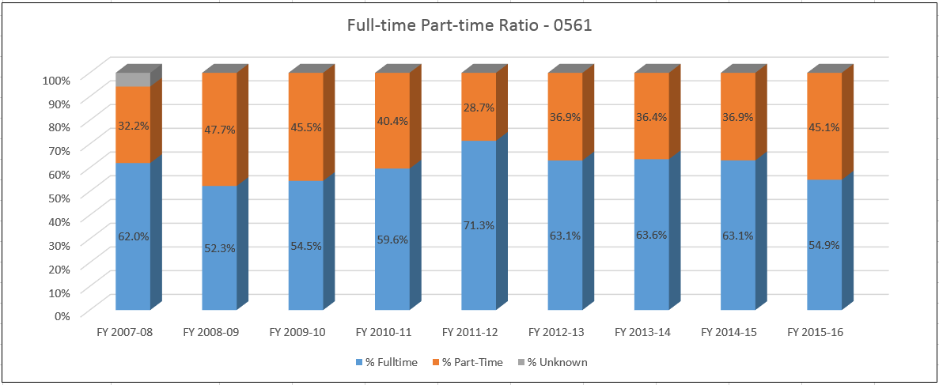

|  |  |
| --- | --- |
| **EET DEPARTMENT MEMBERS** | |
| **Paul Lawrence**  **Nick Reeder**  **Tillie Watts-Brown**  **Kenzie Grogean**  **Don Peters**  **Fahti Mohamed** | **Department Chair**  **Professor**  **Professor**  **Full Time EET Lab Technician**  **Full Time EET Lab Technician**  **EET ACF** |

Does your department have any departmental accreditations or other form of external review?

___X____ Yes ________ No

If yes, please briefly summarize any commendations or recommendations from your most recent accreditation or external review. Note any issues that the external review organization indicated need to be resolved. Is the department meeting all thresholds for accreditation?

The EET Program has been ABET accredited since 1967. Our reaccreditation last review was October 2016. The EET Program has met all thresholds for reaccreditation with the exception of the two weaknesses shown below. All actions to correct the weaknesses have been addressed and corrected.

**Weakness: PEO Review (EET):**

Provide a complete and clearly written documented process to be used systematically for the periodic review of the program educational objectives that ensures they remain consistent with the institutional mission, the program’s constituents’ needs and these criteria.

**Action:** Add to Division Assessment Plan

**Weakness: Advisory review of PEO’s (EET):**

Utilize your advisory committee to advise the program on the establishment, review, and revision of its program educational objectives.

**Action:** EET Advisory Meeting 11-4-16 – documented approval in minutes.

**Automation & Controls Technology w/Robotics (ACT)**

The mission of the Automation and Controls with Robotics department is to prepare students for successful careers in related advanced manufacturing fields. Specifically, this includes industrial maintenance technicians, plant maintenance technicians, robotics technicians, system integrators, supply chain technicians, and control system technicians and designers. The faculty strives to challenge each student to reach their potential, enhance their ability to think critically, develop the required skill set, and master the fundamentals of the technical curriculum. While some students take courses to enhance skills, others prepare to enter directly into the labor force, and still others prepare to transfer to a four-year institution for further study. To maintain the quality of the program and continue to ensure our graduates exceed the expectations of regional employers, the department is committed to lifelong learning, anticipating industry needs, incorporating leading edge technology and techniques for instruction and supporting professional development for both faculty and staff.

The ACT program has one full time faculty with several master’s degrees and over 20 years of industry experience. There is also one full time and one part time technician. With the recent increase in the demand for the ACT program, nineteen of the forty-five class offerings are taught by adjuncts and/or ACFs with industry experience which yields a ratio of 58% to 42% full time to part time faculty. (See table below.)

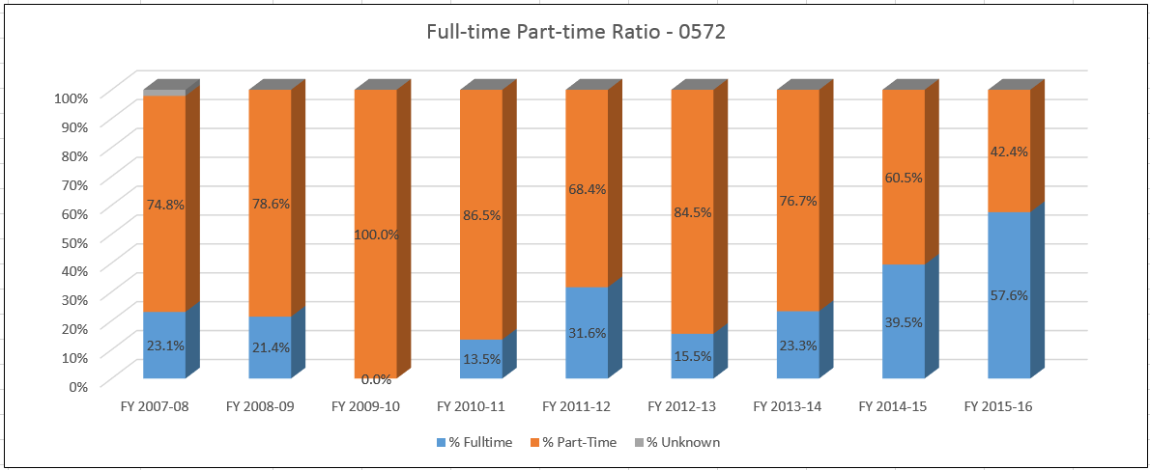

The ACT program offers an associate degree in automation and controls technology with robotics as well as two short-term certifications, one being for an Industrial Maintenance Technician and the other for an Industrial Robotics Technician. The associate’s degree program builds knowledge in the application of electrical and mechanical skills, industrial controls, machine vision systems, human machine interfacing, and controls system integration used in developing, installing, programming, and troubleshooting the complex machinery found in the modern advanced manufacturing environment. The program has 100 students (declared major) with an average age of 29. Whether they are attending Sinclair as regular students, as part of a retraining program, or in pursuit of a short term certification, the department is prepare these students to either enter the job market with a viable, in-demand skill set or continue their education at a four-year institution.

|  |
| --- |
| **ACT PROGRAM OFFERINGS** |
| **2-YEAR ASSOCIATES DEGREE** |
| **Automation and Controls Technology w/Robotics (AMCT.S.AAS)**  **60 Semester Credit HRS** |
| **SHORT TERM CERTIFICATES** |
| **Industrial Robot Technician 1-Year Certificate (IRT.STC)**  **34 Semester Credit HRS** |
| **Industrial Maintenance Technician Certificate (INDMT.S.STC)**  **25 Semester Credit HRS** |

|  |  |
| --- | --- |
| **ACT DEPARTMENT MEMBERS** | |
| **Paul Lawrence**  **Jake Fullard III**  **Harold Pearson**  **Victoria Collingsworth**  **Al Koehler** | **Department Chair**  **Assistant Professor**  **Full Time ACT Lab Technician**  **Part Time ACT Lab Technician**  **ACT ACF** |

* **The department’s one full time faculty has over 25 years of industry experience.**
* **There are also 5 adjunct instructors who average 10 years of industry experience.**

Does your department have any departmental accreditations or other form of external review?

________ Yes _____X___ No

If yes, please briefly summarize any commendations or recommendations from your most recent accreditation or external review. Note any issues that the external review organization indicated need to be resolved. Is the department meeting all thresholds for accreditation?

**Section III: Overview of Program**

1. **Analysis of environmental factors**

This analysis, initially developed in a collaborative meeting between the Assistant Provost of Accreditation and Assessment and the department chairperson, provides important background on the environmental factors surrounding the program. Department chairpersons and faculty members have an opportunity to revise and refine the analysis as part of the self-study process.

How well is the department responding to the (1) current and (2) emerging needs of the community? The college?

**Electronics Engineering Technology (EET)**

The Assistant Provost of Accreditation and Assessment facilitated an environmental scan at an Electronics and Robotics department meeting on September 23, 2016. The document summarizing the results of this exercise can be found in the appendix.

Key internal and external stakeholders of the EET program include:

* Students
* Faculty
* The Automation and Controls Technology program, which uses EET 1120, 1139, 1166, 1198, 2157, 2281, and 2282
* The Engineering University Transfer program, which uses EET 1150 and 1155
* The Heating, Ventilating, Air Conditioning & Refrigeration program, which uses EET 1120 and 1139
* The Unmanned Aerial Systems program, which uses EET 1120, 1158, and 2221
* The Radio Frequency Identification program, which uses EET 2157 and 2257
* The Master Electrical Contractors Association, which uses EET 1181, 1182, 1183, and 1184
* The Mechatronics Apprenticeship Program developed in coordination with Festo, which uses EET 1120, 1139, 1166, and 1198.
* The International Brotherhood of Electrical Workers Local 82
* The SME Internship program
* Employers who hire our students as interns and our graduates as employees
* The EET Advisory Board
* Local high schools that run many EET courses under the guise of College Credit Plus

The EET program continuously evaluates how well we are meeting the current and emerging needs of the community and college, through graduate surveys, employer surveys, advisory board meetings, and meetings with other internal and external stakeholders listed above. These evaluations consistently show a high level of satisfaction with the services the program provides. Students report that they have been well-prepared for the workforce or for transfer to four-year programs (primarily at the University of Dayton). Employers are favorably impressed with the knowledge and skills of our graduates, and demand for graduates exceeds the number we are supplying. Many of our students have one or more job offers by the time they graduate, and many of these offers come from companies with whom the students interned, demonstrating a high level of satisfaction on the part of employers.

As a result of discussions with employers located near Sinclair’s Warren County campus, we have realized for several years that there is a significant unmet demand for maintenance technicians in that geographical region. Therefore we have been offering courses in the Industrial Maintenance Technician short-term certificate program at the Mason campus. (This program includes four EET courses as well as several other SME courses.) Enrollment in these courses has been gradually increasing. Furthermore, in Fall 2016 we started offering courses in coordination with Festo, a German global supplier of pneumatics and automation-control technology that has a large facility in Mason. Eleven students, all employed by Mason-area companies, enrolled as the first cohort in this two-year apprenticeship program. We expect this program to thrive, and we expect that exposure the program has received in the local press will lead to interest among other employers who recognize the benefits of this sort of cooperative training program.

**Automation & Control Technology w/Robotics (ACT)**

The ACT program continuously evaluates how well we are meeting the needs of both the college and the community. On November 4, 2016, the Fall EET/ACT Advisory Board meeting was conducted where part of the agenda was to assess how well the program was meeting the needs of the community and, in turn, the college. The ACT program objectives were reviewed with the committee and their approval of these objectives was requested and unanimously granted. To assess the overall effectiveness of the ACT program, the following three questions were asked specifically of the advisory board members,

* How well is the ACT program responding to your current needs?
* What are your emerging needs?
* Do you have any suggested program modifications to meet any emerging needs?

Our employers expressed their overwhelming satisfaction with the quality of our graduates. They specifically said our graduates come to them with the required skill set to immediately be effective in an advanced manufacturing environment based on their strong understanding of the technical fundamentals of manufacturing. As a result, ACT graduates are in high demand and many times have multiple offers for employment upon graduation. This is supported by the fact that over the past two years, 70% of our graduates obtained permanent employment within 60 days of completion. This is also supported by the fact that three of the advisory board members were alumni of the ACT and/or EET programs.

In terms of emerging needs, members stated that the program was already properly positioned through its focus on PLC programming along with Robotics programming and repair. This is based on the fact that current advanced manufacturing methodologies and any potential expansion of a manufacturer’s automation is based on these two disciplines with automation and controls.

The one major area of concern expressed by committee members is that employers need more qualified manufacturing automation and controls talent than is currently available. It was suggested that we continue to leverage our current partnerships, employer relationships, and internship program to enhance promotion of the EET and ACT programs, career awareness, and talent availability. They were also happy to know that the ACT program offerings were now available at the Mason campus which they feel should help address talent concerns in Butler and Warren County as well as the Northern Cincinnati areas. They did however, strongly suggest that the Mason offerings needed increased marketing and community awareness as many of them had no idea that ACT programs are now offered at the Mason location.

**Section IV: Department Quality**

**PLEASE REFER TO THE DATA BELOW IN RESPONDING TO THE QUESTIONS IN THIS SECTION OF THE SELF-STUDY. DATA INCLUDES:**

* **Number of registrations (also known as seatcount or duplicated headcount) for the budget code by fiscal year**
* **Full-time Equivalents (FTE) (credit hours divided by 15) for the budget code by fiscal year**
* **Average Class Size (ACS) (average section size with appropriate adjustments) for the budget code by fiscal year**
* **Full-time/Part-time Ratio (percent of payload hours taught by full-time and adjunct faculty) for the budget code by fiscal year**

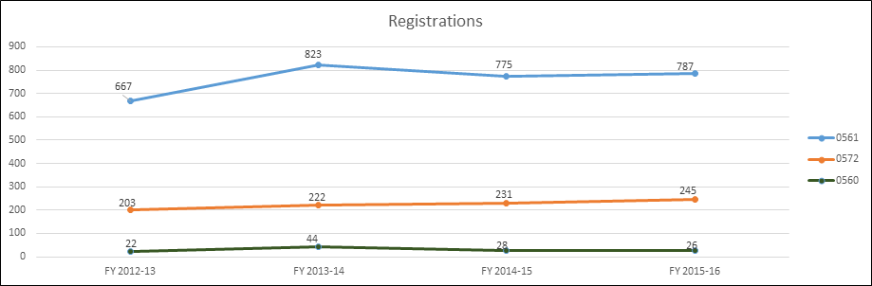

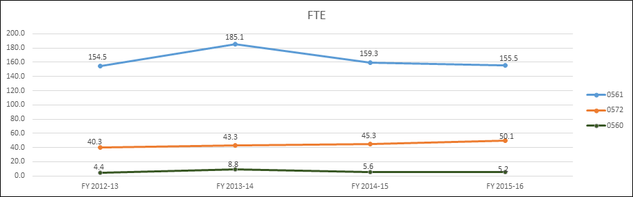

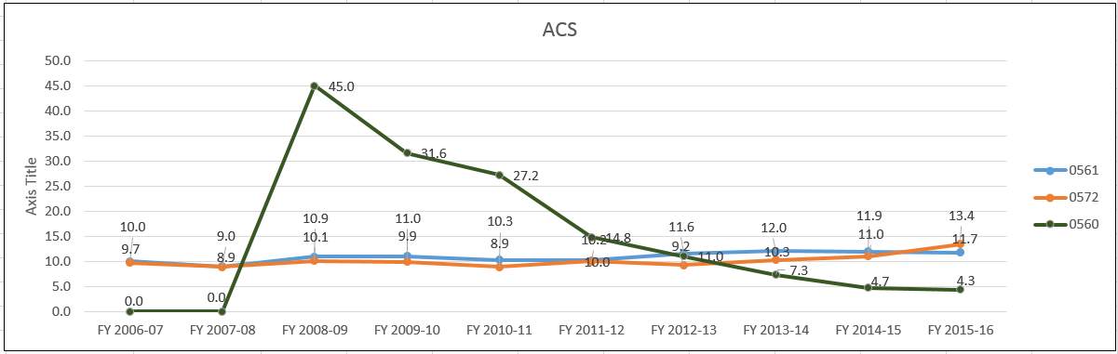





1. **Evidence of student demand for the program**

How has/is student demand for the program changing? Why? Should the department take steps to increase the demand? Decrease the demand? Eliminate the program? What is the likely future demand for this program and why?

**Electronics Engineering Technology (EET)**

For the last few years the student demand for the EET program has been changing due to changes of the job market. The program’s enrollment goes up at both extremes. If the market is bad people are out of work and go back to school. If the market is hot the employers are paying premium salaries and enrollment goes up. If the job market is in the middle enrollment goes down. The recent job market improvements has led the department to make some updates in our program in order to meet the industry’s needs. The EET department has developed relationships with several high schools in the Dayton area, for example: Miami Valley Career Technical Center (MVCTC), Dayton Public Schools, Centerville High School, Kettering Fairmont High School, and Stebbins High School. The high school student earns credit in courses like DC and AC circuits courses (EET1150 and EET 1155), Digital Electronics (EET1131), Digital Technology, Personal Computer Troubleshooting and Repair, and Programmable Logic Controllers. This accomplishes two goals the first being that now the student have a head start on their degree and second is that we have made a Sinclair connection with them.

Sinclair is also partnering with Wright State to offer EGR 1101 Introductory Mathematics for Engineering Applications and a calculus-based introductory engineering courses for Wright State’s engineering science program. Presently we offer Circuit Analysis EGR 2201 and will be offering Digital Analysis EGR 1231 in the Fall of 2017.

Regarding the future demand for EET program, we expect it will continue go up due to industry employers seeking to hire our students to meet their needs. Our challenge now is not creating demand for graduates but the student to file that demand. Presently we have more demand for our graduates than we have graduates. Also, even though the economy in the Dayton area is improving there are still laid-off workers returning to school to learn new skills to increase their employment opportunities. Many of the laid-off workers are coming to Sinclair to get a degree or a certificate and using some of their on-the-job training and experience to obtain great jobs after completing our program.

**Automation & Controls Technology w/Robotics (ACT)**

After a three-year decline from 2009 until 2012, ACT has experienced an increase in student demand for the various ACT program offerings as depicted in the table below. This can also be seen in the increase in enrollment and student completion (See section I). Many students come to Sinclair’s ACT programs as a result of the increased community awareness of the good ACT-related jobs available in the Dayton metropolitan area and beyond.

We have also seen an increased interest in our Industrial Maintenance Technician and Industrial Robotics Technician short term certificates among our students who already have jobs but seek to acquire the ACT technician skill set to move into positions that significantly increase their earning potential and opportunity for career advancement.

**ACT Registrations**

|  |  |  |  |  |
| --- | --- | --- | --- | --- |
| **Year** | **FY12-13** | **FY13-14** | **FY14-15** | **FY15-16** |
| **Registrations** | **203** | **222** | **231** | **245** |
| **% Increase** |  | **9.36%** | **4.05%** | **6.06%** |

1. **Evidence of program quality from external sources (e.g., advisory committees, accrediting agencies, etc.)**

What evidence does the department have about evaluations or perceptions of department/program quality from sources outside the department? In addition to off-campus sources, include perceptions of quality by other departments/programs on campus where those departments are consumers of the instruction offered by the department.

**Electronics Engineering Technology (EET)**

Sinclair has been ABET accredited since 1967. Sinclair’s pending reaccreditation by TAC/ABET in 2016 for six more years is testimony to the quality of the EET program.

Due to the fast changing field of electronics engineering technology, the advisory committee’s active participation is essential to keep the EET and ACT program up to date and meeting employer needs. The makeup of the advisory committee needs to be constantly changed as the technology emphasis of the region changes. The advisory committee for both EET and ACT reviews all proposed changes and approves the changes. The demand from area industry and from local colleges attests to the value of the courses.

Articulation agreements exist between Sinclair and many of the local four-year schools including UD, Miami, Wright State, University of Cincinnati, University of Toledo, and Purdue. Comments from the four years schools tell us that Sinclair graduates do as well as or better than the program population already enrolled in the four year school.

**Automation & Controls Technology w/Robotics (ACT)**

ACT Department personnel work closely with its advisory committee members, employers, and other associate educational institutions (College Credit Plus schools and articulation agreement four-year institutions). We rely on them to give us continuous feedback on the quality of our program offerings through discussions about related curriculums and programs which lend themselves to current and potential articulation agreements and formal surveys of employers of our graduates and internship students.

Other external evidence of program of program quality includes:

* Both Wright University and the University of Dayton refer their engineering students to various courses in the ACT program to satisfy their technical elective requirements.
* Companies come to us for help in developing their apprenticeship program. The most recent example of this is our partnerships with United Technologies Corporation, Meca, JATC IBEW Local 82, and the German company Festo that resulted in the ACT programs now being offered at the Mason campus which now serve as the academic requirements of their apprenticeship program.
* Currently working on an apprenticeship program for D Max

1. **Evidence of the placement/transfer of graduates**

What evidence does the department/program have regarding the extent to which its students transfer to other institutions? What evidence does the department have regarding the rate of employment of its graduates? What data is available regarding the performance of graduates who have transferred and/or become employed? What data is available from RAR graduate surveys?

**Electronics Engineering Technology (EET)**

Of the graduates that go on to four year institutions most transfer to BSEET programs at University of Dayton or Miami University Middletown campus. No data is available for how well our students perform. Comments from the four years schools tell us that Sinclair graduates do as well as or better than the program population already enrolled in the four year school.

We have no data available regarding the success of graduates 3 to 5 year after graduation. We do know that 95% of our graduates not going to a four year school are employed prior to graduation. Many will have to choose from multiple offers. The only data we have is comments from employers requesting more of our graduates or from our graduates telling us how much success they have at their present job. Regarding the grad information from RAR, the data is not good because the graduates do not fill out or respond to the survey.

**Automation & Controls Technology w/Robotics (ACT)**

Historically, data on placement and/or transfer of ACT graduates to four-year institutions has been incomplete, at best. Responses to graduate surveys has been very low so we have not been able to confidently analyze and put faith in the results. However, we do realize the importance of monitoring and analyzing the post-graduate effects of having completed the program. To address this matter, starting in the Spring 2017 semester the following process will be initiated to promote increased truthful responses to our graduate surveys.

* The instructor of the ACT Capstone course, EGR 2278 will reinforce the importance of truthfully responding to and submitting graduate surveys.
* The instructor will request the current personal contact information.
* The instructor will request that a copy of the completed surveys be submitted to the instructor
* Upon receipt of the completed survey, the instructor will send a “Thank You” follow-up notification to each respondent.

Despite the lack of viable input from graduate surveys, in preparation for this program review, ACT graduates from the past two years were contacted by faculty directly by phone and questioned about their post-graduation academic and/or employment activity. The results are as follows:

|  |  |
| --- | --- |
| **ACT POST GRADUTION STUDENT ACTIVITY:** | |
| **Employed in manufacturing** | **87.4%** |
| **Pursuing advanced education in manufacturing** | **6.4%** |
| **Leaving manufacturing** | **6.2%** |

Employers often contact us for information on upcoming graduates. In addition to the fact that, faculty provides employment assistance in the form of resume writing, interviewing skills and direct placement contacts with employers, informal indications from students, interns, and employers show that placement rates for our grads are extremely high. We believe this is one of the major factors in the increased enrollment and public interest in the ACT program among regional employers.

1. **Evidence of the cost-effectiveness of the department/program**

What is the department doing to manage costs? What additional efforts could be made to control costs? What factors drive the costs for the department, and how does that influence how resources are allocated? What has the Average Class Size been for the department since the last Program Review, and what are steps that the department could take to increase Average Class Size? Has the department experienced any challenges in following the Two-Year Course Planning Guide?

**Electronics Engineering Technology (EET)**

The biggest cost factor for the Electronic Engineering Technology Program is faculty cost. For year the department had a full time to part time ratio much higher than the school average. In the past year three tenure track faculty have retired. The plan is to replace one in EET, to transfer the one faculty position to ACT to cover the increase in enrollment at the Dayton campus and at Courseview, and not replace the third. This will reduce cost while keeping the department in a strong position.

In regards to average class size with our present enrollment, the EET department does not offer multiple sections, so managing class size looks different for us. We tend to manage when the course is offered to maximize the enrollment. Instead of offering a course every semester we may only offer it once a year. This was difficult for the students a first but if they know the course is only offered in the Fall they can plan. There are still cases where a few students need a class to graduate and we will run a low enrollment class.

**Automation & Controls Technology w/Robotics (ACT)**

Due to the nature of our discipline, the ACT department incurs cost from equipment, labs, materials, and technicians in addition to faculty and administration. However, we characterize our department as being cost-effective in that we do what we can to effectively manage those cost. This is demonstrated by the following two tables which show increases, though small, in both FTEs and average class sizes.

|  |  |  |  |  |
| --- | --- | --- | --- | --- |
| **ACT** | **FY12-13** | **FY13-14** | **FY14-15** | **FY15-16** |
| **FTEs** | **40.3** | **43.3** | **45.3** | **50.1** |
| **AVERAGE CLASS SIZE** | **9.2** | **10.3** | **11.0** | **11.7** |

One important aspect of cost-effectiveness is the average class size calculation. ACT’s recent performance in this area is shown in the table above. For the ACT Department, managing the average class size is a challenge due to several factors. Most of our classes have a relatively low capacity due to safety and equipment constraints. In addition to this, some of our higher-level classes are only offered once per year so there is pressure to run courses even with a small class size to help our students to complete their programs. There are certain actions that we are undertaking to manage the average class size. We have an added focus on how we schedule classes to make sure we don’t schedule too many sections at any given time. ACT faculty also advise all students to meet with their academic advisors within the first three weeks of the start of each semester to foster the scheduling of upcoming classes match up with projected course availability. This relates to another scheduling challenge in trying to adhere to the two-year planning guide. While being under pressure to offer fewer classes to manage average class size, we are also under pressure to adhere to the scheduling of classes in accordance to the two-year planning guide, which represents two-year old planning.

**Section V: Department/Program Status and Goals**

1. **List the department’s/program’s strengths, weaknesses, opportunities, and threats (SWOT analysis).**

**Electronics Engineering Technology (EET)**

|  |  |  |
| --- | --- | --- |
|  |  |  |
|  | ***Strengths***   * Knowledgeable faculty (over 20 years of industry experience). * Resource Center * Well equipped labs * Low tuition cost. * Strong reputqtion with industry employers. * Strong internship program. * Flexible class times. * Strong presence among regional high schools and training centers. | ***Opportunities***   * Expansion of College Credit Plus program offerings. * Collaborations with employers i.e. Projects Unlimited and L3 in Warren County. * Strong demand for skilled EET technicians in the region. * Expansion of the EET internship program |
|  | ***Weaknesses***   * Limited geographical area (Limited # of classes offered at Mason campus) * Difficult to find adjunct instructors to teach during the day * Marketing of program to increase enrollment in EET | ***Threats***   * Decrease in state funding. * Competition in adult technology career centers. * Negative public perception of jobs available to graduates * Cyclical manufacturing economy. |

**Automation and Controls Technology w/Robotics (ATC)**

|  |  |  |
| --- | --- | --- |
|  |  |  |
|  | ***Strengths***   * Knowledgeable faculty (over 20 years of industry experience). * Modern facilities. * Low tuition cost. * Strong brand name recognition among local industry. * Strong ties with industry and employers. * Strong internship program. * Flexible class times. * Strong presence among regional high schools and training centers. | ***Opportunities***   * Expansion of College Credit Plus program offerings. * Collaborations with employers i.e. Festo and United Technologies. * Collaboration with other technical areas for service learning opportunities * Strong demand for skilled ACT technicians in the region. * Expansion of the ACT internship program to increase OJT opportunities * MVCTC Adult Ed articulation. * Festo partnership in training |
|  | ***Weaknesses***   * Limited geographical area (Limited # of classes offered at Mason campus) * Difficult to find faculty with industry experience. * Ineffective marketing of program offerings at Mason Campus. * Web presence. | ***Threats***   * Decrease in state funding. * Competition in adult technology career centers. * Negative public perception of manufacturing. * Cyclical manufacturing economy. * New Advanced Manufacturing program at Clark State. |

1. **List noteworthy innovations in instruction, curriculum and student learning over the last five years (including student awards, faculty awards, etc.).**

**Electronics Engineering Technology (EET)**

* Expanded the use of portfolios from EET 1116 and EET 1164 to EET 1150 and EET1155 and EET 2201
* EGR 2201 Circuit Analysis was developed in 2014 and since 2015 we need to run two sections every semester to keep up with the demand.
* Expanded the use of portfolios in more courses.
* MET 2711 Ethics for Engineering Technology Professional was added to the curriculum to discuss and assess the cultural diversity and global citizen aspects of the technical ACT curriculum and associated professions.

**Automation and Controls Technology w/Robotics (ATC)**

* Updated EET 2282 Advanced PLC course to incorporate current equipment platforms (AB ControlLogix 5000 and Panelview Plus Human Machine Interface systems) and programming methodologies
* Added electrical schematic drawing course MET 1371 CAD Concepts in Auto CAD which is the industry standard used to create and modify electrical prints to replace a 3D Inventor mechanical schematic drawing course commonly used in mechanical engineering
* Modified EGR 1128 Computer Integrated Manufacturing course to incorporate a module to enhance career awareness of Supply Chain Management Technician and other ACT-related careers in support of a National Science Foundation grant awarded to Sinclair’s business school.
* Expanded the EGR 1166 Industrial Wiring and Panel Building course from 2 credit hour to 3 credit hours to incorporate the proper use of measurement, hand tools, power tools, and general construction tools used in the design and building of electrical control panels.
* MET 2711 Ethics for Engineering Technology Professional was added to the curriculum to discuss and asses the cultural diversity and global citizen aspects of the technical ACT curriculum and associated professions.
* Developed an innovative apprenticeship program with the Festo Corporation through the creation of a Mechatronics program by leveraging the existing ACT associate degree curriculum.
* Service learning project with Synergy Family Therapy through interfacing of the EGR 2278 ACT Capstone course’s project requirements.
* Leveraging of Engineer’s Day student visits to create an ACT “Direct Contact Recruiting” (DCR) program where ACT faculty present to elementary, middle, and high school students in their home locations to promote Sinclair and the various ACT program offerings. In 2015, 5 visits were undertaken and 9 in 2016. On November 18, 2016, Engineer’s Day yielded visits from over 350 students from 16 different high schools. As a result of the visits to the ACT Robotics Lab, ACT faculty have already been scheduled for 5 visits to different high schools in the first 3 months of 2017.

1. **What are the department’s/program’s goals and rationale for expanding and improving student learning, including new courses, programs, delivery formats and locations? Are there unmet goals from the most recent Program Review? Please note that the department goals listed in this section will be reviewed for progress on Annual Updates and in your next Program Review.**

**Electronics Engineering Technology (EET)**

* EGR 1231 Digital Analysis has been developed to run in the Fall of 2017. We expect this course to need to run two sections per semester to keep up with the demand.
* The EET department will improve processes and procedures to improve retention and completion of students in ACT curriculums with an emphasis on improving and documenting faculty advising

**Automation and Controls Technology w/Robotics (ACT)**

* The ACT department will continue to expand the number of ACT courses offered at the Mason Courseview campus to meet the needs of current and future Mason ACT students and employers in the Warren, Butler, and Northern Cincinnati areas.
* The ACT department will improve processes and procedures to improve retention and completion of students in ACT curriculums with an emphasis on: Improving and documenting faculty advising.
* Work with D Max to develop an apprentice program.

1. **What resources and other assistance are needed to accomplish the department’s/program’s goals?**

**Electronics Engineering Technology (EET)**

* An aggressive marketing plan is needed to recruit the students needed to satisfy industries demand for graduates.
* As more EUT, University of Dayton, and Wright State students sign up for the EGR 2201 and EGR 1231 courses the department may need additional faculty

**Automation and Controls Technology w/Robotics (ACT)**

* An aggressive marketing plan is need to recruit the students needed to satisfy industries demand for graduates
* There is a need for additional ACT faculty to cover the increase in the enrollment at the Dayton campus, the increase in enrollment in the Industrial Maintenance Technician program at Courseview, and to cover the Mechatronics apprenticeship program with Festo as it ramps up.

**Section VI: Appendices: Supporting Documentation**

**PROGRAM REVIEW - ENVIRONMENTAL SCANNING TEMPLATE 2016**

**Department: 0561-Electronic Technology - 0572-Automation & Control Technology - 0560-ATI**

|  |  |
| --- | --- |
| **Who are your key internal stakeholders?** | **Students**  **Faculty**  **EET – EUT program uses a great number of courses that are EGR courses.**  **ACT – supply courses for the HVAC program and that UAS programs (Basic AC/DC, Sensors and Systems, Introduction to UAS).**  **EET – Aerospace Visualization (Satellite Toolkit) for UAS.**  **EET supports ACT.**  **Internships** |
| **How do you know if you are meeting their needs?** | **STUDENTS:**  **Job placements – anecdotal**  **Employers – ask us to send more students. We could provide more graduates if we could attract more students, more demand than supply.**  **EUT - Talk with program director all the time, Nick is on the Advisory board.**  **ACT/EET - Department meetings for EET/ACT supports.**  **UAS – chair constantly talks with AVT chair. Collaborated to get curriculum developed by a third party.**  **Internships – work closely with Chad Bridgeman** |
| **Who are your key external stakeholders?** | **Companies students do internships with - large number of small companies. Projects Unlimited for EET, L3 for ACT, leads to jobs for many students. COP Communication is another, are on the advisory board.**  **Advisory Board - bi-annual meetings.**  **IEEE – have a student section**  **IBEW union, Local 82.**  **High schools – running a large number of CCP courses.**  **MECA**  **FESTO** |
| **How do you know if you are meeting their needs?** | **Internship companies – some of them on Advisory Committee. Get really good feedback from the employers. As an example, one student got sent back, worked with employer to find out what the problem is.**  **IBEW – offer articulated credit to their apprentices, have their apprentices come and we articulate classes, get into EET and ACT programs. At one time taught classes for them, now we consult.**  **MECA – Facilitate their apprenticeship program, have equipment and facilities, register their students.**  **FESTO – just getting off the ground.** |
| **What challenges or support concerns do you have? Who feeds your program? Which courses/departments outside of your own are you reliant on for educating students in your programs?** | **Rely on MAT, ENG, COM. Couple of mechanical engineering courses we use. Physics. There is some give and take, sometimes we have to accommodate their needs and they accommodate ours. Example, Tech math and Tech math faded away, we had to make some accommodations.**  **Academic advising – have been great lately!**  **IT department – have really stepped up their game, have gotten much better. Gotten better, but there are still too many surprises, not always good communication when they make changes. At least now we have someone who will return our calls.** |
| **What opportunities exist to help your stakeholders that you are not currently exploring? How do you know?** | **Nothing really, things may surface during development of self-study.**  **MORE DEMAND FOR STUDENTS THAN WE HAVE STUDENTS – wish we could have more recruitment.** |
| **What data are you currently using to inform your decision making? Where is your data weakest?** | **First Program Review for some faculty, would like reports that we would see the data that is provided in the self-study annually, would be good if the data included in the self-study were more readily available on an ongoing basis, rather than just seeing it every five years.**  **Better graduate information.**  **Where are our students coming from?**  **ITT Tech, for-profits shutting down, Sinclair looking at it, would be good to know what Sinclair is doing, we don’t have a lot of spare time, it isn’t easy for us to respond at the last minute, would be helpful if we knew sooner what we will be expected to do.**  **ITT not transferrable in the past.** |
| **If you had this info, what actions could you take as a result of collecting this data?** | **What we use as a point of focus in the recruiting of students would be more effective if we had some of the data we would like to have– currently just sitting at a table at an event isn’t cutting it.**  **Would like more information on recruitment, where our students are coming from.**  **CCP – seem to have a huge yield in terms of recruitment. What institutional support would be available to expand CCP offerings?** |

**SME EET Proficiency Exam Analysis 2013-2015**

**Overview**

This exam is a third-party nationally-normed proficiency examination specifically for two-year EET programs. It is intended to aid colleges to assess their program breadth and depth through a series of 120 multiple-choice questions covering all aspects of EET curricula. The tested body of knowledge is not tied to any specific accreditation program and exceeds in breadth that covered by a typical EET curriculum. At Sinclair, EET Capstone Project students take the exam, normally in their last semester at Sinclair. The exam has been given annually since 2013. The mean outcome is a raw score of 44% correct responses. Sinclair’s mean score to date is 45%.

This evaluation records cumulative responses of all examinees since 2013 (three iterations). Responses are presented in seven broad areas, with several sub-areas in each. First we examine the overall scores in the seven major areas. Then we look at performance in the tested sub-areas. For each of the lowest scoring categories, a brief analysis and assessment is followed by recommended actions to improve the weakest topic areas.

**Summary of results.**

Thirty-eight Sinclair students have taken the exam: 11 students in 2013, 16 students in 2014, and 11 students in 2015.

**This table summarizes the 38 students’ performance in the exam’s seven major areas**. Lowest-performing areas are marked by a color background.

|  |  |  |  |
| --- | --- | --- | --- |
| Area | Number of questions seen | Number of questions answered correctly | Percentage of questions answered correctly |
| Basic Concepts of Electricity | 608 | 357 | 58.72% |
| **Alternating Current (AC) Circuit Concepts** | 608 | 212 | 34.87% |
| **Basic Circuit Analysis Methods** | 304 | 97 | 31.91% |
| Digital Electronics | 988 | 584 | 59.11% |
| **Analog Electronics** | 798 | 245 | 30.70% |
| Microcontrollers and Microprocessors | 722 | 377 | 52.22% |
| **Instrumentation and Measurements** | 532 | 165 | 31.02% |

**Analysis.**

The weakest performance occurred in the following four areas: Alternating Current (AC) Circuit Concepts, Basic Circuit Analysis Methods, Analog Electronics, and Instrumentation and Measurements. Weakness in these areas could probably have been anticipated, since AC Circuits, Circuit Analysis Methods, and Analog Electronics require more mathematics than the other areas, and since some sub-areas within Instrumentation and Measurements do not receive much emphasis in our program.

**The following table summarizes students’ performance in the sub-areas of AC Circuit Concepts:**

| Sub-Area within AC Circuit Concepts | Number of questions seen | Number of questions answered correctly | Percentage of questions answered correctly |
| --- | --- | --- | --- |
| Sinusoidal Concepts | 76 | 30 | 39.47% |
| Inductance and Inductors | 38 | 16 | 42.11% |
| Energy Consumption and Storage | 38 | 15 | 39.47% |
| Capacitive and Inductive Reactance | 114 | 47 | 41.23% |
| **AC Impedance/Admittance** | 76 | 11 | 14.47% |
| Phase Relationships | 38 | 25 | 65.79% |
| Simplified RC and RL Transients | 38 | 13 | 34.21% |
| **Complex Numbers and Phasors** | 38 | 6 | 15.79% |
| **AC Power, Power Factor and Power Triangle** | 38 | 7 | 18.42% |
| Maximum Power Transfer | 38 | 19 | 50.00% |
|  |  |  |  |
| Series and Parallel Resonance | 76 | 23 | 30.26% |

**Analysis.**

Not surprisingly, performance was weakest on the more mathematical sub-areas (AC Impedance/Admittance, Complex Numbers and Phasors, and the Power Triangle) within this area. The highest mathematics course that students must take before taking EET 1155 is MAT 1270 (Beginning Algebra). Therefore, many students do not come into EET 1155 with the background in trigonometry needed to understand Complex Numbers, Phasors, and the Power Triangle.

**The following table summarizes students’ performance in the sub-areas of** **Basic Circuit Analysis Methods:**

|  |  |  |  |
| --- | --- | --- | --- |
| Sub-Area within Basic Circuit Analysis Methods | Number of questions seen | Number of questions answered correctly | Percentage of questions answered correctly |
| Ideal and Practical Source Models | 38 | 13 | 34.21% |
| Kirchhoff’s Laws | 38 | 9 | 23.68% |
| Voltage and Current Divider Rules | 38 | 5 | 13.16% |
| Mesh Current Analysis | 38 | 9 | 23.68% |
| Node Voltage Analysis | 38 | 14 | 36.84% |
| Thevenin and Norton Theorems | 38 | 16 | 42.11% |
| Superposition | 38 | 13 | 34.21% |
| Bridge and Ladder Networks | 38 | 18 | 47.37% |

**Analysis.**

Surprisingly, performance was weakest on Kirchhoff’s Laws and the Voltage and Current Divider Rules, techniques that are more fundamental than and are presumably given greater emphasis than more advanced techniques such as Thevenin and Norton Theorems, for which performance was considerably better.

**The following table summarizes students’ performance in the sub-areas of Analog Electronics:**

|  |  |  |  |
| --- | --- | --- | --- |
| Sub-Area within Analog Electronics | Number of questions seen | Number of questions answered correctly | Percentage of questions answered correctly |
| Semiconductor Theory | 38 | 17 | 44.74% |
| The Semiconductor Diode | 38 | 12 | 31.58% |
| Voltage Rectification and Regulation Concepts | 38 | 11 | 28.95% |
| The Bipolar Junction Transistor | 76 | 20 | 26.32% |
| The Field Effect Transistor | 76 | 22 | 28.95% |
| **Discrete-Device Amplifier Concepts, Design and Operation** | 76 | 15 | 19.74% |
| Ideal Operational Amplifiers | 38 | 16 | 42.11% |
| Actual Operational Amplifiers | 38 | 18 | 47.37% |
| Basic Operational Amplifier Circuits | 38 | 15 | 39.47% |
| Advanced Operational Amplifier Circuits | 76 | 24 | 31.58% |
| Special Purpose Amplifiers | 76 | 27 | 35.53% |
| **Frequency Response** | 38 | 8 | 21.05% |
| Precision Diode Circuits | 76 | 23 | 30.26% |
| Power Supply and Regulator Circuits | 38 | 11 | 28.95% |
| **Timers and Relaxation Oscillators** | 38 | 6 | 15.79% |

**Analysis.**

The number and complexity of sub-areas within Analog Electronics makes it unlikely that students in a two-year degree program will be competent in each of these sub-areas after taking a one-semester course devoted to these topics. Therefore, emphasis should be given to the sub-areas that are most important for electronics technicians. For example, the weak performance in Discrete-Device Amplifier Concepts, Design and Operation is not of great concern, since few electronics technicians will be expected to design discrete-component amplifiers on the job. On the other hand, it’s appropriate that performance should be strongest in the sub-areas dealing with op amps and op-amp circuits, since op amps are very widely used. Of greater concern is the weak performance in Frequency Response, since technicians should be conversant in this topic, and in Timers and Relaxation Oscillators, since students are exposed to this topic in both EET 1131 (Digital Electronics) and EET 2201 (Electronic Devices and Circuits).

**The following table summarizes students’ performance in the sub-areas within Instrumentation and Measurements:**

| Sub-Area within Instrumentation and Measurements | Number of questions seen | Number of questions answered correctly | Percentage of questions answered correctly |
| --- | --- | --- | --- |
| Measurement Parameters | 114 | 46 | 40.35% |
| Roundoff Strategies | 76 | 24 | 31.58% |
| Statistical Measures of Data | 76 | 21 | 27.63% |
| Basic Passive DC Instruments | 38 | 6 | 15.79% |
| Multimeters | 38 | 20 | 52.63% |
| Oscilloscope Specifications and Measurements | 38 | 12 | 31.58% |
| Frequency Response Measurements | 38 | 11 | 28.95% |
| Spectrum Measurements | 76 | 20 | 26.32% |
| Miscellaneous Electrical/Electronic Instruments | 38 | 5 | 13.16% |

**Analysis.**

Not surprisingly, performance was weakest in areas that receive relatively light coverage in our program: Basic Passive DC Instruments (which encompasses the d’Arsonval galvanometer dc ammeter and how DC voltmeters and ohmmeters are derived from a dc ammeter) and Miscellaneous Electrical/Electronic Instruments (which encompasses systems that measure temperature, pressure, flow, and strain/force). As a department we should decide whether these topics are important enough to merit greater emphasis in the program.

**Recommendations.**

1. **Weakness:**

Highest priority should be given to Basic Circuit Analysis Methods, particularly Kirchhoff’s Laws and the Voltage and Current Divider Rules. These elementary techniques are essential to success in other areas, including AC Circuits and Analog Electronics.

**Action Plan:**

1. Make MAT 1580 a pre-requisite for EET 1155 (AC Circuits)
2. Reinforce Kirchhoff’s Laws and Voltage and Current Divider Rules in EET 1155
3. Reinforce Kirchhoff’s Laws and Voltage and Current Divider Rules in EET 2201
4. Reinforce Kirchhoff’s Laws and Voltage and Current Divider Rules in EET 2259

**Goal:**

50% increase of students’ scores from current 2013-2015 in 2 years.

1. **Weakness:**

Low performance in the area of AC Impedance/Admittance.

Make MAT 1580 (Precalculus) a pre-requisite for EET 1155 (A.C. Circuits) or for EET 1150 (D.C. Circuits), which is a pre-requisite for EET 1155. Currently, significant time must be devoted in EET 1155 to teaching trigonometry, which is essential for analyzing A.C. Circuits. If MAT 1580 is made a pre-requisite for EET 1155, students will be better prepared to succeed in the course, which should improve performance on the AC Circuits area of the assessment exam. Furthermore, the time saved from not having to teach trigonometry can be devoted to Basic Circuit Analysis Methods, which students will have seen once already in EET 1150 and which are revisited in EET 1155.

**Action Plan:**

Make MAT 1580 a pre-requisite for EET 1155 (AC Circuits)

**Goal:**

50% increase of students’ scores from current 2013-2015 in 2 years.

1. **Weakness**

Low performance in Timers and Relaxation Oscillators

**Action Plan:**

1. Include Timers and Relaxation Oscillators in EET 1131
2. Add Timers and Relaxation Oscillators in EET 1131 Master Syllabus
3. Provide the students additional practice with Timers and Relaxation Oscillators again in EET 2201

**Goal:**

50% increase of students’ scores from current 2013-2015 in 2 years.

1. **Weakness**

Low performance in the area Frequency Response.

**Action Plan**

Provide the students additional practice with Frequency Response in EET 2201

**Goal:**

50% increase of students’ scores from current 2013-2015 in 2 years.

**Summary Observation**

In reviewing the summary of results, one could infer a “resentcy factor.” Microcontroller courses are usually taken concurrent with or the semester before the capstone, hence may be easier to recall. The lowest scores come from “basic circuit analysis methods” topics introduced earliest. (*Exception:* By this reasoning, analog electronics should be stronger. But as noted, analog is a complex topic to retain after only one term of exposure.) Therefore, to refresh early topics, consider implementing in second-year courses an intentional, planned, progressive, and coordinated reinforcement of elementary topics