Department/Program Review
Self-Study Report

2016 – 2017

Department: 0576- Industrial Engineering Technology

Section I: Annually Reviewed Information

A: Department Trend Data, Interpretation, and Analysis

Degree and Certificate Completion Trend Data – OVERALL SUMMARY

Please provide an interpretation and analysis of the Degree and Certificate Completion Trend Data: i.e. What trends do you see in the above data? Are there internal or external factors that account for these trends? What are the implications for the department? What actions have the department taken that have influenced these trends? What strategies will the department implement as a result of this data?

Please be sure to address strategies you are currently implementing to increase completions of degrees and certificates. What plans are you developing for improving student success in this regard?

Overall

This department/program review self-study document addresses the Industrial Engineering Technology department. The department had previously been named Operations Technology (from FA/2007 - SU/2016), but due to input from advisors, students, faculty, and employers, the department decided to revert to its previous name of Industrial Engineering Technology, effective FA/2016. The name Industrial Engineering Technology is more descriptive of our career field, it coincides with more position titles, and it better aligns with our main transfer institution (University of Dayton). Due to restrictions from the Higher Learning Commission, we are unable to change the three letter prefix of our courses, so throughout this document the term OPT will refer to the Industrial Engineering Technology program and its courses. Where possible, the term IET/OPT will be used in attempt to minimize confusion.

Completion Trends

The IET/OPT department has been experiencing a decline in completions over the past several years except for a spike in FY 10-11, as shown in the preceding graph. This trend is echoed in the FTE enrollment data presented in Section IV, and detailed data on completion and success rates can be found in Appendix A.

The spike in completions can be attributed to two factors - semester conversion and displaced workers. During the three years prior to the semester conversion in FA/2012, the IET/OPT department experienced its three highest years of completion, as students pushed for graduation under the quarter system. But the biggest reason for the one year completion spike in FY 10-11 is that the IET/OPT department enrolled many displaced workers after the financial crash in 2008. Many of those students were on various government assistance programs that required then to take a full load of classes and therefore most of them completed their degrees in FY 10-11.

But even if the spike in completions in FY 10-11 is disregarded due to assignable causes, the department is still concerned about the overall declining number of completions. This has been the major concern of the department for several years. Some factors that account for this trend include:
- the long-standing, negative stigma of manufacturing held by many people in the region,
- the focus on Project Lead The Way in technical high school programs, which prepares and directs students for college programs in engineering and not technology,
- the confusion regarding the program name "Operations Technology" from 2007-2016,
- the reduction in the number of other departments using IET/OPT courses due to the state restrictions in the total number of credit hours allowed in associate degrees,
- the increasing trend of students coming to the IET/OPT department to only take selective courses to build their resumes and not complete a degree or certificate,
- and the cumulative effect of class cancellations due to low enrollment.

To address this trend, the department has been participating in marketing and outreach opportunities such as high school events, college open houses, Tech Fest, and Tech Prep events. We have an active partnership with the University of Dayton and many of our graduates transfer there in either Industrial Engineering Technology or Global Manufacturing Systems. We have an active Advisory Committee that provides program guidance and validates the appropriateness of our curriculum. We have streamlined the curriculum and we have changed the name of the program. We are looking at bringing in newer technology to attract students. We continue to offer classes in high schools wherever we can and are beginning to offer classes at Courseview. Also, we have benchmarked with other institutions. These activities are crucial for making sure we have the right program for maintaining our presence in the community and attracting new students. Despite these efforts we continue to see declining numbers both in completion and enrollment.

Course Success Trend Data – OVERALL SUMMARY

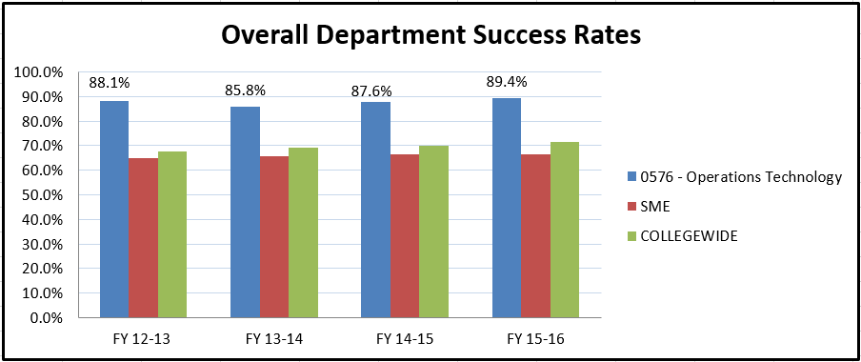

Please provide an interpretation and analysis of the Course Success Trend Data. Please discuss trends for high enrollment courses, courses used extensively by other departments, and courses where there have been substantial changes in success.
Please be sure to address strategies you are currently implementing to increase course success rates. What plans are you developing for improving student success in this regard?

Success Trends

The success data for the IET/OPT department remain strong with numbers well above the division and college-wide averages. One factor that is influencing the IET/OPT success rates is our history of faculty-student support and advising. For over 20 years, the IET/OPT faculty have worked directly with students to address academic problems, assist in scheduling courses, and assist in the long range planning for degree completion. This type of assistance also finds its way into the classrooms where faculty work with students to maximize course success.

The top three IET/OPT courses in terms of enrollment are deserving of extra attention when it comes to success rates. Those courses are:

1. OPT 1100 - Tooling & Machining Metrology
2. OPT 2251 - Supply Chain Management
3. OPT 2211 - Safety Risk Management

These three courses are also the top courses used by other departments at Sinclair. OPT 1100 is taken by all Computer Aided Manufacturing (CAM) students, OPT 2251 is part of the Business division's Supply Chain certificate, and OPT 2211 was taken by Automotive (AUT) students, although the AUT program has unfortunately removed OPT 2211 from its curriculum due to the state requirement to limit associate degrees to 65 credit hours.

Success Rates of the Highest Enrolled IET/OPT Courses
COURSE | FY 13-14 | FY 14-15 | FY 15-16
OPT 1100 | 76.3% | 79.3% | 89.0%
OPT 2251 | 88.8% | 88.7% | 95.2%
OPT 2211 | 92.7% | 83.3% | 79.2%
Dept Average | 85.8% | 87.6% | 89.4%

OPT 1100 is an introductory course that is used by the CAM program and we've seen lower than average (for the department) success rates. Being an introductory course, it is usually taken by CAM students in their first semester. Sometimes new students in the CAM program find out that the program is not to their liking and their academic performance suffers, although the recent numbers show an increase in success, due in part to changes in how the course is organized and conducted.

OPT 2251 is a higher level course and is experiencing strong success rates. We have been fortunate to be able to staff the course with the same faculty member who developed the course years ago and the students are benefiting from that consistency and high-quality instruction.

OPT 2211 has seen a decrease in success rates, although the 79.2% from FY 15-16 is still above the divisional and college-wide averages. Nonetheless, we need to be concerned about the downward trend, although since the Automotive program has removed the course it will probably be discontinued in the near future.

OPTIONAL - Please provide any additional data and analysis that illustrates what is going on in the department (examples might include accreditation data, program data, benchmark data from national exams, course sequence completion, retention, demographic data, data on placement of graduates, graduate survey data, etc.)

Through an analysis of demographic data of active IET/OPT majors using the DAWN SME Student Progress Report (see Appendix B), we determined that there were 52 unduplicated IET/OPT majors taking classes in FA/15 toward their degrees and/or certificates. Of those 52 students, 14 (26.9%) were female and 8 (15.4%) were black or African American. These numbers are actually very favorable compared to national averages of enrollment in engineering technology programs, according to the American Society for Engineering Education (see chart below, and Appendix C), mostly due to the fact that typically the IET field attracts more females and minorities than most other engineering technology disciplines.

Enrollment Demographics, FA/15

 | Percent Female | Percent Black or African American
Sinclair IET/OPT Majors | 26.9% | 15.4%
National Average of Engineering Technology Majors | 12.5% | 9.9%

B: Progress Since the Most Recent Review

Below are the goals from Section IV part E of your last Program Review Self-Study. Describe progress or changes made toward meeting each goal over the last year.
GOALS | Status | Progress or Rationale for No Longer Applicable
Transition to Semesters  To do this, we analyzed every degree program, certificate program and course offering. We have eliminated courses which had little activity the past few years. We combined others in line with recommendations from our advisory committee to ensure that the program outcomes meet the needs of the community. We added content to certain courses to enhance our industry partners’ needs, and we created a course in quality control (OPT 1112 -World Class Quality Systems and Procedures) to ensure that students get a basic understanding of the quality process and procedures needed in today’s business environment. The higher level quality courses (OPT 2221, 2225, 2267) that provide more in-depth exploration of a topic have been kept as electives and are part of our Quality Control certificate, which will help with enrollment. | In progress  Completed  No longer applicable | Goal completed.
Revamped the OPT Advisory Committee  Due to the changes in focus, we have added more non-manufacturing representatives on this committee. We have also added recent graduates of the OPT program. They bring valuable information about how well our programs prepare them for the workplace. | In progress  Completed  No longer applicable | The Advisory Committee was reconfigured. We continue to have strong participation by employers. We will continue to update our membership as necessary.
Certificates  We will offer under semesters those certificates we offer under quarters and will use this as a strategy to recruit more adult students into the program. And hopefully this will encourage more companies to send employees for additional or continuing education. | In progress  Completed  No longer applicable | Our focus is shifting towards adults seeking skills to enhance their employability. We are working with companies that we know offer tuition reimbursement. This is where many of our current students come from.
Learning Centers  We are pursuing the opportunities of offering OPT classes at two of Sinclair’s Learning Centers, particularly Courseview and Preble County. They offer potential for growth of the program. In particular, we will address this issue with our OPT Advisory Committee members who are from Warren County. | In progress  Completed  No longer applicable | We ran the OPT 1100 (Metrology) at Preble County Learning Center for three semesters with very low enrollment. We are working closely with the Courseview campus and its Warren County Manufacturing Roundtable. OPT 1130 (Lean Operations) ran at Courseview for the first time in FA/16 as part of an apprenticeship program.
Additional Articulation Agreements  We currently have an agreement with UD on the OPTIO program that will continue. We also have an agreement for the base OPT program with Purdue University-Richmond in their Organization and Leadership Program. We have made initial contact with Ohio University and are actively pursuing that opportunity. We will continue to seek other partners. | In progress  Completed  No longer applicable | After meetings in spring and fall of 2015, Sinclair and UD have revised and updated the articulation agreement between Sinclair’s IET/OPT program and UD’s Industrial Engineering Technology program. The IET/OPT curriculum was streamlined in FA/16, so additional articulation agreements will be pursued at this time.
More Minority Students and Women into the Program  Appendix F illustrates that the vast majority of OPT students are white males. We will continue to work with local high schools, particularly the Ponitz Career Technology Center, to attract more minorities and will continue to work with WISTEM to attract more women into the programs. | In progress  Completed  No longer applicable | As shown in Section I, the demographic numbers in IET/OPT are encouraging, compared to national averages.
More involvement with DRMA and their Extreme BOTS competition.  We are a member of the DRMA (Dayton Region Manufacturers Association) and are involved with their Extreme Bots competition. This competition is designed to interest students in careers in manufacturing. In addition to being a “fun” activity, the participants see a connection to a career, particularly in the Industrial Engineering Technology/Quality field. | In progress  Completed  No longer applicable | The BOTS competition is now managed by a non-profit organization, MADEinOHIO. The IET/OPT program is still involved with both the BOTS competition and DRMA, as well as the national Manufacturing Day in October.

Below are the Recommendations for Action made by the review team. Describe the progress or changes made toward meeting each recommendation over the last year.
RECOMMENDATIONS | Status | Progress or Rationale for No Longer Applicable
Currently the semester curriculum in programs in this department are at the maximum of 73 credit hours and well above the 60 credit hours that would constitute a two-year, full-time program. The department should consider scaling back the program requirements where appropriate to facilitate completion of the degree program by students. This work, of course, should take into careful consideration how to offer a strong program without compromising quality of student learning and their professional preparedness. | In progress  Completed  No longer applicable | The IET/OPT department submitted changes to reduce the total credit hours to under 65 hours, effective FA/15. Furthermore, we developed plans to get down to 60 hours if needed.  In addition, the IET/OPT consolidated its three associate degrees into one, effective FA/16.
The department is encouraged to enhance its assessment of program outcomes. The department has considerable professional expertise in continuous quality improvement and thus could serve as a model for other departments on the collection of data on student learning outcomes, the analysis of this data, and the use of results to further improve the quality of student learning. While anecdotal information from students is a valued qualitative source of information about students’ experience in OPT, there is a need for a much more focused and systematic approach to evidence of student learning outcomes, an issue also cited in the TAC/ABET review. | In progress  Completed  No longer applicable | It has been decided that the OPT program will not pursue ETAC/ABET reaccreditation. That changes the program assessment requirements somewhat, although this recommendation is still appropriate. We have developed rubrics and tied outcomes to tests and specific questions. This is a work in progress that has been somewhat hampered by loss of faculty through retirements, but is one of our priorities. We feel we have good data on our key courses and we will continue to refine these data gathering methods.
The department is encouraged to explore options to allow students the ability to maintain employment while working to complete their degree programs. Flexibility in scheduling may be called for to make this a reality for some of our students in these programs who also work full-time. | In progress  Completed  No longer applicable | This has always occurred in our program as we try to offer classes that make it easier for students to enroll in classes while maintaining full or part-time employment. We have discovered by surveying students that we not only need to provide day and evening classes, but also consider students who work second shift and need to be done with classes by 1:00 PM. This is prompting us to offer more morning classes. We have offered some Saturday classes to broaden our reach to students, but these have not proven popular.
The department has recognized the need to educate students on the opportunities in the field and to combat the misperceptions that there are no jobs in manufacturing. The department is encouraged to explore the use of institutional resources in getting this message out, which may include Marketing, Career Services, and other areas in the institution. It may be a good idea to develop talking points about the program that could be shared in different venues as a means of attracting students to the OPT programs. | In progress  Completed  No longer applicable | We are involved with a new, national effort called “Manufacturing Day,” where manufacturing companies open their doors to area high school classes and try to promote a better understanding of today’s manufacturing employment opportunities.  We have created a banner, tablecloths, and have a new recruiting video from IISE (Institute of Industrial and Systems Engineers). We have brochures and are buying some “keepsakes” to keep the IET/OPT name in front of potential students. We are sharing these points with many of the areas mentioned.
Similarly, the department should work to increase its profile on campus. The department’s expertise in continuous quality improvement could be applied to a number of campus processes, and such opportunities could provide students with practical experience and also raise the department’s profile on campus. | In progress  Completed  No longer applicable | This is on our schedule, but due to lack of personnel, this has taken a back-seat to other initiatives. 10 years ago, the IET/OPT department had 6 tenure track faculty. Now we have one ACF.
The high success rates in OPT courses indicate that the department is doing some things that are extremely effective – how can these things be shared and replicated in other departments? The department is encouraged to explore approaches to sharing the techniques that are working so well for them with other departments, perhaps through workshops or Fall Faculty Professional Development Day. | In progress  Completed  No longer applicable | While we feel proud of our success rates, we don’t feel we are doing anything that many other departments are not already doing. Part of our course success rates have to do with the fact that many students are older, more mature, have a basic understanding of the concepts or are already working in the field and need degrees or certificates to further their careers. Also the fact that many of our students are being paid to attend classes and need to make a certain grade encourages completion and higher achievements.
The self-study submitted for this review focused on ETAC/ABET general education outcomes. Accreditation requirements are crucial, and the department needs to be able to demonstrate it is meeting the ETAC/ABET general education assessment requirements, but Sinclair’s General Education outcomes also must be met. The department is encouraged to explicitly map out the relationships between ETAC/ABET and Sinclair general education outcomes and ensure that they are addressing both in their assessment efforts. | In progress  Completed  No longer applicable | This recommendation is no longer applicable as the OPT program will not be seeking reaccreditation from ETAC/ABET.
The department’s mission statement should be revised to be more crisp, concise, and focused. Communicating more clearly the purpose and expertise of the department can be valuable in promoting wider understanding on campus and off of the expertise and programs of the department. | In progress  Completed  No longer applicable | The IET/OPT Mission statement has been revised.
The department is encouraged to work with RAR to increase the data it has on graduates and industry trends. Ohio Department of Jobs and Family Services data can provide information on graduate employment and earnings, and Career Coach data can provide information on industry trends. RAR is an excellent resource in accessing both of these sources of data. | In progress  Completed  No longer applicable | We worked with RAR to get as much data as we could for the 2016-17 Program Review, although not much information is available.
The department is benefitting from its work with its Advisory Committee, and it is encouraged to keep the committee fresh, replacing inactive members as the need arises. | In progress  Completed  No longer applicable | As mentioned above in the goal section, we feel our Advisory Committee is one of our real strengths. They work throughout the year assisting in our program, especially in recruiting. We are adding more graduates from our program onto the committee to get fresh, new perspectives of what we could improve. They are also excited about helping the program grow.
Finally, the department is encouraged to increase the diversity of faculty and students. | In progress  Completed  No longer applicable | We have added one female adjunct to our list of regular instructors and another prospective female adjunct is shadowing a class in SP/17. We will continue to emphasize this issue, which is a challenge, in general, for engineering technology programs.

C: Assessment of General Education & Degree Program Outcomes

For the past two years, departments have been asked in their Annual Update submissions to identify courses and assignments where General Education Outcomes could be assessed for mastery (with the exception of Oral and Written Communication – for those two outcomes the College is piloting a process to collect data, no data need be reported for those two outcomes in this self-study). Please report any assessment results you have for the first four General Education outcomes based on the courses and assignments that were identified by your department in the previous two Annual Update cycles. (the last two are optional).

General Education Outcomes | Courses identified by the department where mastery could be assessed | Assessment Methods  Used | What were the assessment results?  (Please provide brief summary data)
Critical Thinking/Problem Solving | OPT 2780 - Operations Technology Capstone | External Examiner - Using the OPT 2780 Employer Assessment of Capstone Student Performance, at least 80% of the students will meet or exceed requirements on items 11, 12, and 13.  Written Survey - Using the OPT 2780 Capstone Student Reflection Survey, at least 80% of students will rate question #5 as a 3 or 4. | SP/15 and SP/16 - the OPT 2780 Employer Assessment of Capstone Student Performance indicated that 89% of students met or exceeded requirements on items 9-12. (See Appendix D for the Employer Assessment instrument).  SP/15 and SP/16 - The OPT 2780 Capstone Student Reflection Survey showed that 100% of students rated question #5 as a 3 or 4. (See Appendix E for the Student Reflection Survey).
Values/Citizenship/Community | OPT 1126 – Supervision, Team Leadership, & Project Management | Locally Developed Exam - Using the OPT 1126 Mid-term Exam, at least 80% of students will correctly answer questions 12, 15, and 22. | FA/13 - On the OPT 1126 Mid-term Exam, 86% of students correctly answered questions 12, 15, and 22.
Computer Literacy | OPT 2207 - Operations Systems Analysis | Project - Using the OPT 2207 Final Systems Analysis Project, at least 80% of the students will be rated 4 or 5 (from project rubric) on developing and executing a computer program in ProModel. | SP/15 - On the OPT 2207 Final Systems Analysis Project, 100% of the students were rated a 4 or 5 (from the project rubric) on developing and executing a computer program in ProModel.
Information Literacy | OPT 1126 – Supervision, Team Leadership, & Project Management | Presentation - Using the OPT 1126 Presentation, at least 80% of students will be rated a 4 or 5 on the information literacy part of the rubric. | FA/15 - On the OPT 1126 Presentation, 100% of the students were rated a 4 or 5 (from the presentation rubric) on information literacy.
Oral Communication | OPTIONAL
Written Communication | OPTIONAL
Are changes planned as a result of the assessment of general education outcomes? If so, what are those changes? | No changes are planned as a result of the assessment of general education outcomes, although we are looking for a better method of measuring Values/Citizenship/Community. The competency is addressed in OPT 1126 (Supervision and Project Management) in a chapter on “Supervising a Diverse Workforce,” but we may want to add MET 2711 to allow students to achieve a higher level of mastery.
How will you determine whether those changes had an impact?
The Program Outcomes for the degrees are listed below. All program outcomes must be assessed at least once during the 5 year Program Review cycle, and assessment of program outcomes must occur each year.
Program Outcomes | To which course(s) is this program outcome related? | Year assessed or to be assessed. | Assessment Methods  Used | What were the assessment results?  (Please provide brief summary data)
Demonstrate appropriate technical communication skills (written, verbal and drawing). | OPT 1126, 2216, 2780, ENG 1101, | 2012-13 | External Examiner – Using the OPT 2278 Employer Assessment of Capstone Student Performance, at least 80% of the students will meet or exceed requirements on items 14-17.  Locally Developed Exams – Using the OPT 1126 Mid-Term Exam, at least 80% of the questions related to technical communications Q's 7-11) will be answered correctly.  Portfolio/Project Appraisal – Using the OPT 2278 Project Rubric, at least 80% of team will score a 4 or 5 on items A, B, C, D, E, F, G | 2012/2013 - In the OPT 2278 Capstone Employer Assessment, employers indicated that 100% of the students in SP 2013 met or exceeded requirements in questions regarding communication skills (questions 14, 15, 16 and 17).  2013/2014 Update: In the OPT 1126 Mid-Term Exam for Fall 2013, 88% of the communications questions were answered correctly.  2012/13 - 100% of the teams scored 4 or higher on items A,B,C,D,E,F, and G.
Use continuous improvement techniques to reduce operational waste, improve cost efficiency and increase system productivity. | OPT 1101, 1130, 2207, 2240, 2780 | 2012-13 | Written Survey – Using the OPT 2278 Capstone Reflection Survey, at least 80% of students will rate questions #2 and 4 as a 3 or 4  Portfolio/Project Appraisal – Using the OPT 2780 Project Rubric, at least 80% of teams will score a 4 or 5 on items C and G  Portfolio/Project Appraisal – Using the OPT 1130 Project Rubric, at least 80% of teams will score a 4 or 5 on items C and G | 2012-2013 - The OPT 2278 Capstone Reflection Survey showed that 100% of students rated themselves competent or highly competent in the areas of continuous improvement (#2), and quality (#4) and more than 80% on the other areas.  2012-2013 - On the OPT 2780 Project Rubric, 100% of teams scored 4 or 5 on items C and G.  2012-2013 - On the OPT 1130 Project Rubric, 100% of the teams scored a 4 or 5 on items C and G.
Document, monitor, evaluate and improve product and process quality through the use of a variety of quality tools and techniques. | OPT 1100, 1101, 1112, 1113, 1125, 2201, 2240, 2780 | 2013-2014 | Written Survey – Using the OPT 2780  Capstone Reflection Survey, at least 80% of students will rate question #4 as a 3 or 4.  Locally Developed Exams – Using the OPT 2201 Final Exam, at least 80% of the students will score 80% or better on the questions related to Quality: all questions.  Locally Developed Exams – Using the OPT 1125 Final Exam, at least 80% of the students will score 80% or better on the questions related to Quality: #’s 3 and 6. | 2013/2014 - On the OPT 2780 Capstone Reflection Survey, 100% of students rated question #4 as a 3 or 4.  Data unavailable, being collected in SP/17.  2013/2014 - On the OPT 1125 Final Exam, 85% of students scored 80% or better on questions #3 and 6.  NOTE: OPT 1125 is being discontinued in the IET/OPT program. We will start to use OPT 1112 for outcome assessment.
Analyze the cost, performance and value of operations. | OPT 2206, 2207, 2780, MAT 1580, MET 1131, PHY 1141 | 2013-2014 | Portfolio/Project Appraisal – Using the OPT 2207 final Systems Analysis Project, 80% of the students will score 80% or better.  Locally Developed Exams – Using the OPT 2208 (Engineering Economics and Cost Analysis) Final Exam, at least 80% of the students will score 80% or better. All questions on this exam are related to this program outcome.  Written Survey – Using the OPT 2780 Capstone Reflection Survey, 80% of the students will rate question #5 a 3 or higher. | 2013/2014 - On the OPT 2207 Final Project, 90% of students scored 80% or better.  2013/2014 - 88% of students taking the OPT 2208 final exam scored 80% or better.  2013/2014 - 100% of students completing the OPT 2278 Capstone Reflection Survey rated question #5 as a 3 or 4.
Demonstrate principles of human integration into technical operations through ergonomics, workplace safety and supervision. | OPT 1101, 1110, 1125, 1126, 2205, 2216, 2780, COM 2206/2211, OTM SOC, OTM HUM | 2014-2015 | Written Survey – Using the OPT 2780 Capstone Reflection Survey, at least 80% of students will rate questions 3, 6, 7, and 11 as a 3 or 4  Archival Records – At least 80% of OPT 2205 students will earn their OSHA 10 Hour Card upon completion of the course  Locally Developed Exams – Using the OPT 1126 Final Exam, at least 80% of the students will score 80% or better on the questions related to human interaction: all questions.  Portfolio/Project Appraisal – Using the OPT 1126 Project Rubric, at least 80% of teams will score a 4 or 5 on items A, B, C, E, and G. | 2014-2015 - 100% of students completing the OPT 2278 Capstone Reflection Survey rated questions #3, 6, 7, and 11 as a 3 or 4.  2014/2015 - 86% of students taking the OPT 2205 earned their OSHA 10-hour card.  2014/2015 - 82% of students taking the OPT 1126 final exam scored 80% or better.  2014/2015 - On the OPT 1126 Team Project Rubric, 100% of teams scored a 4 or 5 on items A, B, C, E and G.
Demonstrate the math and science skills required for Industrial Engineering Technology functions. | MAT 1580, PHY 1141, OPT 2201, 2208 | 2015-2016 | Locally Developed Exams – Using the OPT 2208 Final Exam, at least 80% of the students will score 80% or better on the questions related to Engineering Economics calculations: all.  Locally Developed Exams – Using the OPT 2201 Final Exam, at least 80% of the students will score 80% or better on the questions related to Quality calculations: | 2015-2016 – On the OPT 2208 Final Exam, 100% of students scored 80% or better on questions related to engineering economics calculations (all the questions).  2015-2016 - OPT 2201 has been revised and will be studied in SP/17 for math outcomes.  We are looking into developing ways to capture OPT student performance in other department’s classes. We are looking at surveying outside classes for input.
Are changes planned as a result of the assessment of program outcomes? If so, what are those changes? | The IET/OPT department thinks that the assessment plans for the Quality and Math/Science outcomes need to be strengthened. OPT 2201 has been revised and is being offered in its new format in SP/17. We will be looking to that course for both Quality and Math/Science outcomes. Also, one of our Quality outcome measurement courses, OPT 1125, is being discontinued as a result of the consolidation of the IET/OPT degrees. OPT 1112 will take its place as a Quality outcome measurement course.
How will you determine whether those changes had an impact? | The department will closely monitor the new program assessment results from OPT 1112 and 2201. Results will be shared with the Advisory Committee.

Section II: Overview of Department
- Mission of the department and its programs(s)
What is the purpose of the department and its programs? What publics does the department serve through its instructional programs? What positive changes in students, the community and/or disciplines/professions is the department striving to effect?
The mission of the IET/OPT department and its programs is to provide world-class educational support in the field of Industrial Engineering Technology with a focus on process improvement and quality, for the purpose of students becoming employed in the discipline or continuing their studies at a four-year institution.

Students in the IET/OPT department range from recent high school graduates to older students wanting a promotion or a change in careers. We have also had several students with advanced degrees wanting to add to their skill set.

Employers of IET/OPT graduates include Dayton's wide array of manufacturing companies (aerospace, medical, and automotive suppliers), distribution and logistics organizations, health care providers, as well as many service organizations. Basically, any company that would like to do things better and more efficiently could benefit from hiring an IET/OPT graduate.

Our programs include:

Associate Degree
- Industrial Engineering Technology
Certificate
- Quality Control Technology
Short Term Certificates
- Continuous Process Improvement
- Manufacturing Management
- Measurement and Calibration
Courses
- Topics include process improvement, metrology, quality, lean operations, supply chain management, facility layout, cost analysis, ergonomics, systems analysis, supervision, and project management.

The curriculum for the Industrial Engineering Technology degree can be found in Appendix F.

Does your department have any departmental accreditations or other form of external review?
________ Yes ____X____ No

Section III: Overview of Program

This section is left blank – per instructions from the Provost's Office.

Section IV: Department Quality

PLEASE REFER TO THE DATA BELOW IN RESPONDING TO THE QUESTIONS IN THIS SECTION OF THE SELF-STUDY. DATA INCLUDES:

- Number of registrations (also known as seatcount or duplicated headcount) for the budget code by fiscal year
- Full-time Equivalents (FTE) (credit hours divided by 15) for the budget code by fiscal year
- Average Class Size (ACS) (average section size with appropriate adjustments) for the budget code by fiscal year
- Full-time/Part-time Ratio (percent of payload hours taught by full-time and adjunct faculty) for the budget code by fiscal year

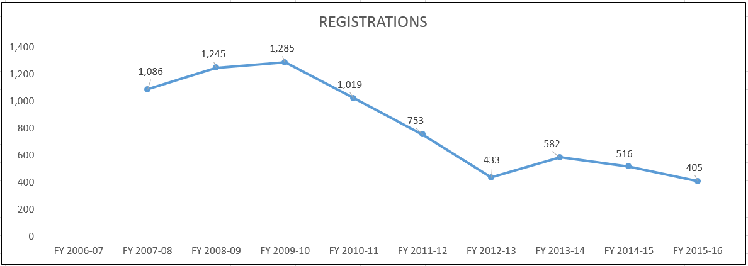

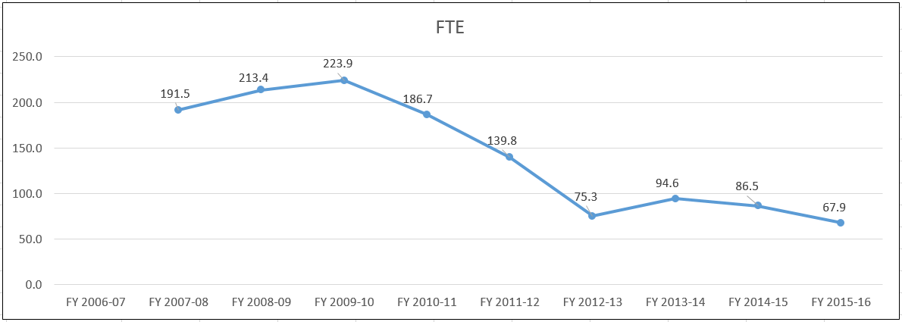

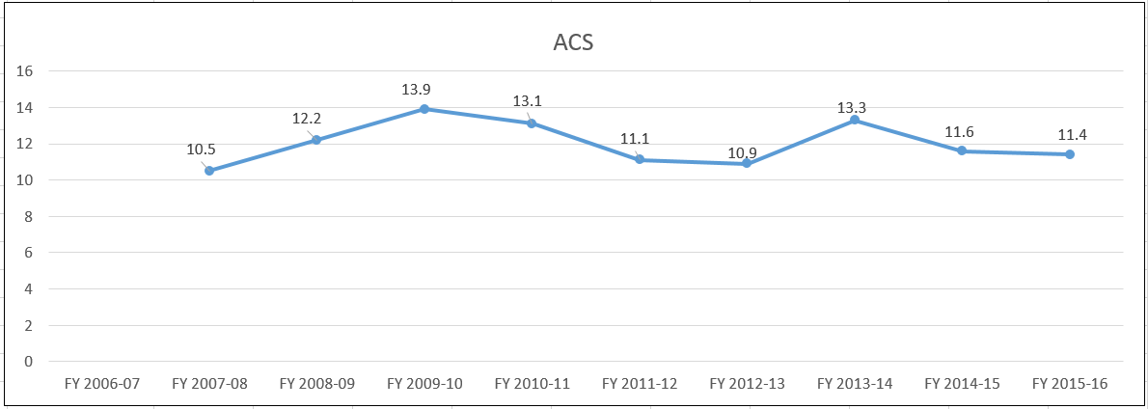

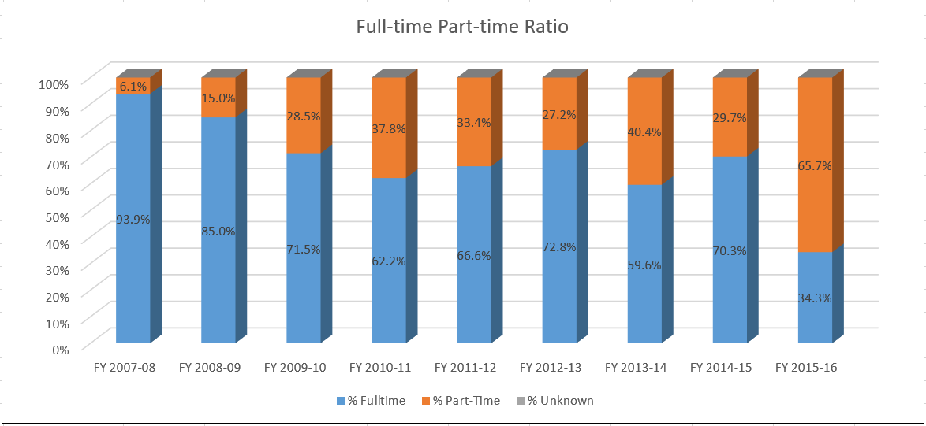

- Evidence of student demand for the program
How has/is student demand for the program changing? Why? Should the department take steps to increase the demand? Decrease the demand? Eliminate the program? What is the likely future demand for this program and why?
As seen in Section I and in this section's graphs of registrations and FTE, the enrollment for IET/OPT has been declining. Factors attributing to this as well as the departmental reaction were documented in Section I.

Employer demand is an additional factor should be taken into consideration when examining the IET/OPT programs. Throughout the year, we are contacted by many different employers in many fields looking for our graduates to apply for their job openings. The Dayton Daily News ran an article in 2016 indicating that Industrial Engineers were some of the most needed talent based on a survey of advertised job openings (See Appendix G). Also, when Festo Corporation in Mason was designing their new apprenticeship program in Mechatronics, two of the subjects that they requested were metrology (OPT 1100) and lean operations (OPT 1130). The IET/OPT program is in demand, but we are struggling to attract students.

Part of the struggle is that the field of IET/OPT is often hard to understand and does not always appeal to the high school crowd. Once a person has been in the workplace for a while, they are better able to see the benefit of the discipline. At the University of Dayton, many of the students in the Industrial Engineering Technology program come to them not as freshmen, but as sophomores and juniors who are getting a better idea of what the different disciplines involve.

An open, honest, benchmarking discussion with Cuyahoga Community College revealed that they are having similar problems with enrollment in their Manufacturing & Industrial Engineering Technology program. It's a good program and there is employer demand, but they struggle to get students.

- Evidence of program quality from external sources (e.g., advisory committees, accrediting agencies, etc.)
What evidence does the department have about evaluations or perceptions of department/program quality from sources outside the department? In addition to off-campus sources, include perceptions of quality by other departments/programs on campus where those departments are consumers of the instruction offered by the department.

For many years the program has had a very committed and involved industrial advisory committee that has been instrumental in the design of our curriculum and the monitoring of the quality of our programs. Our advisors help shape the curriculum by scrutinizing individual topics and suggesting appropriate changes. Many of our advisory committee members have actually hired our graduates and thus they can speak directly to the quality of our students and programs. Employers in general and our advisors in particular keep coming back to hire more of our graduates. We see this as the ultimate measure of program quality. A listing of our Advisory Committee members can be found in Appendix H.
We also monitor the performance of our students who transfer to the University of Dayton. UD faculty tell us that the experience at Sinclair has prepared our students well for advanced studies at UD.
Another external indicator of the quality of our program is the OPT 2270 Internship course which can be taken as an elective in the IET associate degree. Students in the internship course work for an employer in the IET/OPT field. During the semester, a faculty advisor conducts a site visit at the company, meeting with the student and the onsite supervisor to discuss the student's performance. Discussions usually last at least 30 minutes and the feedback in recent years has been very positive.

- Evidence of the cost-effectiveness of the department/program
What is the department doing to manage costs? What additional efforts could be made to control costs? What factors drive the costs for the department, and how does that influence how resources are allocated? What has the Average Class Size been for the department since the last Program Review, and what are steps that the department could take to increase Average Class Size? Has the department experienced any challenges in following the Two-Year Course Planning Guide?

The decline in student enrollment over the past years has coincided with the retirements of several faculty. Since 2008, five tenured faculty have retired, being replaced by one annually contracted faculty. This has been a hardship for the department but a significant savings for the college. The Full-time/Part-time Ratio graph presented earlier in this section shows the drastic growth of part-time instruction from 6.1% in FY 2007-08 to 65.7% in FY 2015-16.

Also, the IET/OPT department formerly had a lab technician that would support the Metrology and Process Improvement Labs, which are utilized by many of our courses. Over the years, a full-time technician was reduced to part-time status, and for the past three years the position has been vacant. Again, this is a cost savings for the college but also a burden for the department which at this point consists of a department chair who manages two different departments and one ACF.

Another measure of cost effectiveness is the average class size, which has remained fairly constant despite declining enrollment.

And lastly, the department consolidated its Process Improvement Lab in the summer of 2015, reducing its floor space by 600 square feet.

Section V: Department/Program Status and Goals
- List the department’s/program’s strengths, weaknesses, opportunities, and threats (SWOT analysis).

 | Strengths  - Knowledgeable faculty.  - Faculty willing to work with students.  - Articulation with UD.  - Strong curriculum.  - Strong ties with industry advisors and employers.  - New program name.  - Gender and racial diversity of students. | Opportunities  - Growth at Courseview.  - College's new Advanced Manufacturing strategy.  - Strong demand for graduates.  - Additional articulation agreements.  - Expand implementation of competency based education.  - New portable coordinate measuring arm.
 | Weaknesses  - Declining enrollment.  - Department of 1 ACF.  - 5 recent faculty retirements.  - No lab technician.  - Lack of course coordination.  - Outdated coordinate measurement equipment.  - Web presence. | Threats  - Negative public perception of manufacturing.  - Cyclical manufacturing economy.  - New Advanced Manufacturing program at Clark State.

- What are the department’s/program’s goals and rationale for expanding and improving student learning, including new courses, programs, delivery formats and locations? Are there unmet goals from the most recent Program Review? Please note that the department goals listed in this section will be reviewed for progress on Annual Updates and in your next Program Review.

Align with national certification. Identify a nationally recognized credential such as a certification from the American Society for Quality and align the program with it.

Expand presence at Courseview. Increase exposure in Warren and Butler Counties, enabling more courses to be offered at Courseview campus.

Increase number of articulation agreements. Now that the curriculum has been streamlined, develop additional transfer options for students.

Obtain a portable coordinate measuring arm. Bringing OPT 1113, Coordinate Measurement, up to date.

Continue implementation of competency-based education. Continue to work out the details of running a CBE version of OPT 1100.

- What resources and other assistance are needed to accomplish the department’s/program’s goals?

Faculty - In order for the IET/OPT department to be able to do anything more than teach classes, we need to have a tenure track faculty position. The current staffing level of one department chair and one ACF does not allow for any kind of additional work. The chair is split between two departments and the workload is predominantly administrative. The ACF is prohibited from doing anything other than teach class. A tenure track position would enable work to be done on department goals.

Capital - The department needs capital to be able to purchase a portable coordinate measurement arm to update the department's capabilities. This would bring in new technology, which would be a selling point for the programs. The IET/OPT department has submitted a capital request for this item to be purchased in FY 17-18.

Marketing - The IET/OPT department needs marketing assistance in order to reestablish a more stable enrollment in its programs.

Section VI: Appendices: Supporting Documentation

Appendix A: Completion and Success Rate Data

Appendix B: IET/OPT Student Progress Report (from DAWN)

Appendix C: Engineering Technology Enrollment (from ASEE)

Appendix D: Employer Assessment of Capstone Student Performance Survey

Appendix E: Capstone Student Reflection Survey

Appendix F: Industrial Engineering Technology AAS degree

Appendix G: Top 10 Most Advertised Jobs (from Dayton Daily News)

Appendix H: IET/OPT Advisory Committee members

