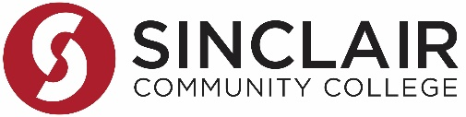
Application Must Be Typed & Submitted to Room 7340 for SDIC Approval

Staff Career Seminar Application
Name: | Dept/Division:
Effective Date of Employment:

Seminar Title: REACH Across Dayton Conference | Seminar Date: 02/28/2020

Check this box if you will combine your allotted fiscal year SDIC funding for participation in one career seminar.
Staff: | Full-Time: | Part-Time:
SDIC Funds Requested: | $50.00  (up to $200 per fiscal year) | $50.00  (up to $100 per fiscal year)

- Objectives: List one specific outcome you anticipate as a result of participating in this activity.
The conference provides a wide range of cultural programs and educational opportunities to facilitate an integrated exploration of the humanities and art unique to ethnic traditions throughout the Miami Valley area.
- Results: Identify how you anticipate the outcomes/results of this activity will impact you, colleagues, department, and/or the college.
REACH Across Dayton promotes learning in the arts and humanities by creating an atmosphere that builds respect, knowledge, appreciation, and understanding for the area's diverse cultural populations. It provides educators with ideas and suggestions that can be used in to facilitate multicultural understanding. The areas of fine arts, communication, film, theater, dance, music, and social issues will be explored.
- Strategic Priorities: Describe how this seminar aligns with one of the three Strategic Priorities:
EQUITY: This conference is focused on celebrating diversity & inclusion in our community. By participating, I will expand my understanding of the need and the role I must take to make our community a better place.

______________________________________ | ____________________
Applicant Signature | Date

Statement of Support by Immediate Supervisor:

______________________________________ | ____________________
Supervisor Signature | Date

______________________________________ | ___________________
SDIC Approval | Date

